

CAPSTONE PROJECT REPORT
Report 3 – Software Requirement Specification

– Hanoi, Jan 2024 –
Table of Contents
I. Record of Changes 3
II. Software Requirement Specification 4
1. Overall Requirements 4
1.1 Context Diagram 4
1.2 Main Workflows 5
1.3 User Requirements 8
1.4 System Functionalities 24
1.5 Entity Relationship Diagram 28
2. Use Case Specifications 30
3. Functional Requirements 31
3.1 Public Access 31
3.2 Authentication 43
3.3 Student Management 55
3.4 Teacher Management 90
3.5 Manager Management 103
3.6 Expert Management 113
3.7 Admin Management 142
4. Non-Functional Requirements 153
4.1 External Interfaces 153
4.2 Quality Attributes 155
5. Requirement Appendix 156
5.1 Business Rules 156
5.2 System Messages 160
5.3 Other Requirements 162

I. Record of Changes
Date | A*  M, D | In charge | Change Description
21/01/2026 | A | LinhVTK | Add Overall Requirements
24/01/2026 | M | DatMN, ThanhMC,AnhDHD, | Modify Context Diagram, Main Workflows, User Requirements, Entity Relationship Diagram
31/01/2026 | M | LinhVTK | Modify Context Diagram, Main Workflows, User Requirements
06/02/2026 | A | LinhVTK | Add Use Case Specifications, Functional Requirements, Non-Functional Requirements, Requirement Appendix
23/02/2026 | M | LinhVTK | Modify Overall Requirements
26/02/2026 | M | LinhVTK | Modify Functional Requirements, Non-Functional Requirements, Requirement Appendix
4/3/2026 | M | DatMN | Modify Entity Relationship Diagram, Entity Description
10/3/2026 | M | DatMN | Modify Entity Relationship Diagram
28/3/2026 | M | LinhVTK | Modify Context Diagram, System Functionalities
29/3/2026 | M | AnhDHD | Modify Use Case Diagrams
13/4/2026 | M | DatMN | Modify Entity Relationship Diagram
*A - Added M - Modified D - Deleted

II. Software Requirement Specification

1. Overall Requirements

1.1 Context Diagram
The Nova Learning Management System (NLMS) is a comprehensive, integrated platform designed to streamline academic and administrative operations within an English language training center. It supports end-to-end learning workflows, including user registration, placement testing, course enrollment, content delivery, assessments, grading, and progress tracking, enabling efficient management of the entire learning lifecycle. The system also provides centralized management of courses, classes, users, and learning resources to ensure consistency and scalability.
The system facilitates seamless interaction between students, teachers, and administrative roles through centralized data and workflows. It also integrates with external services such as a Payment System for transaction processing and an AI-powered service – Google Gemini – for automated question generation and writing evaluation, positioning NLMS as the central hub of the online learning ecosystem.
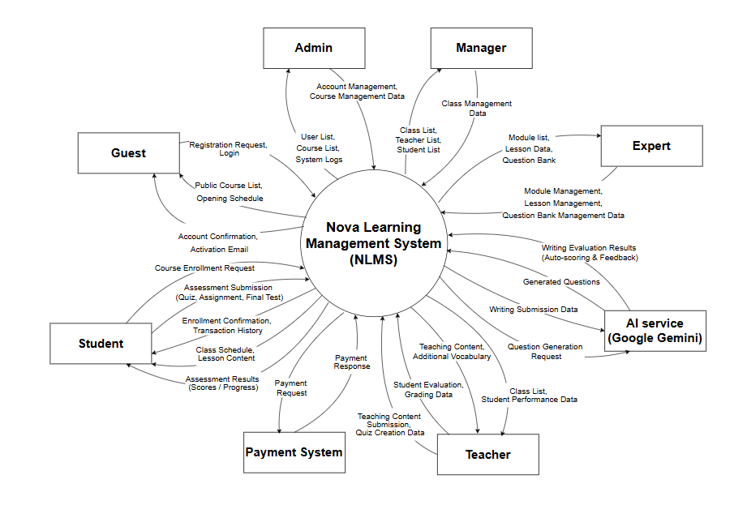
Figure 1: Context Diagram of Nova LMS
Link: Context Diagram of Nova LMS

1.2 Main Workflows

1.2.1 Student Enrollment & Payment Onboarding
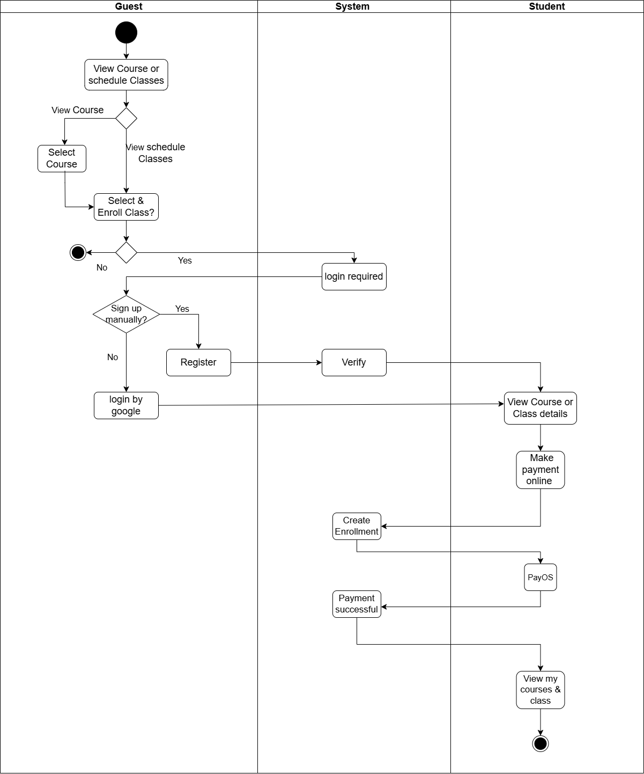
Figure 1: Student Enrollment & Payment Onboarding Flow of Nova LMS
Link: Student Enrollment & Payment Onboarding

1.2.2 Course Setup and Class Assignment

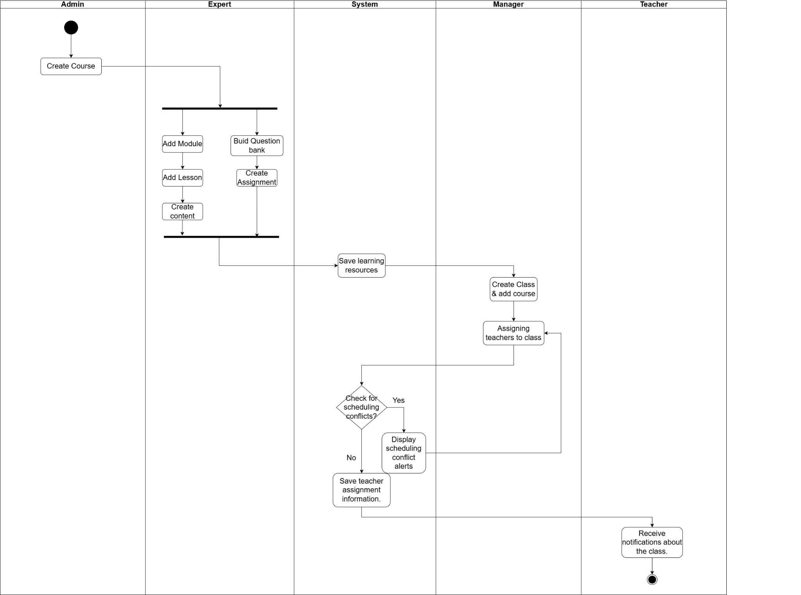
Figure 2: Course Setup and Class Assignment Flow of Nova LMS
Link: Live Course Orchestration & Academic Scheduling

1.2.3 Class Preparation and Rescheduling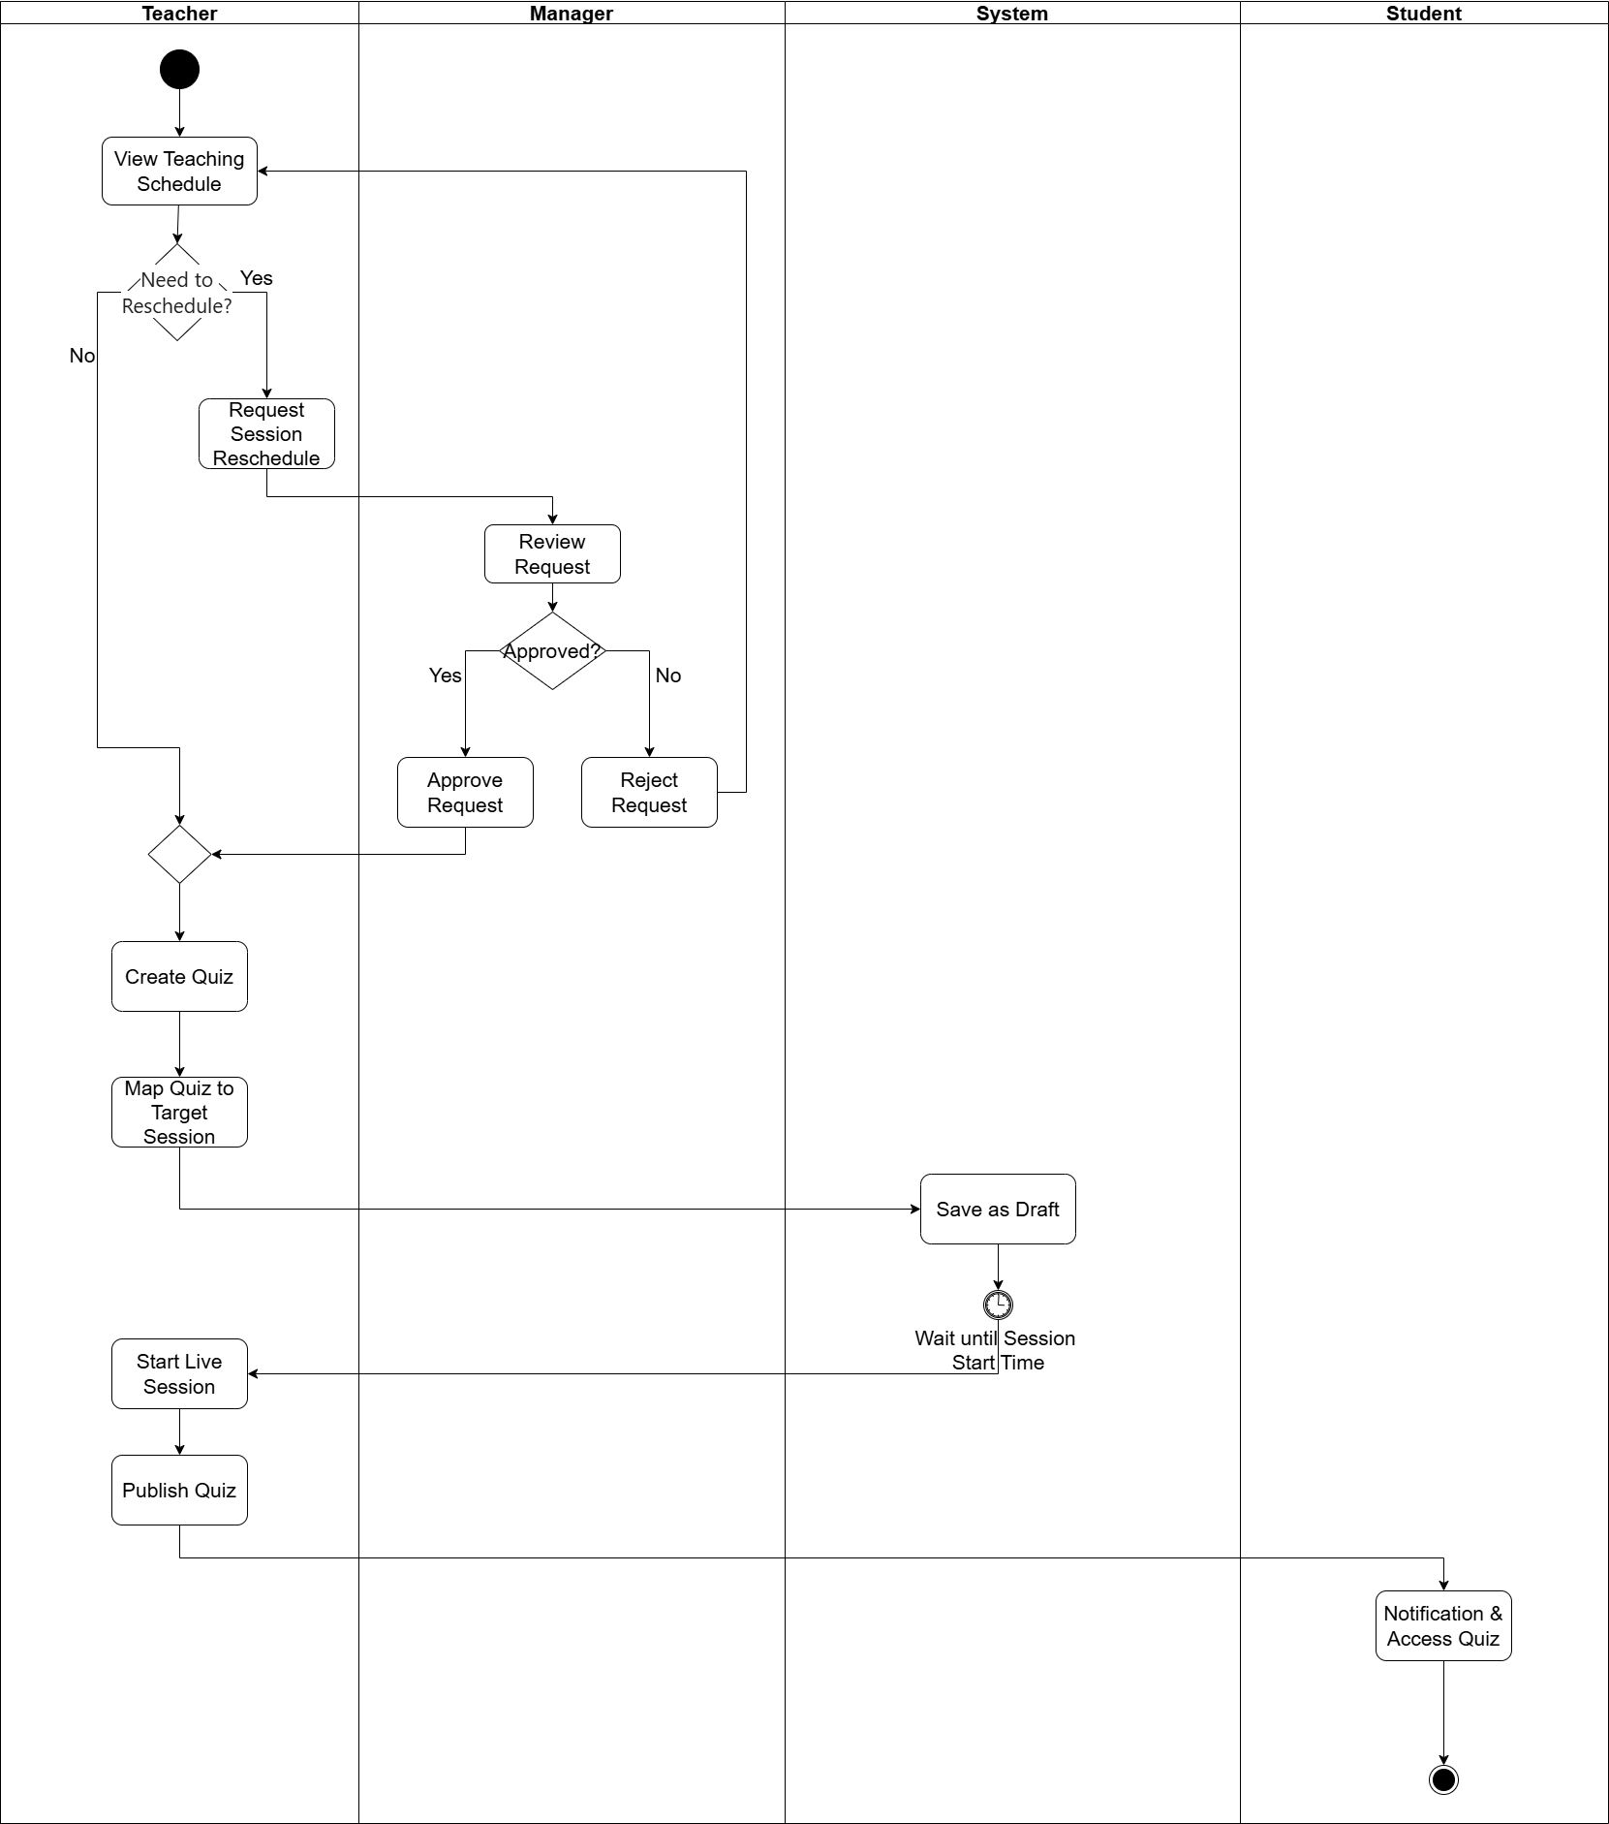
Figure 3: Class Preparation and Rescheduling Flow of Nova LMS
Link: Class Preparation and Rescheduling

1.2.4 Class Execution and AI-Assisted Evaluation
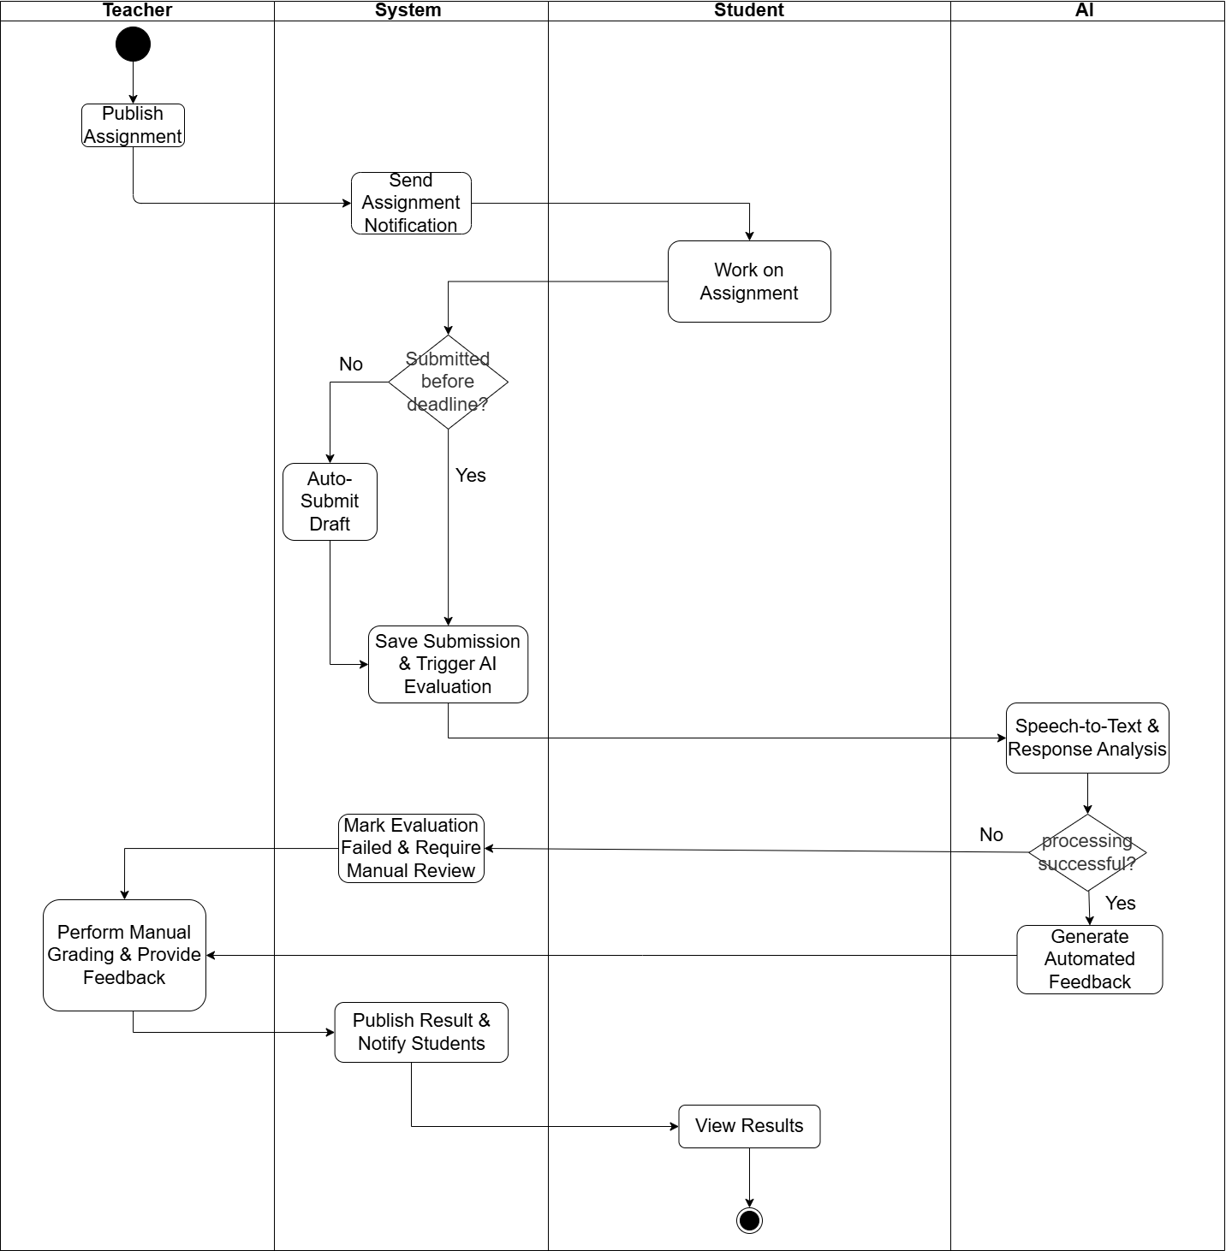
Figure 4: Class Execution and AI-Assisted Evaluation Flow of Nova LMS
Link: Class Execution and AI-Assisted Evaluation

1.3 User Requirements

1.3.1 Actors
# | Actor | Description
1 | Guest | An anonymous visitor who has not created an account. Guests can view public course information and create a new account to become a Registered User.
2 | Student | A learner who has been approved for enrollment in one or more courses. Students can participate in live classes, complete assignments and quizzes, view learning materials, and track their academic progress.
3 | Teacher | An instructor assigned to teach one or more classes. Teachers are responsible for conducting live sessions, uploading course materials and recordings, activating assignments and quizzes, and reviewing student submissions with the authority to override AI-generated scores.
4 | Manager | An operational role responsible for managing training logistics. The Manager instantiates specific classes based on existing course catalogs and is responsible for assigning and coordinating teachers for each of those classes.
5 | Expert | A subject matter specialist responsible for developing and curating the educational content within course shells initialized by the Admin. The Expert designs the curriculum structure (chapters/lessons) and creates assessments (assignments/quizzes) that are strictly aligned with the learning objectives of each content module.
6 | Administrator | A system administrator with full access to all system functions. Administrators manage user accounts and permissions, approve enrollment requests, configure courses and curricula, define AI grading rules and Placement Test formats, and oversee all system configuration.

1.3.2 Use Cases (UC)
ID | Use Case | Feature | Description
1 | View Home Page | Public Access | Guests visit the landing page to see general information.
2 | Register Account | Public Access | Guest creates a new account to become a registered member.
3 | View Public Courses | Public Access | Guest browses the list of available courses.
4 | View Public Course Details | Public Access | The user initiates password recovery to regain account access.
5 | View Public Classes | Public Access | Guest browses the list of current class offerings.
6 | Login System | Authentication | User authenticates to access personal system features.
7 | Reset Password | Authentication | The user recovers account access via email if the password is lost.
8 | Update User Profile | Authentication | The user modifies personal details and contact information.
9 | Change Password | Authentication | Users update their existing password for security purposes.
10 | Enroll Course/Class | Student Management | The student selects a specific class session and submits an enrollment request with payment information.
11 | View My Enrollments | Student Management | Students track the status of all their registration requests including payment and approval state.
12 | Cancel My Enrollment | Student Management | Student withdraws a pending enrollment request that has not yet been approved or paid.
13 | View My Courses | Student Management | Students access the list of all courses they are currently enrolled in with an Approved status.
14 | View Course/Class Info | Student Management | Students view the general overview of their class including schedule, teacher, and class members.
15 | View Module Lessons | Student Management | Students explore the structured curriculum tree organized by Modules and their associated Lessons.
16 | View Grade Book | Student Management | Students review their academic performance including quiz scores, grading status, and teacher feedback.
17 | Create Payment Link | Student Management | The system generates a QR-based PayOS payment link after a student submits a paid enrollment request.
18 | Check Payment Status | Student Management | System or student manually syncs and verifies the latest transaction status from the PayOS gateway.
19 | View Payment History | Student Management | Student views all completed payment records and invoice details for their enrolled courses.
20 | Access Lesson Materials | Student Management | Students open and consume lesson content such as embedded videos and structured reading texts.
21 | Download Attachments | Student Management | Student downloads supporting files attached to a lesson, such as PDFs, worksheets, or exercise files.
22 | Take Course Quiz | Student Management | Students start and complete a quiz assigned to their course or class session within the time limit.
23 | Request Quiz Unlock | Student Management | The student submits a written reason requesting the teacher to unlock a quiz that was automatically locked.
24 | Log System Violation | Admin Management | The system automatically records an entry each time a student switches tabs or exits the quiz screen.
25 | View Manager Dashboard | Manager Management | Manager views a summary of system operations including enrollment stats, revenue, and class statuses.
26 | View Class List | Manager Management | Manager browses the full directory of all existing classes with filters by course, status, and teacher.
27 | Create New Class | Manager Management | The manager initializes a new class by selecting a course, assigning a teacher, and setting the schedule.
28 | Update Class Details | Manager Management | The manager edits class information such as name, start/end dates, schedule, meet link, or assigned teacher.
29 | Create Quiz Draft | Expert Management | Teacher or Expert creates a new quiz shell by entering the title, description, and basic configuration.
30 | Add Questions to Quiz | Expert Management | Teacher or Expert selects questions from the question bank and adds them to a specific quiz.
31 | Set Quiz Timer | Expert Management | Teacher or Expert configures the total time limit in minutes that students have to complete the quiz.
32 | Set Pass Score | Expert Management | Teacher or Expert defines the minimum percentage score required for a student to pass the quiz.
33 | Toggle Quiz Status | Expert Management | The teacher opens or closes a quiz to control whether students in the assigned class can currently access it.
34 | View Teacher Dash | Teacher Management | The teacher views a summary of their assigned classes and the number of pending subjective answers to grade.
35 | View My Classes | Teacher Management | View the list of classes you are assigned to teach.
36 | View Teaching Timetable | Teacher Management | View the weekly teaching schedule in a grid format of 7 days × slots.
37 | View Class Students | Teacher Management | View the list of students in the classes you teach.
38 | View Expert Dash | Expert Management | Experts view an overview of all courses they are responsible for managing and building content within.
39 | Manage Module List | Expert Management | Expert views the ordered list of all modules (chapters) within a specific course.
40 | Add New Module | Expert Management | Expert creates a new module by providing a name and order index to extend the course curriculum.
41 | Edit Module Name | Expert Management | Experts update the title or description of an existing module within the course structure.
42 | Reorder Modules | Expert Management | Expert adjusts the display sequence of modules by updating their order index values.
43 | Delete Module | Expert Management | Expert permanently removes a module that contains no lessons from the course curriculum.
44 | Manage Lesson List | Expert Management | Experts view all lessons belonging to a specific module in their defined sequence.
45 | Create New Lesson | Expert Management | Expert authors a new lesson by specifying its name, type (Video/Doc/Quiz), and content body.
46 | Upload Lesson Media | Expert Management | Expert uploads a video file or document to Cloudinary and attaches it to a specific lesson.
47 | Edit Lesson Detail | Expert Management | Expert modifies the content, description, or attached media file of an existing lesson.
48 | Archive Lesson | Expert Management | Experts hide a lesson from the student view without deleting it, preserving historical data.
49 | Manage Question Bank | Expert Management | Expert views and manages all questions stored in the central repository, filterable by skill and type.
50 | Add Manual Question | Expert Management | Experts manually authors a new question including answer options and the correct answer key.
51 | Import Bank Excel | Expert Management | Expert bulk-uploads a structured set of questions into the system using a predefined Excel template.
52 | Edit Question Data | Expert Management | Expert modifies the content, answer choices, difficulty level, or skill tag of an existing question.
53 | Preview Question | Expert Management | Expert previews a question exactly as it would appear to a student during an actual quiz attempt.
54 | Review AI Suggestions | Expert Management | Expert reviews AI-generated question suggestions from a context prompt and selects items to add to the bank.
55 | View Admin Dash | Admin Management | Admin views a high-level system overview including total users, revenue metrics, and recent activity logs.
56 | Manage Account List | Admin Management | Admin searches, filters, and views all user accounts across every role in the system.
57 | Block/Unblock User | Admin Management | Admin changes a user's account status to Blocked or Active to control their access to the system.
58 | Create Staff Account | Admin Management | Admin manually creates a new account for internal staff roles such as Expert, Manager, or Teacher.
59 | Create Course Shell | Admin Management | Admin initializes a new course framework and assigns it to an Expert to begin building the curriculum content.
60 | Config System Data | Admin Management | Admin manages system-wide configuration parameters including roles, course categories, level tags, and API keys.
61 | Export System Logs | Admin Management | Admin exports activity and error logs from the system for auditing, debugging, or compliance purposes.
62 | View Session Detail | Admin Management | Access comprehensive session details, including course materials, assessments, and the virtual meeting link
63 | Check Reschedule Status | Teacher Management | Verify the status of a schedule modification request for a specific session.
64 | Request Session Reschedule | Teacher Management | Submit a session rescheduling request to the Manager for approval.
65 | Create Quiz Draft | Teacher Management | Create a quiz "shell": title, description, basic configuration.
66 | View Quiz List by Class | Teacher Management | View all quizzes associated with a specific class.
67 | Update Quiz Config | Teacher Management | Edit the title, time limit, and passing score of a quiz.
68 | Toggle Quiz Open/Close | Teacher Management | Enable or disable quiz access for students within a class.
69 | Submit Question for Expert Review | Teacher Management | Submit created questions to an Expert for approval to be added to the question bank.
70 | Generate Questions via AI | Teacher Management | Input a topic or skill to auto-generate AI-suggested questions.
71 | Import AI Questions to Quiz | Teacher Management | Select and import AI-generated questions into a quiz.
72 | View Assignment Grading Queue | Teacher Management | View the list of student assignments pending grading.
73 | View Assignment Grading Detail | Teacher Management | View the detailed submission of a student's assignment.
74 | Grade Assignment Submission | Teacher Management | Input grades and feedback for a student's assignment.
75 | Unlock Student Quiz Attempt | Teacher Management | Approve requests to unlock exams restricted due to policy violations.

1.3.3 Use Case Diagrams

1.3.3.1 UCs for Guest
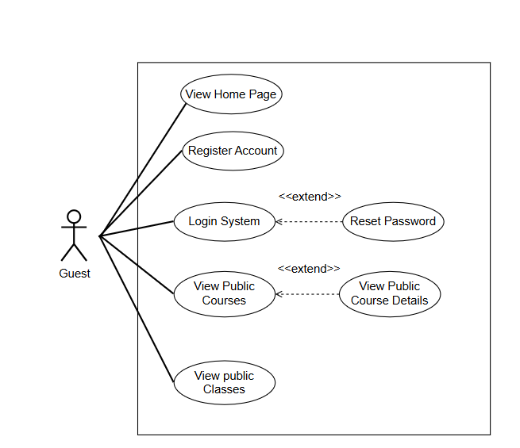
Figure 5: UCs for Guest of Nova LMS
Link: UCs for Guest of Nova LMS

1.3.3.2 UCs for Student
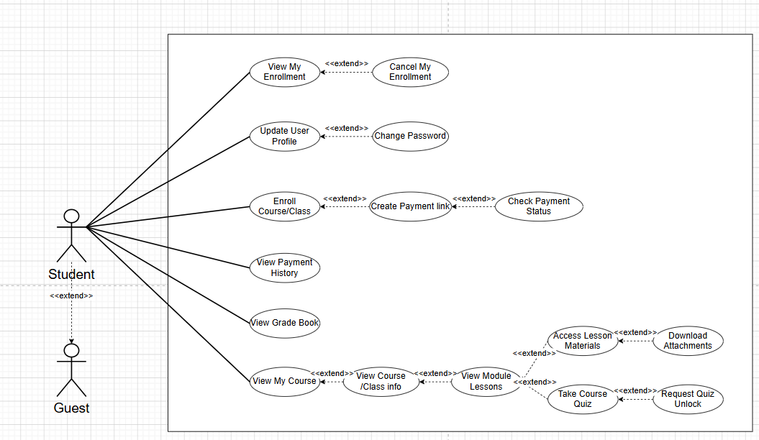
Figure 7: UCs for Student of Nova LMS
Link: UCs for Student of Nova LMS

1.3.3.3 UCs for Teacher
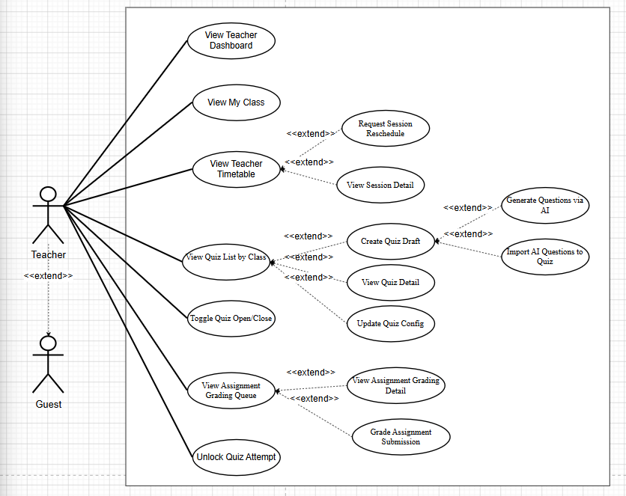
Figure 8: UCs for Teacher of Nova LMS
Link: UCs for Teacher of Nova LMS

1.3.3.4 UCs for Manager
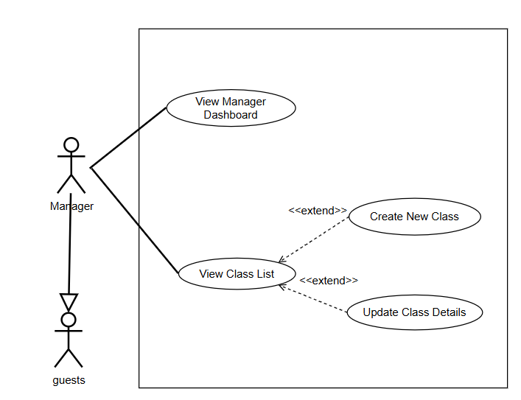
Figure 9: UCs for Manager of Nova LMS
Link: UCs for Manager of Nova LMS

1.3.3.5 UCs for Admin
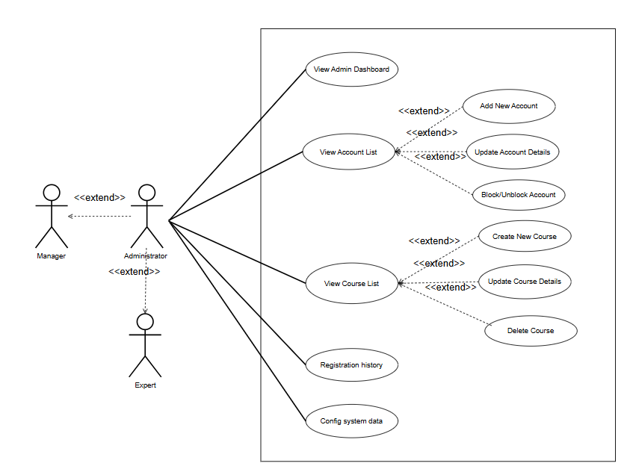
Figure 10: UCs for Admin of Nova LMS
Link: UCs for Admin of Nova LMS

1.3.3.6 UCs for Expert
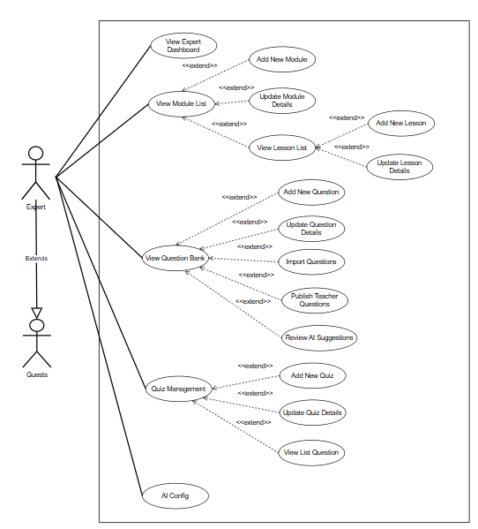 Figure 11: UCs for Expert of Nova LMS
Link: UCs for Expert of Nova LMS

1.4 System Functionalities
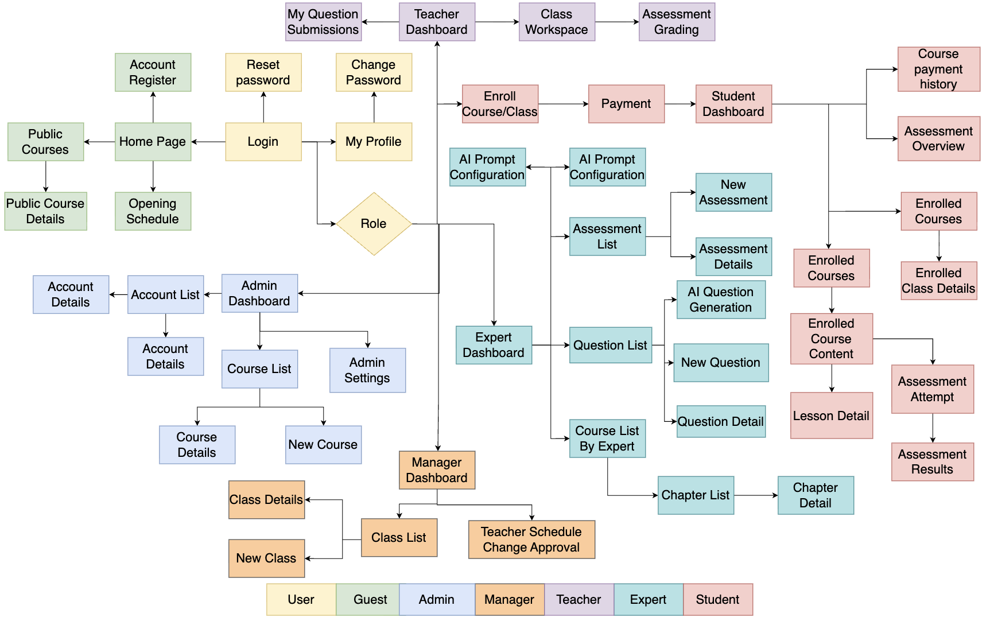
Figure 12: Screen flow of Nova LMS
Link: Screen flow of Nova LMS

1.4.2 Screen Authorization
Screen | Guest | Student | Teacher | Expert | Manager | Admin
Home Page | X | X | X | X | X | X
Opening Schedule | X | X | X | X | X | X
Public Courses List | X | X | X | X | X | X
Public Courses Detail | X | X | X | X | X | X
Account Register | X | X | X | X | X | X
Login | X | X | X | X | X | X
Reset Password |  | X | X | X | X | X
My Profile |  | X | X | X | X | X
Student Dashboard |  | X
Payment |  | X
Payment Result |  | X
Course Payment History |  | X
Enrolled Courses |  | X
Enrolled Course Content |  | X
Lesson Detail |  | X
Assessment Attempt |  | X
Assessment Results |  | X
Enrolled Classes |  | X
Enrolled Class Details |  | X
Assessment Overview |  | X
Manager Dashboard |  |  |  |  | X | X
Class List |  |  |  |  | X | X
New Class |  |  |  |  | X | X
Class Details |  |  |  |  | X | X
Teacher Schedule Change Approval |  |  |  |  | X | X
Teacher Dashboard |  |  | X
Class Workspace |  |  | X
Assessment Grading |  |  | X
My Question Submissions |  |  | X
Expert Dashboard |  |  |  | X |  | X
Course List By Expert |  |  |  | X |  | X
Chapter List |  |  |  | X |  | X
Chapter Detail |  |  |  | X |  | X
Question List |  |  |  | X |  | X
New Question |  |  |  | X |  | X
AI Question Generation |  |  |  | X |  | X
Question Detail |  |  |  | X |  | X
Assessment List |  |  |  | X |  | X
New Assessment |  |  |  | X |  | X
Assessment Details |  |  |  | X |  | X
AI Prompt Configuration |  |  |  | X |  | X
Question Approval |  |  |  | X |  | X
Admin Dashboard |  |  |  |  |  | X
Account List |  |  |  |  |  | X
New Account |  |  |  |  |  | X
Account Detail |  |  |  |  |  | X
Course List |  |  |  |  |  | X
New Course |  |  |  |  |  | X
Course Detail |  |  |  |  |  | X

1.4.3 Non-UI Functions
# | Feature | System Function | Description
1 | Authentication | User Authentication | Verify user credentials during login to allow secure access to the system.
2 | Authentication | Password Encryption | Encrypt and securely store user passwords in the database.
3 | Authorization | Role-based Access Control | Control system access based on user roles such as Guest, Student, Teacher, Expert, Manager, and Admin.
4 | Account Management | Account Data Validation | Validate user information when creating or updating accounts.
5 | Course Management | Course Data Processing | Handle backend operations for creating, updating, and retrieving course information.
6 | Enrollment | Enrollment Processing | Process student enrollment into courses or classes.
7 | Learning Management | Learning Progress Tracking | Track and update student learning progress in courses and lessons.
8 | Quiz Management | Quiz Evaluation | Automatically calculate and store quiz scores after submission.
9 | Placement Test | Placement Test Evaluation | Evaluate placement test results to determine student proficiency level.
10 | System Monitoring | Activity Logging | Record user activities and system events for auditing and troubleshooting.

1.5 Entity Relationship Diagram
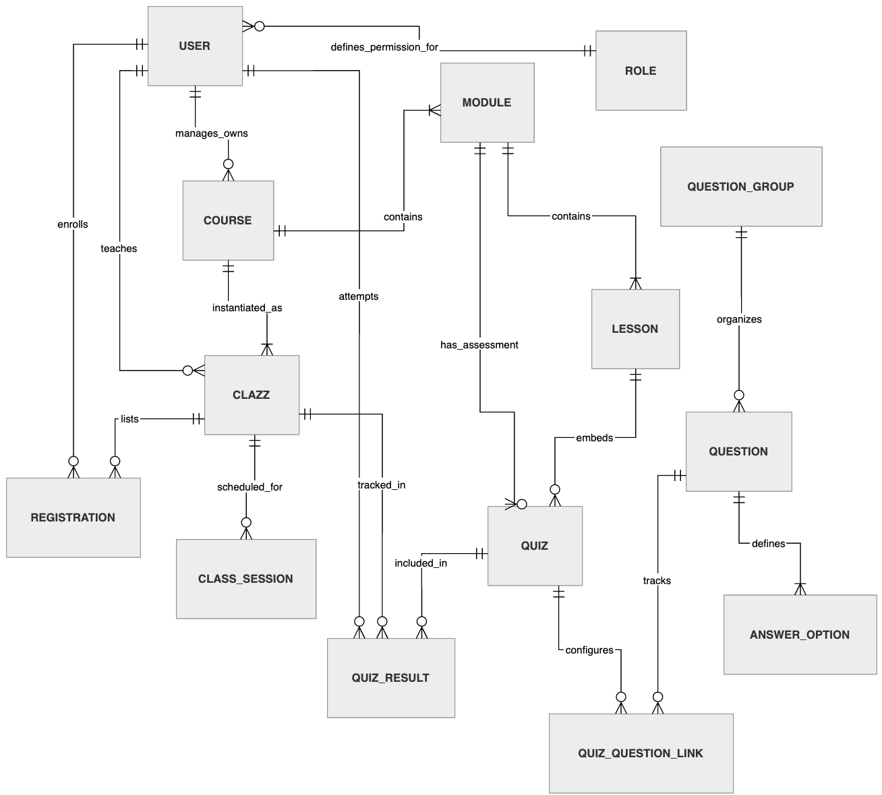
Figure 13: Entity Relationship Diagram of Nova LMS
Link: Entity Relationship Diagram of Nova LMS

Entities Description
# | Entity | Description
1 | ROLE | Defines authorization groups and roles within the system (Admin, Expert, Teacher, Student). It dictates the scope of data access and functional permissions.
2 | USER | Represents individuals interacting with the system. Stores credentials, contact details, authentication data, and links to a specific ROLE.
3 | COURSE | The master educational product (Template). Holds general information, target proficiency levels (CEFR), pricing, and publishing status.
4 | MODULE | Structural segments or chapters within a course. Used to organize the curriculum into a logical and manageable learning roadmap.
5 | LESSON | Granular content units within a module (Videos, documents). This is the primary medium for knowledge delivery to the students.
6 | CLAZZ | A real-world instance of a course (implementation). It tracks the actual schedule, assigned teacher, and the specific student roster.
7 | REGISTRATION | Records of student enrollments into a class or course. Manages clinical business logic such as approval status and payment information.
8 | CLASS_SESSION | Specific scheduled meetings for a class. Stores the precise timestamps and external learning links (e.g., Virtual Meeting URLs).
9 | QUESTION | The basic unit of assessment. Holds the prompt content, skill categorization, CEFR level, and parameters for automated grading.
10 | QUESTION_GROUP | Groups questions based on shared context (Passages or Audio clips). Critical for handling IELTS reading and listening components.
11 | ANSWER_OPTION | The available choices for multiple-choice questions. Identifies the correctness of each option to facilitate automatic scoring.
12 | QUIZ | An assessment or assignment structure. Configures rules such as time limits, passing scores, and question selection methods.
13 | QUIZ_RESULT | Captures the performance of a student's quiz attempt. Stores final scores, submission times, and the manual/auto grading status.
14 | QUIZ_QUESTION_LINK | A bridge entity connecting QUIZ and QUESTION. Enables question reusability across multiple assessments and manages item ordering.

2. Use Case Specifications
(Use Case Specifications use cases are described in this section 3)
View Home Page
Primary Actors | Guest | Secondary Actors | None
Description | As a Guest, I want to view the Home Page so that I can understand Nova LMS services, explore featured courses, and navigate to other public pages.
Preconditions | - Public system URLs are accessible.  - The website server is running normally.
Postconditions | - Home Page is displayed successfully.  - Public content (banner, featured courses, navigation menu) is visible.
Normal Sequence/Flow | 1. Guest accesses Nova LMS main URL.  2. System loads Home Page.  3. System displays header (Logo, Home, Schedule, Courses, Login/Register).  4. The system displays a main banner with introduction and action buttons (e.g., “View Courses”, “Learn More”) that allow users to navigate to other pages.  5. The system displays a featured courses section.  6. The system displays the instructor/expert section (if configured).  7. Guests can use navigation menu or action buttons to access other pages such as Courses, Schedule, Login, or Register.

3. Functional Requirements

3.1 Public Access

3.1.1.2 Home Page
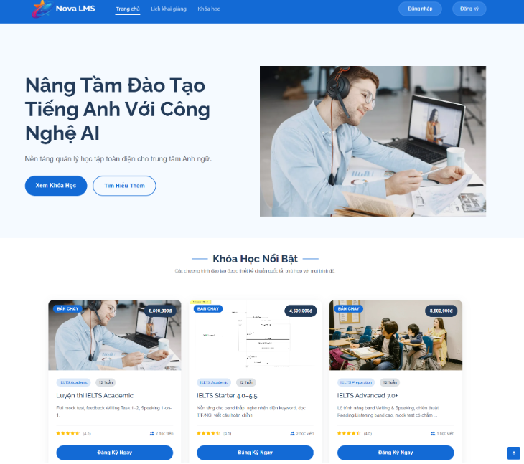

This screen allows the Guest (or logged-in User) to:
- View the main landing interface of the Nova LMS platform immediately after accessing the system.
- Understand the core value proposition of the platform through headline, description, and visual banner.
- Navigate to key public features including course listing, opening schedule, login, and registration.
- Browse and explore featured courses displayed on the homepage.
- View summarized course information such as name, level, duration, price, rating, and popularity.
- Access course detail or initiate enrollment from featured courses.
Mapped Use Cases:
- View Home Page
- View Public Courses
- View Course Detail
- Register Account
- Login System

Field Name | Description
Nova LMS Logo | Displays system logo and platform name at the top-left corner. Clicking redirects users to the Home Page from any screen.
Trang chủ (Home) | Navigation menu item. Default active state when user is on Home Page. Clicking reloads the Home Page.
Lịch khai giảng (Opening Schedule) | Navigation menu item. Redirects to the Opening Schedule screen displaying upcoming classes and start dates.
Khóa học (Courses) | Navigation menu item. Redirects to the Public Course List screen.
Đăng nhập (Login) | Button displayed on the header. Redirects to the Login screen. Only visible for Guest users.
Đăng ký (Register) | Button displayed on the header. Redirects to the Register screen. Only visible for Guest users.
User Avatar/Profile | Displayed when the user is logged in. Replaces Login/Register buttons. Provides access to the user menu (Profile, Dashboard, Logout).
Header Section | Top navigation bar containing logo, menu items, and authentication buttons. May be fixed (sticky) when scrolling.
Main Banner Section | The hero section displayed at the top of the page including headline, description, CTA buttons, and banner image.
Main Banner Title | Displays main headline: “Nâng Tầm Đào Tạo Tiếng Anh Với Công Nghệ AI”. Emphasizes platform value.
Main Banner Description | Displays short description introducing Nova LMS as an AI-powered English learning platform.
Xem Khóa Học (View Courses) | Primary CTA button. Redirects to the Public Course List screen.
Tìm Hiểu Thêm (Learn More) | Secondary CTA button. Scrolls to an additional information section or redirects to the introduction page.
Banner Image | Displays visual illustration related to online learning (e.g., student studying with laptop).
Khóa Học Nổi Bật (Featured Courses) | Section title indicating list of highlighted courses configured by the system (e.g., best sellers, recommended).
Featured Section Description | Displays supporting text describing course quality and standards.
Course List Container | Layout container displaying course cards in grid format (e.g., 3 columns on desktop).
Course Card | Represents a single course. Includes thumbnail, tag, name, level, duration, rating, price, and action button. Clicking the card redirects to the Course Detail screen.
Course Thumbnail | Displays course images representing learning content.
Course Tag (e.g., Bán chạy) | Labels displayed on course cards indicating special status such as “Best Seller”. Configurable by admin.
Course Name | Displays full course name (e.g., IELTS Academic).
Course Level | Displays course category or level (e.g., Foundation, Advanced).
Course Duration | Displays estimated duration (e.g., 12 weeks).
Course Description (Short) | Displays a brief summary of course content. Text may be truncated if it exceeds the UI limit.
Course Price | Displays course fee in VND format (e.g., 5.500.000đ).
Course Rating | Displays average rating with star icons (e.g., 4.5/5).
Course Review Count | Displays number of learners or reviews.
Đăng Ký Ngay (Enroll Now) | CTA button on each course card. Redirects to Course Detail or Enrollment flow depending on user authentication status.
Xem Tất Cả Khóa Học (View All Courses) | Button at the end of the Featured Courses section. Redirects to the Public Course List screen.
Scroll Behavior | Supports vertical scrolling through sections. Headers may remain fixed for easier navigation.
Responsive Behavior | Layout adapts to different screen sizes (desktop, tablet, mobile). The course grid adjusts the number of columns accordingly.
Guest Access Rule | All content is viewable without login. Enrollment actions require user authentication.
Logged-in Behavior | Logged-in users see profile menu instead of Login/Register. Enrollment actions may proceed directly to payment or enrollment flow.

3.1.1.3 Opening Schedule
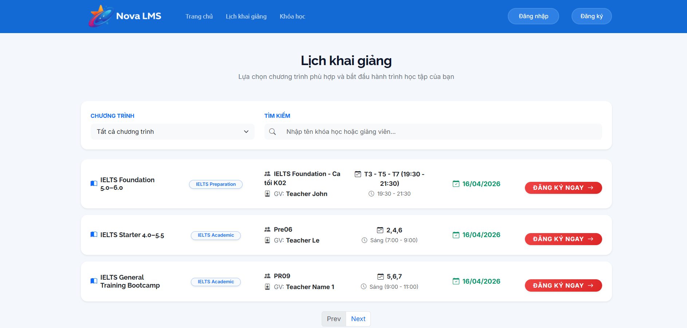
This screen allows the Guest (or logged-in User) to:
- View the list of available course schedules (opening classes) provided by the system.
- Search for schedules by course name or instructor name.
- Filter schedules by program/category.
- View detailed information of each class including course name, class code, teacher, study days, time, and start date.
- Identify suitable schedules based on personal availability.
- Register/enroll in a selected class directly from the schedule list.
Mapped Use Cases:
- View Opening Schedule
- Search Schedule
- Filter Schedule
- View Class Detail
- Enroll Course/Class
Field Name | Description
Lịch khai giảng (Opening Schedule Title) | Displays the title of the page indicating the schedule listing screen.
Subtitle Description | Displays supporting text: “Lựa chọn chương trình phù hợp và bắt đầu hành trình học tập của bạn”.
Chương trình (Program Filter) | Dropdown filter allows users to select a specific program/category (e.g., IELTS, TOEIC). The default value is “Tất cả chương trình”.
Tìm kiếm (Search Bar) | Input field allowing users to search schedules by course name or instructor name. Supports partial matching.
Search Placeholder | Displays hint text: “Nhập tên khóa học hoặc giảng viên…”.
Schedule List Container | Displays a list of available class schedules in a vertical layout.
Schedule Item / Class Card | Represents a single class schedule. Each item displays course and class information along with enrollment action.
Course Name | Displays the name of the course (e.g., IELTS Foundation 5.0–6.0).
Course Tag | Displays category label (e.g., IELTS Preparation, IELTS Academic).
Class Code | Displays class identifier (e.g., K02, Pre06, PR09).
Teacher Name | Displays assigned instructor (e.g., GV: Teacher John).
Study Days | Displays learning days in week format (e.g., T3 - T5 - T7 or 2,4,6).
Study Time | Displays time range for each session (e.g., 19:30 - 21:30 or 07:00 - 09:00).
Start Date | Displays class start date (e.g., 16/04/2026).
Đăng ký ngay (Enroll Now) | CTA button. Redirects users to enrollment or course detail flow depending on login status.
Pagination (Prev/Next) | Allows users to navigate between multiple pages of schedule results.
Empty State | Displays messages when no schedules match search/filter conditions.
Search Behavior | Results update dynamically or after submit based on keyword input.
Filter Behavior | Schedule list updates based on selected programs.
Guest Access Rule | Guest users can view all schedule information but must log in before enrolling.
Logged-in Behavior | Logged-in users can directly proceed to enrollment/payment when clicking “Đăng ký ngay”.
Responsive Behavior | Layout adapts across devices. Schedule items stack vertically on smaller screens.

3.1.1.4 Public Courses List
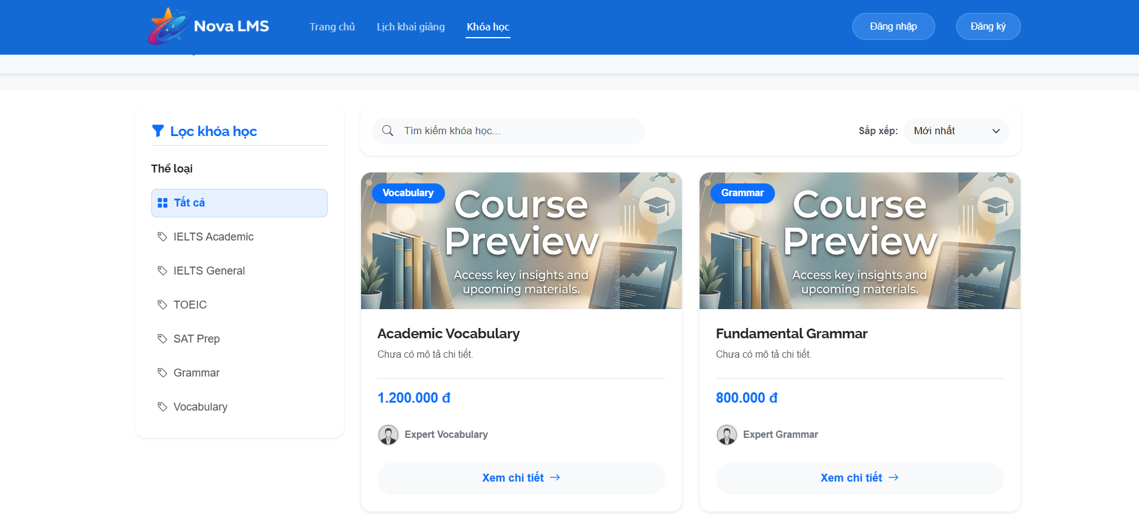
This screen allows the Guest (or logged-in User) to:
- View the list of all available public courses in the system.
- Search courses by course name using keyword input.
- Filter courses by category (e.g., IELTS Academic, TOEIC, Grammar, Vocabulary).
- Sort courses based on different criteria such as newest, price ascending, or price descending.
- View summarized course information including image, name, price, and instructor.
- Navigate to the course detail page for more information.
Mapped Use Cases:
- View Public Courses
- Search Course
- Filter Course
- Sort Course
- View Course Detail
Field Name | Description
Khóa học (Courses Title) | Indicates the current page is the Public Course List screen.
Lọc khóa học (Filter Panel) | Sidebar section allowing users to filter courses by category.
Thể loại (Category Filter) | Displays list of course categories (e.g., Tất cả, IELTS Academic, IELTS General, TOEIC, SAT Prep, Grammar, Vocabulary).
Tất cả (All) | Default selected option. Displays all courses without filtering.
Category Item | Each selectable category is used to filter the course list. Only one category can be active at a time.
Tìm kiếm khóa học (Search Bar) | Input field allowing users to search courses by name.
Search Placeholder | Displays hint text: “Tìm kiếm khóa học…”.
Sắp xếp (Sort Dropdown) | Dropdown control allows users to sort course lists based on selected criteria.
Mới nhất (Newest) | Sort option. Displays courses based on latest created or recently updated (default option).
Giá thấp đến cao (Price Ascending) | Sort option. Displays courses in ascending order of price.
Giá cao đến thấp (Price Descending) | Sort option. Displays courses in descending order of price.
Sort Behavior | When a user selects a sort option, the course list is re-ordered immediately based on selected criteria.
Course List Container | Grid layout displaying course cards (e.g., 2–4 columns depending on screen size).
Course Card | Represents a course item. Includes thumbnail, tag, name, description, price, instructor, and action link. Clicking the card redirects to the Course Detail screen.
Course Thumbnail | Displays course image/banner.
Course Tag (e.g., Vocabulary, Grammar) | Displays course category label on the thumbnail.
Course Name | Displays full course name (e.g., Academic Vocabulary, Fundamental Grammar).
Course Description (Short) | Displays short description. If not available, shows placeholder text (e.g., “Chưa có mô tả chi tiết”).
Course Price | Displays course fee (e.g., 1.200.000đ).
Instructor Name | Displays instructor or expert name (e.g., Expert Vocabulary).
Xem chi tiết (View Detail) | Button/link. Redirects to Course Detail screen.
Empty State | Displays messages when no courses match search/filter/sort conditions.
Search Behavior | Filters course list based on keyword. May support real-time or submit-based search.
Filter Behavior | Updates course list based on selected category.
Guest Access Rule | Guest users can view the course list and detail but must log in to enroll.
Logged-in Behavior | Logged-in users may proceed to enrollment from the Course Detail screen.
Responsive Behavior | Layout adapts across devices. Sidebar filters may collapse into dropdowns on mobile.

3.1.1.5 Public Courses Detail

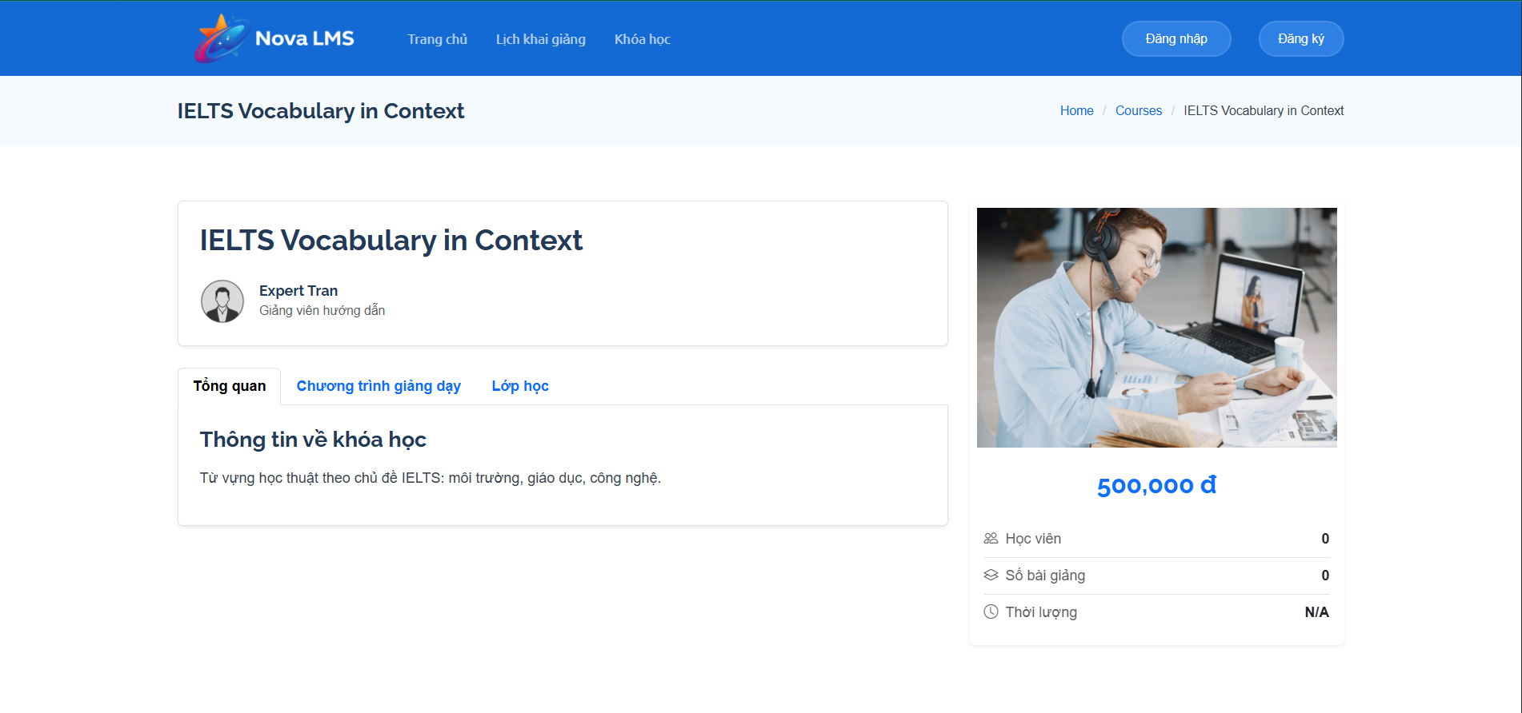
This screen allows the Guest (or logged-in User) to:
- View detailed information of a selected course including title, instructor, and description.
- Understand course content through overview, curriculum, and class information tabs.
- View instructor information associated with the course.
- Check course pricing and basic statistics such as number of students and lessons.
- Navigate between different sections of the course detail (Overview, Curriculum, Classes).
- Decide whether the course is suitable before proceeding to enrollment.
Mapped Use Cases:
- View Course Detail
- View Course Curriculum
- View Course Classes
- View Instructor Information
Field Name | Description
Course Title | Displays the full name of the course (e.g., IELTS Vocabulary in Context).
Instructor Name | Displays instructor name (e.g., Expert Tran).
Instructor Role | Displays instructor role/description (e.g., Giảng viên hướng dẫn).
Instructor Avatar | Displays profile image/icon of the instructor.
Course Header Section | Top section containing course title and instructor information.
Course Image | Displays representative image of the course on the right side.
Course Price | Displays course fee (e.g., 500,000đ).
Tổng quan (Overview Tab) | Default active tab. Displays general course information and description.
Chương trình giảng dạy (Curriculum Tab) | Tab that displays detailed course content such as lessons, modules, or syllabus.
Lớp học (Classes Tab) | Tab that displays available classes/schedules for this course.
Tab Navigation | Allows users to switch between Overview, Curriculum, and Classes sections without leaving the page.
Thông tin về khóa học (Course Information Section) | Section displaying detailed description of the course.
Course Description | Displays course content summary (e.g., vocabulary topics such as environment, education, technology).
Học viên (Student Count) | Displays number of enrolled students.
Số bài giảng (Lesson Count) | Displays total number of lessons in the course.
Thời lượng (Duration) | Displays total course duration. May show “N/A” if not configured.
Right Sidebar | Section containing course image, price, and quick stats.
Data Binding | All course information is dynamically loaded based on the selected course.
Guest Access Rule | Guest users can view all course details but must log in to enroll.
Logged-in Behavior | Logged-in users can proceed to enrollment or select class from “Lớp học” tab.
Responsive Behavior | Layout adapts to different screen sizes. The sidebar may move below the main content on mobile.

3.2 Authentication

3.2.1 Account Register
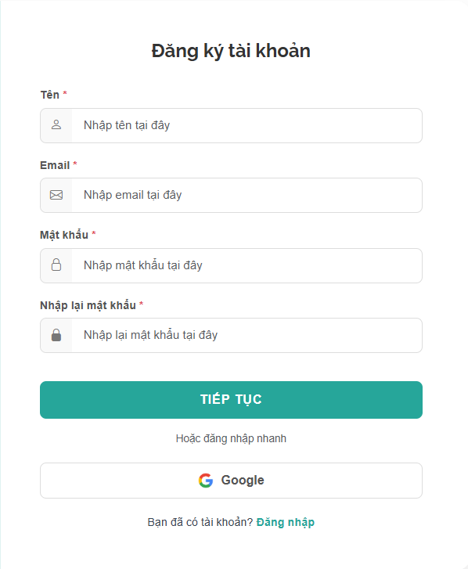
This screen allows the Guest to:
- Register a new account in the system by providing required personal information.
- Input and submit registration details including name, email, and password.
- Confirm password to ensure accuracy before account creation.
- Register quickly using a third-party account (Google).
- Navigate to the Login screen if already having an account.
Mapped Use Cases:
- Register account
- Validate input data
- Register with google
- Navigate to login
Field Name | Description
Đăng ký tài khoản (Register Title) | Displays the title of the registration screen.
Tên (Name) | Input field for user’s full name. This is a required field.
Name Placeholder | Displays hint text: “Nhập tên tại đây”.
Email | Input field for user’s email address. Must be in valid email format. This is a required field.
Email Placeholder | Displays hint text: “Nhập email tại đây”.
Mật khẩu (Password) | Input field for password. Characters are masked. This is a required field.
Password Placeholder | Displays hint text: “Nhập mật khẩu tại đây”.
Nhập lại mật khẩu (Confirm Password) | Input field to re-enter password. Must match Password field. This is a required field.
Confirm Password Placeholder | Displays hint text: “Nhập lại mật khẩu tại đây”.
Required Field Indicator (*) | Indicates mandatory fields that must be filled before submission.
TIẾP TỤC (Submit Button) | Button to submit registration form. Triggers validation and account creation process.
Button State | Disabled when required fields are empty or invalid. Enabled when all inputs are valid.
Validation Rules | Includes: required fields, valid email format, password length requirement, confirm password must match password.
Validation Message | Displays error messages under fields when validation fails (e.g., “Email không hợp lệ”, “Mật khẩu không khớp”).
Hoặc đăng nhập nhanh (Divider Text) | Displays alternative login method section separator.
Google Button | Allows users to register/login using Google account (OAuth).
Google Icon | Displays Google logo inside the button.
Bạn đã có tài khoản? Đăng nhập | Text with link. Redirects the user to the Login screen.
Form Submission | On successful validation, the system creates a new user account and redirects to the appropriate screen (e.g., Dashboard or Home).
Error Handling | Displays error message if email already exists or system error occurs.
Guest Access Rule | Only Guest users can access this screen. Logged-in users should be redirected away.
Responsive Behavior | Form is centered and adapts to different screen sizes (desktop/mobile).

3.2.2 Login
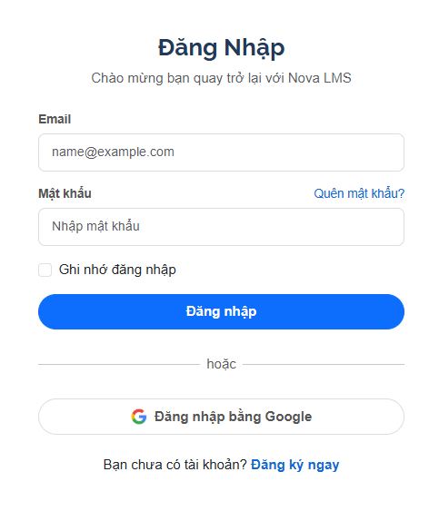
This screen allows the Guest (or logged-out User) to:
- Log in to the system using registered email and password.
- Input login credentials and submit authentication requests.
- Use the “remember me” option to maintain the login session.
- Recover password through “forgot password” feature.
- Log in quickly using a Google account.
- Navigate to the Register screen if the user does not have an account.
Mapped Use Cases:
- Login System
- Validate Login Credentials
- Remember Login Session
- Forgot Password
- Login with Google
- Navigate to Register
Field Name | Description
Đăng nhập (Login Title) | Displays the title of the login screen.
Welcome Text | Displays message: “Chào mừng bạn quay trở lại với Nova LMS”.
Email | Input field for user’s email address. This is a required field.
Email Placeholder | Displays hint text: “name@example.com”.
Mật khẩu (Password) | Input field for password. Characters are masked. This is a required field.
Password Placeholder | Displays hint text: “Nhập mật khẩu”.
Quên mật khẩu? (Forgot Password) | Link that redirects users to Reset Password screen.
Ghi nhớ đăng nhập (Remember Me) | Checkbox option to keep users logged in for future sessions.
Đăng nhập (Login Button) | Button to submit login form. Triggers authentication process.
Button State | Disabled when required fields are empty. Enabled when all required fields are filled.
Validation Rules | Includes: required fields, valid email format.
Validation Message | Displays error messages when login fails (e.g., “Sai email hoặc mật khẩu”).
hoặc (Divider Text) | Displays separator between normal login and social login.
Đăng nhập bằng Google (Google Login) | Button that allows users to log in via Google account (OAuth).
Google Icon | Displays Google logo inside the button.
Bạn chưa có tài khoản? Đăng ký ngay | Text with link. Redirects users to the Register screen.
Login Processing | On successful authentication, the system redirects the user to Home Page or Dashboard.
Error Handling | Displays error message if credentials are incorrect or account does not exist.
Guest Access Rule | Only Guest users can access this screen. Logged-in users should be redirected.
Responsive Behavior | Form is centered and adapts to different screen sizes.

3.2.3 Reset Password
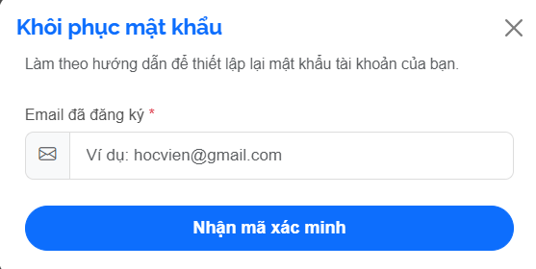
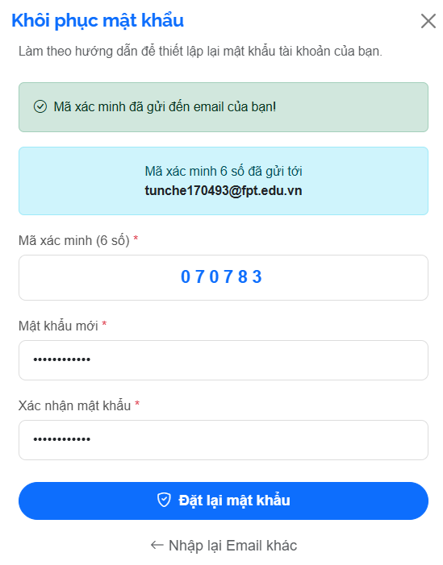
This screen allows the Guest (or logged-out User) to:
- Request a password reset by entering their registered email address.
- Submit an email to receive a verification code or password reset instructions.
- Initiate the password recovery process securely.
- Close the dialog without performing any action.
Mapped Use Cases:
- Forgot Password
- Request Password Reset
- Validate Email Input
Field Name | Description
Khôi phục mật khẩu (Reset Password Title) | Displays the title of the password recovery screen.
Instruction Text | Displays guidance message: “Làm theo hướng dẫn để thiết lập lại mật khẩu tài khoản của bạn.”
Email đã đăng ký (Registered Email) | Input field for user to enter the registered email address. This is a required field.
Email Placeholder | Displays hint text: “Ví dụ: hocvien@gmail.com”.
Required Field Indicator (*) | Indicates that the email field is mandatory.
Nhận mã xác minh (Get Verification Code) | Button to submit the email and request a verification code or reset link.
Button State | Disabled when the email field is empty or invalid. Enabled when input is valid.
Validation Rules | Includes: required field and valid email format.
Validation Message | Displays error message if email is invalid or not found in the system.
Close Icon (X) | Icon button at top-right corner. Closes the popup/modal.
Form Submission | On valid submission, the system sends verification code or reset instructions to the provided email.
Error Handling | Displays error if email does not exist or system fails to send email.
Security Handling | Prevents exposure of whether an email exists in the system (optional based on design).
Guest Access Rule | Only accessible to users who are not logged in.
Display Type | This screen is presented as a modal/popup overlay on top of the current page.
Responsive Behavior | Modal is centered and adjusts properly on different screen sizes.

3.2.3 My Profile
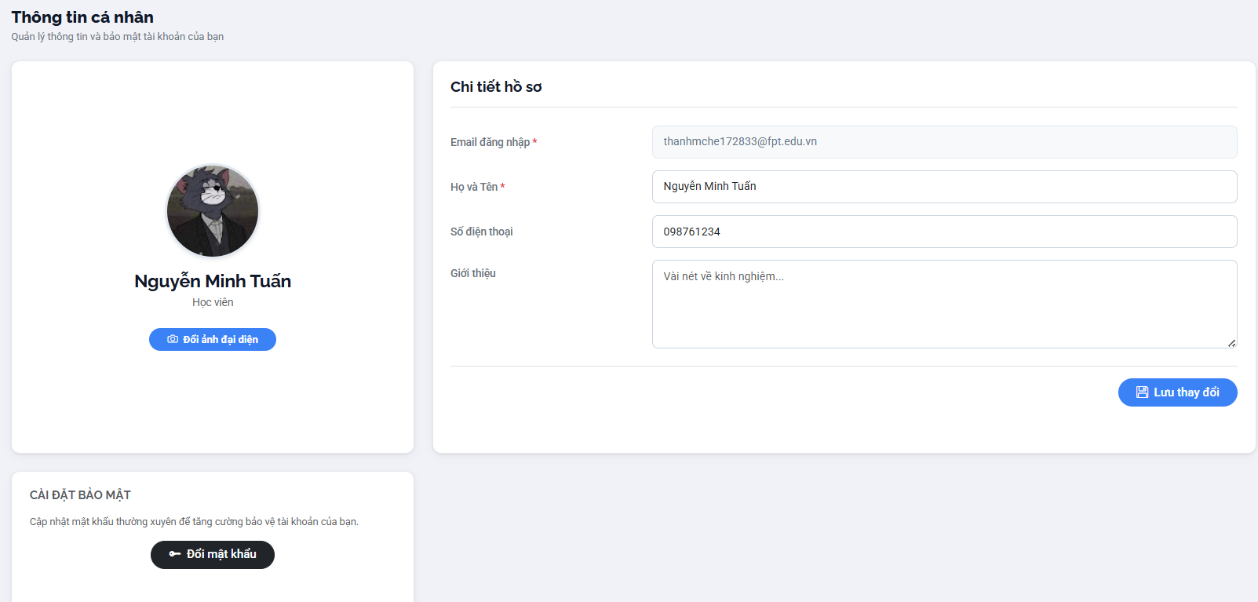
This screen allows the logged-in User to:
- View and manage their personal profile information.
- Update basic information such as full name, phone number, and personal introduction.
- View registered email (read-only).
- Upload or change profile avatar.
- Save updated profile information.
- Navigate to change password functionality for account security.
Mapped Use Cases:
- View Profile
- Update Profile Information
- Upload Avatar
- Change Password
Field Name | Description
Thông tin cá nhân (Profile Title) | Displays the title of the personal information screen.
Subtitle Description | Displays supporting text about managing account information and security.
Avatar | Displays current user profile image.
Đổi ảnh đại diện (Change Avatar) | Button allows users to upload or change profile pictures.
User Name Display | Displays full name of the user (e.g., Nguyễn Minh Tuấn).
User Role | Displays user role (e.g., Học viên).
Chi tiết hồ sơ (Profile Detail Section) | Section containing editable user information fields.
Email đăng nhập (Email) | Displays user email. This field is read-only and cannot be edited.
Họ và Tên (Full Name) | Input field for user’s full name. This is a required field.
Số điện thoại (Phone Number) | Input field for user’s phone number. Optional or required based on system rules.
Giới thiệu (Introduction) | Textarea field for user to input personal description or bio.
Placeholder Introduction | Displays hint text: “Vài nét về kinh nghiệm...”.
Lưu thay đổi (Save Changes) | Button to save updated profile information.
Button State | Enabled when there are changes in form data.
Validation Rules | Includes: required full name, valid phone number format (if provided).
Validation Message | Displays error messages if validation fails.
Cài đặt bảo mật (Security Settings Section) | Section related to account security.
Đổi mật khẩu (Change Password) | Button that redirects user to Change Password screen or opens modal.
Update Behavior | On successful update, the system saves data and shows success notification.
Error Handling | Displays error message if update fails due to system issue.
Access Rule | Only accessible to authenticated users.
Responsive Behavior | Layout adapts across devices; sections stack vertically on smaller screens.

3.2.4 Change Password
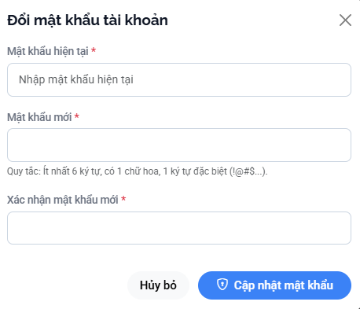
This screen allows the logged-in User to:
- Change their account password by providing current and new passwords.
- Ensure account security by updating passwords with required validation rules.
- Confirm the new password before submission to avoid input mistakes.
- Cancel the action and close the popup without saving changes.
Mapped Use Cases:
- Change Password
- Validate Password
- Confirm Password
Field Name | Description
Đổi mật khẩu tài khoản (Change Password Title) | Displays the title of the change password modal.
Mật khẩu hiện tại (Current Password) | Input field for entering current password. This is a required field.
Current Password Placeholder | Displays hint text: “Nhập mật khẩu hiện tại”.
Mật khẩu mới (New Password) | Input field for entering new password. This is a required field.
Password Rules | Displays password requirements (e.g., at least 6 characters, 1 uppercase letter, 1 special character).
Xác nhận mật khẩu mới (Confirm New Password) | Input field to re-enter new password. Must match the New Password field. This is a required field.
Hủy bỏ (Cancel Button) | Button to cancel the action and close the modal without saving changes.
Cập nhật mật khẩu (Update Password Button) | Button to submit password change request.
Button State | Disabled when required fields are empty or invalid. Enabled when all inputs are valid.
Validation Rules | Includes: required fields, correct current password, new password meets rules, confirm password matches new password.
Validation Message | Displays error messages (e.g., “Mật khẩu hiện tại không đúng”, “Mật khẩu không hợp lệ”, “Mật khẩu xác nhận không khớp”).
Close Icon (X) | Icon button to close the modal.
Form Submission | On successful validation, the system updates password and shows success notification.
Error Handling | Displays error if current password is incorrect or system error occurs.
Security Handling | Password fields are masked; may include additional security checks (e.g., session validation).
Display Type | This screen is presented as a modal/popup.
Access Rule | Only accessible to authenticated users.
Responsive Behavior | Modal is centered and adapts to different screen sizes.

3.3 Student Management

3.2.1 Student Dashboard
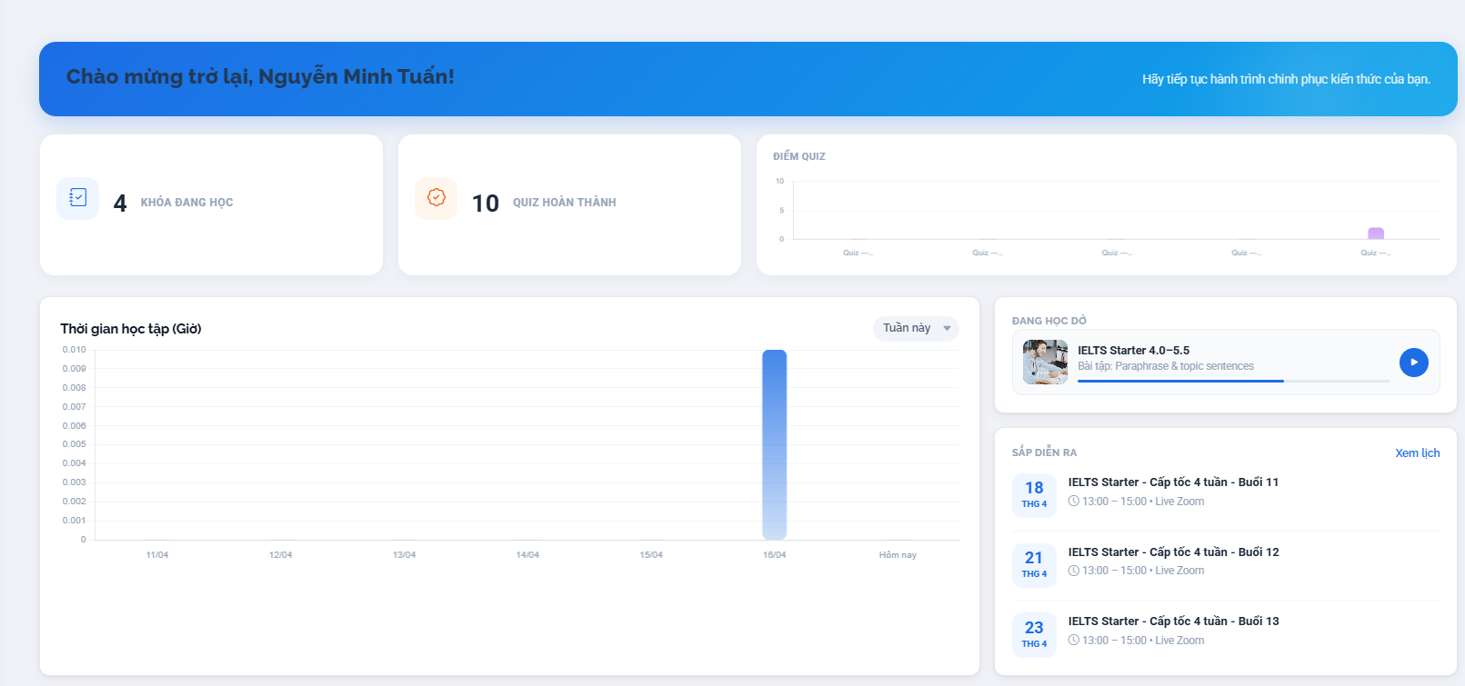
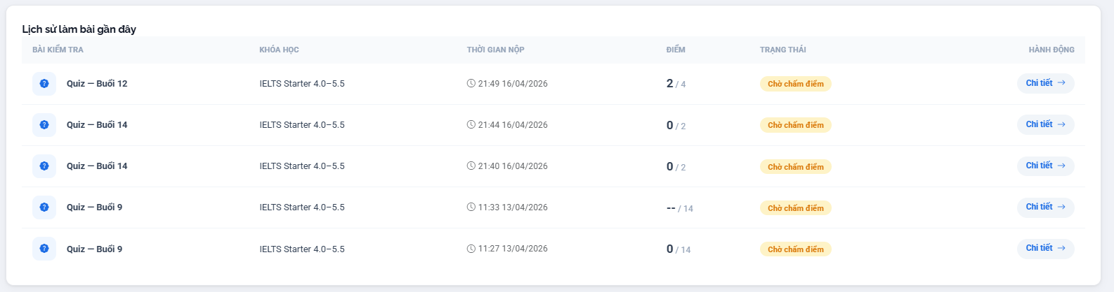
This screen allows the logged-in Student to:
- View an overview of their learning progress and activities on the system.
- Track number of enrolled courses and completed quizzes.
- Monitor learning time statistics through visual charts.
- View current learning course and quickly continue learning.
- Check upcoming class schedule and important sessions.
- Review recent quiz/assignment submission history and results.
Mapped Use Cases:
- View Student Dashboard
- Track Learning Progress
- View Learning Statistics
- Continue Learning
- View Upcoming Classes
- View Assessment History
Field Name | Description
Welcome Banner | Displays greeting message with student name (e.g., “Chào mừng trở lại, Nguyễn Minh Tuấn!”).
Subtitle Message | Displays motivational messages encouraging learning continuation.
Khóa đang học (Enrolled Courses Count) | Displays number of courses the student is currently enrolled in.
Quiz hoàn thành (Completed Quiz Count) | Displays number of quizzes completed by the student.
Điểm Quiz (Quiz Score Chart) | Displays chart showing quiz performance over time.
Thời gian học tập (Learning Time Chart) | Displays bar chart representing learning time by date (e.g., hours per day).
Time Filter | Dropdown (e.g., “Tuần này”) to filter chart data by time range.
Đang học dở (Continue Learning Section) | Displays the course currently in progress.
Current Course Card | Shows course name, lesson title, and progress bar.
Continue Button (Play Icon) | Button to continue learning the current lesson. Redirects to the learning content screen.
Sắp diễn ra (Upcoming Classes) | Section displaying upcoming class sessions.
Xem lịch (View Schedule) | Link to navigate to full schedule screen.
Upcoming Class Item | Displays date, course name, session info, and time (e.g., Live Zoom).
Lịch sử làm bài gần đây (Recent Activity) | Section showing recent quiz/assignment attempts.
Assessment Table | Table listing quiz attempts with columns: quiz name, course, submission time, score, status, and action.
Bài kiểm tra (Quiz Name) | Displays quiz title (e.g., Quiz – Buổi 12).
Khóa học (Course Name) | Displays related course names.
Thời gian nộp (Submission Time) | Displays timestamp of submission.
Điểm (Score) | Displays achieved score (e.g., 2/4).
Trạng thái (Status) | Displays status (e.g., “Chờ chấm điểm”).
Chi tiết (Detail Action) | Button to view detailed results of the attempt.
Data Loading | Dashboard data is dynamically loaded based on the student account.
Access Rule | Only accessible to logged-in students.
Responsive Behavior | Layout adapts across devices; charts and tables adjust accordingly.

3.2.2 Enrollment Management

3.2.2.1 Enrolled Courses
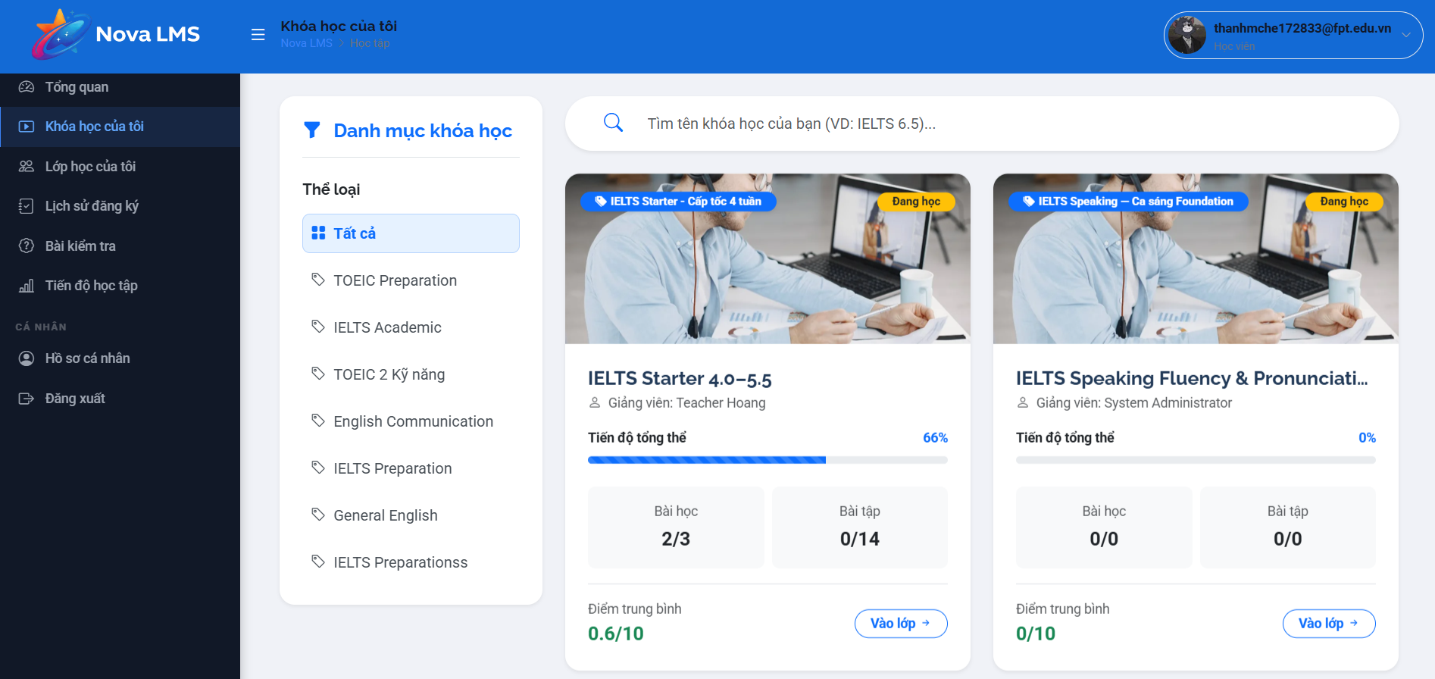
This screen allows the logged-in Student to:
- View the list of courses they have enrolled in.
- Search enrolled courses by course name.
- Filter enrolled courses by category.
- Track learning progress for each course.
- View summary information such as lessons completed, exercises completed, and average score.
- Access a specific course to continue learning.
Mapped Use Cases:
- View Enrolled Courses
- Search Enrolled Course
- Filter Enrolled Course
- Track Course Progress
- Access Course Learning
Field Name | Description
Danh mục khóa học (Course Category Panel) | Sidebar section displaying course categories for filtering enrolled courses.
Thể loại (Category Filter) | Displays list of course categories (e.g., Tất cả, TOEIC Preparation, IELTS Academic, English Communication).
Tất cả (All) | Default selected option. Displays all enrolled courses.
Category Item | Each selectable category is used to filter the enrolled course list.
Tìm tên khóa học của bạn (Search Bar) | Input field allowing users to search enrolled courses by name.
Search Placeholder | Displays hint text (e.g., “VD: IELTS 6.5”).
Course List Container | Grid layout displaying enrolled course cards.
Course Card | Represents an enrolled course with progress and summary information.
Course Thumbnail | Displays course image/banner.
Course Tag (e.g., IELTS Starter) | Displays course category or label.
Đang học (Status Tag) | Indicates the course is currently in progress.
Course Name | Displays full course name (e.g., IELTS Starter 4.0–5.5).
Instructor Name | Displays instructor name (e.g., Giảng viên: Teacher Hoang).
Tiến độ tổng thể (Progress Bar) | Visual progress bar indicating completion percentage (e.g., 66%).
Progress Percentage | Displays numeric progress value.
Bài học (Lesson Count) | Displays number of completed lessons over total lessons (e.g., 2/3).
Bài tập (Assignment Count) | Displays number of completed exercises over total (e.g., 0/14).
Điểm trung bình (Average Score) | Displays average score achieved in the course (e.g., 0.6/10).
Vào lớp (Enter Course) | Button to access the course learning screen.
Empty State | Displays messages when no enrolled courses are found.
Filter Behavior | Updates course list based on selected category.
Search Behavior | Filters course list based on keyword input.
Access Rule | Only accessible to logged-in students.
Responsive Behavior | Layout adapts across devices; sidebar may collapse on smaller screens.

3.2.2.2 Enrolled Classes
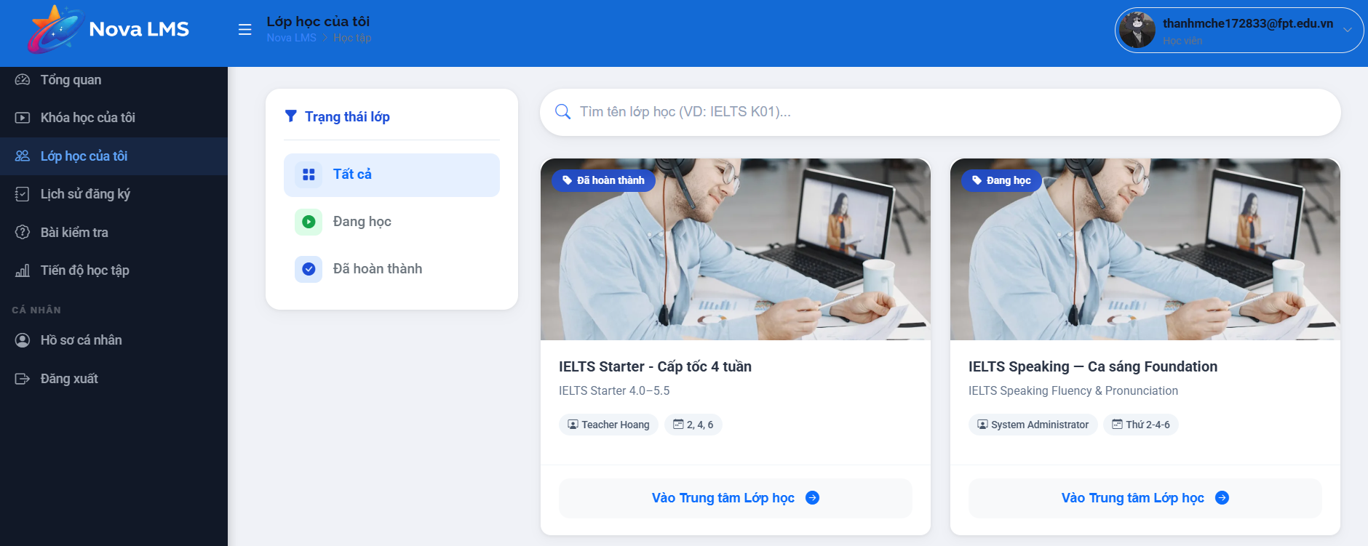
This screen allows the logged-in Student to:
- View the list of classes they are enrolled in.
- Search classes by class name or class code.
- Filter classes based on learning status (e.g., all, in progress, completed).
- Identify the current learning status of each class.
- View basic class information such as course name, instructor, and study schedule.
- Access the class learning center to participate in learning activities.
Mapped Use Cases:
- View Enrolled Classes
- Search Class
- Filter Class by Status
- View Class Information
- Access Class Learning
Field Name | Description
Trạng thái lớp (Status Filter Panel) | Sidebar section allowing users to filter classes by status.
Tất cả (All) | Default selected option. Displays all classes regardless of status.
Đang học (In Progress) | Filter option showing classes currently in progress.
Đã hoàn thành (Completed) | Filter option showing completed classes.
Search Class Bar | Input field allowing users to search classes by name or code.
Search Placeholder | Displays hint text (e.g., “VD: IELTS K01”).
Class List Container | Grid layout displaying class cards.
Class Card | Represents a class with status, course, instructor, and schedule information.
Class Thumbnail | Displays representative images for the class/course.
Status Tag (Đang học / Đã hoàn thành) | Indicates current status of the class.
Class Name | Displays class name (e.g., IELTS Starter – Cấp tốc 4 tuần).
Course Name | Displays associated courses (e.g., IELTS Starter 4.0–5.5).
Instructor Name | Displays instructor (e.g., Teacher Hoang, System Administrator).
Study Schedule | Displays study days (e.g., Thứ 2-4-6).
Vào Trung tâm Lớp học (Enter Class) | Button to access the class learning center.
Empty State | Displays messages when no classes match search/filter conditions.
Filter Behavior | Updates class list based on selected status.
Search Behavior | Filters class list based on keyword input.
Access Rule | Only accessible to logged-in students.
Responsive Behavior | Layout adapts across devices; sidebar may collapse on smaller screens.

3.2.2.3 Enrolled Class Details

3.2.2.3.1 Course Information
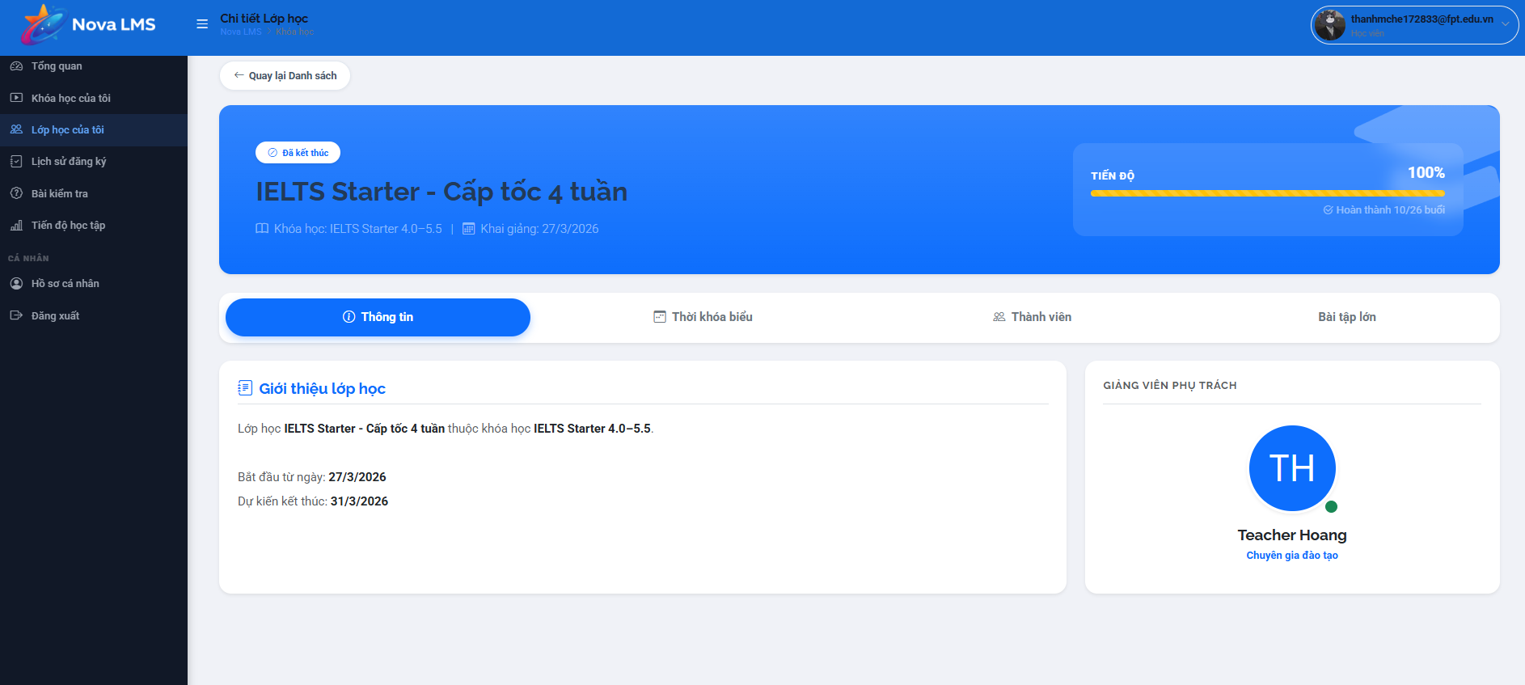
This screen allows the logged-in Student to:
- View detailed information of a specific enrolled class.
- Track overall learning progress within the class.
- Navigate between different sections such as information, schedule, members, and assignments.
- View class introduction including start date and end date.
- Identify the assigned instructor for the class.
Mapped Use Cases:
- View Class Detail
- Track Class Progress
- View Class Information
- View Instructor Information
- Navigate Class Sections
Field Name | Description
Quay lại Danh sách (Back Button) | Button to navigate back to the class list screen.
Class Status Tag | Displays class status (e.g., “Đã kết thúc”).
Class Name | Displays full class name (e.g., IELTS Starter – Cấp tốc 4 tuần).
Course Name | Displays associated courses (e.g., IELTS Starter 4.0–5.5).
Khai giảng (Start Date) | Displays class start date (e.g., 27/3/2026).
Tiến độ (Progress Section) | Displays overall class progress with percentage (e.g., 100%).
Progress Bar | Visual representation of completion progress.
Progress Detail | Displays completed sessions (e.g., Hoàn thành 10/26 buổi).
Tab Navigation | Navigation bar allowing switching between sections: Thông tin, Thời khóa biểu, Thành viên, Bài tập lớn.
Thông tin (Information Tab) | Default active tab showing general class information.
Thời khóa biểu (Schedule Tab) | Tab displaying class schedule and sessions.
Thành viên (Members Tab) | Tab displaying list of students in the class.
Bài tập lớn (Assignment Tab) | Tab displaying major assignments or projects.
Giới thiệu lớp học (Class Introduction) | Section describing class details and related course.
Start Date Detail | Displays class start date in detail.
End Date Detail | Displays expected end date (e.g., 31/3/2026).
Giảng viên phụ trách (Instructor Section) | Section displaying assigned instructor.
Instructor Avatar | Displays instructor avatar or initials.
Instructor Name | Displays instructor name (e.g., Teacher Hoang).
Instructor Role | Displays instructor role (e.g., Chuyên gia đào tạo).
Data Binding | All class data is dynamically loaded based on selected class.
Access Rule | Only accessible to students enrolled in the class.
Responsive Behavior | Layout adapts across devices; tabs and sections adjust accordingly.

3.2.2.3.2 Weekly Table
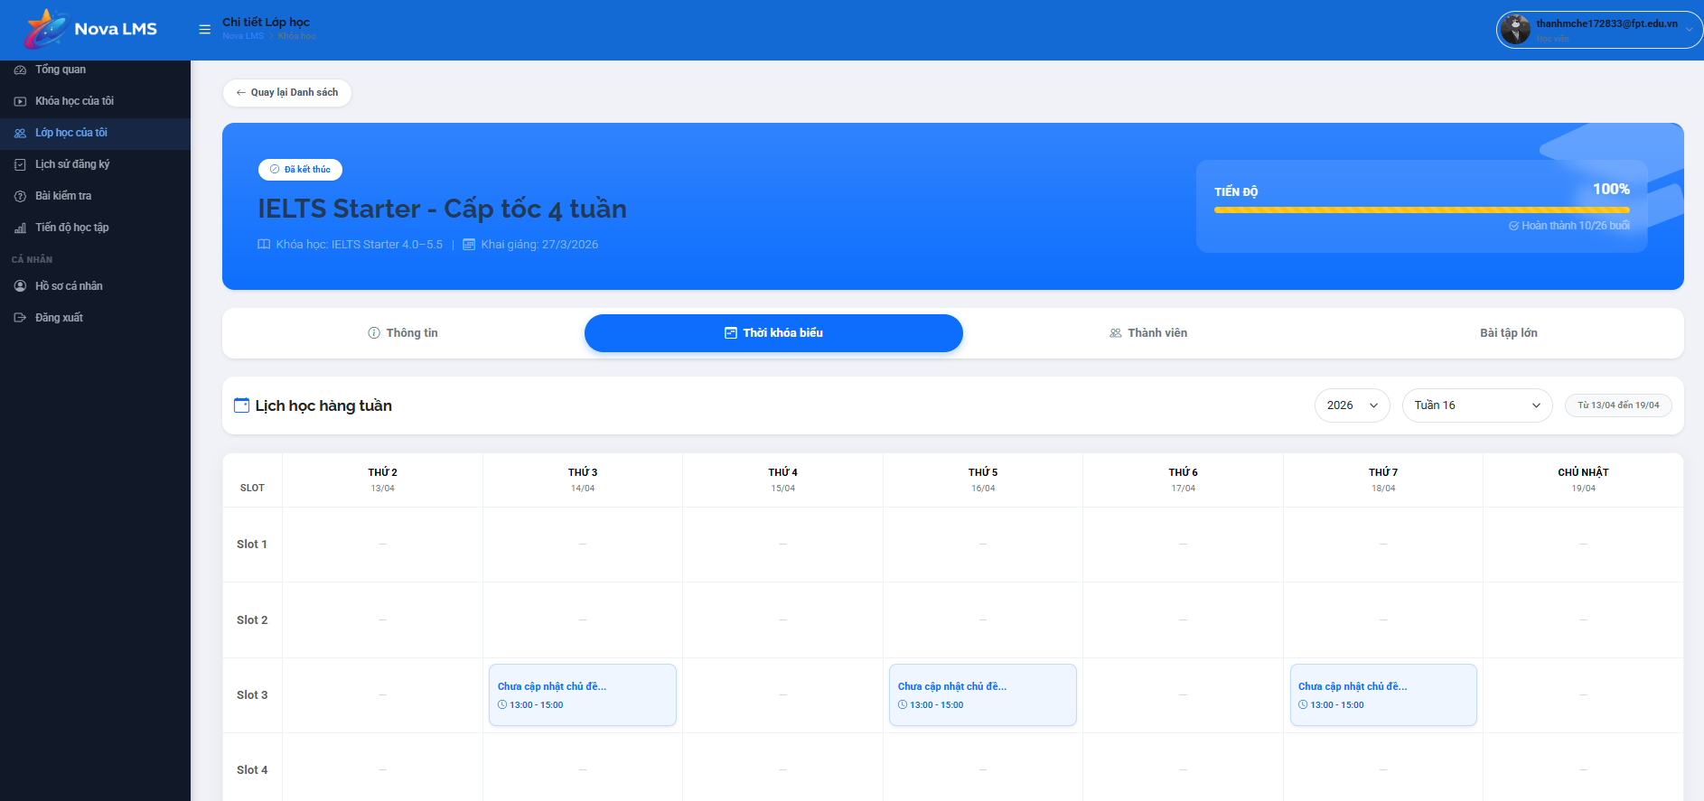
This screen allows the logged-in Student to:
- View the detailed weekly schedule of a selected class.
- Track learning sessions by day and time slot.
- Identify scheduled lessons, including time and session status.
- Navigate between different weeks and years to view past or upcoming schedules.
- Understand class timetable structure for better planning.
Mapped Use Cases:
- View Class Schedule
- View Weekly Timetable
- Navigate Schedule by Week
- Track Learning Sessions
Field Name | Description
Tab Thời khóa biểu (Schedule Tab) | Active tab indicating the user is viewing the class schedule.
Lịch học hàng tuần (Weekly Schedule Title) | Displays the title of the weekly timetable section.
Year Selector | Dropdown allows users to select a year (e.g., 2026).
Week Selector | Dropdown allows users to select specific weeks (e.g., Tuần 16).
Date Range Display | Displays date range of selected week (e.g., Từ 13/04 đến 19/04).
Schedule Table | Table layout displaying timetable by days of the week and time slots.
Column Headers (Thứ 2 → Chủ nhật) | Displays days of the week along with specific dates.
Slot Column | Displays time slots (e.g., Slot 1, Slot 2, Slot 3, Slot 4).
Schedule Cell | Each cell represents a session at a specific day and slot.
Empty Slot | Displays “–” if no class is scheduled for that time slot.
Session Card | Displays scheduled session information inside a cell.
Session Title | Displays lesson title (e.g., “Chưa cập nhật chủ đề…”).
Session Time | Displays time range (e.g., 13:00 – 15:00).
Session Status | Indicates status if applicable (e.g., upcoming, completed).
Navigation Behavior | Changing week/year updates timetable data dynamically.
Data Binding | Schedule data is loaded based on selected class and time range.
Access Rule | Only accessible to students enrolled in the class.
Responsive Behavior | Tables may scroll horizontally on smaller screens for better visibility.

3.2.2.3.3 Members List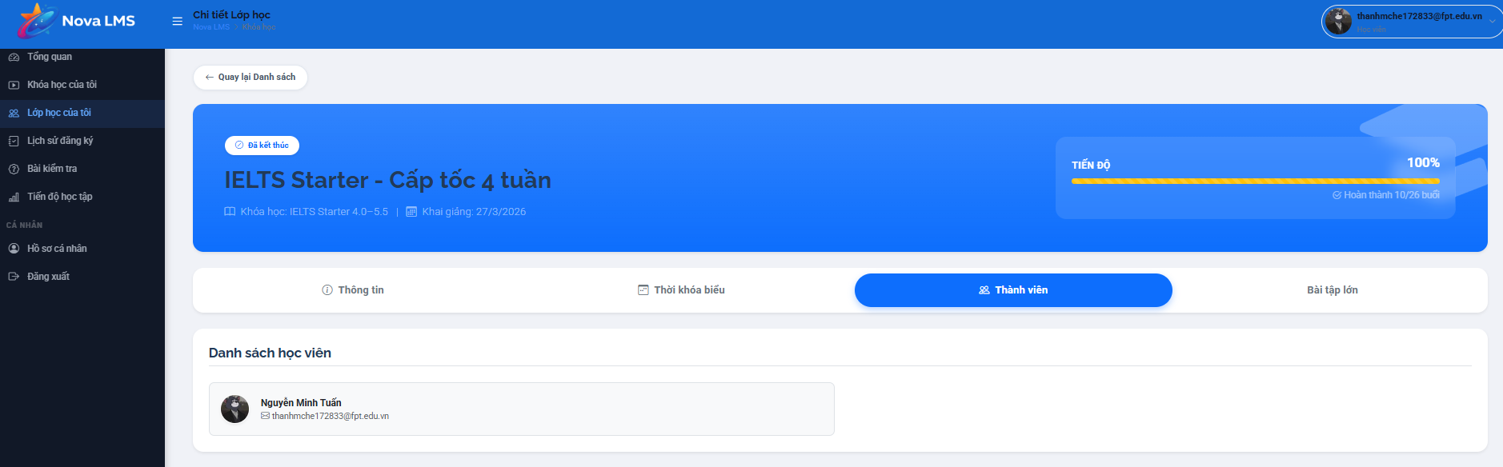
This screen allows the logged-in Student to:
- View the list of members in the selected class.
- Identify other students enrolled in the same class.
- View basic information of each member such as name and email.
- Understand class participation and member composition.
Mapped Use Cases:
- View Class Members
- View Student Information
Field Name | Description
Tab Thành viên (Members Tab) | Active tab indicating the user is viewing class members.
Danh sách học viên (Student List Title) | Displays the title of the member list section.
Member List Container | Container displaying list of students in the class.
Member Item | Represents a single student in the class.
Student Avatar | Displays profile image of the student.
Student Name | Displays full name of the student (e.g., Nguyễn Minh Tuấn).
Student Email | Displays registered email of the student.
List Behavior | Displays all enrolled students in the class.
Empty State | Displays messages when no students are found in the class.
Data Binding | The member list is dynamically loaded based on the selected class.
Access Rule | Only accessible to students enrolled in the class.
Responsive Behavior | Layout adapts across devices; member items stack vertically on smaller screens.

3.2.2.3.4 Assessment
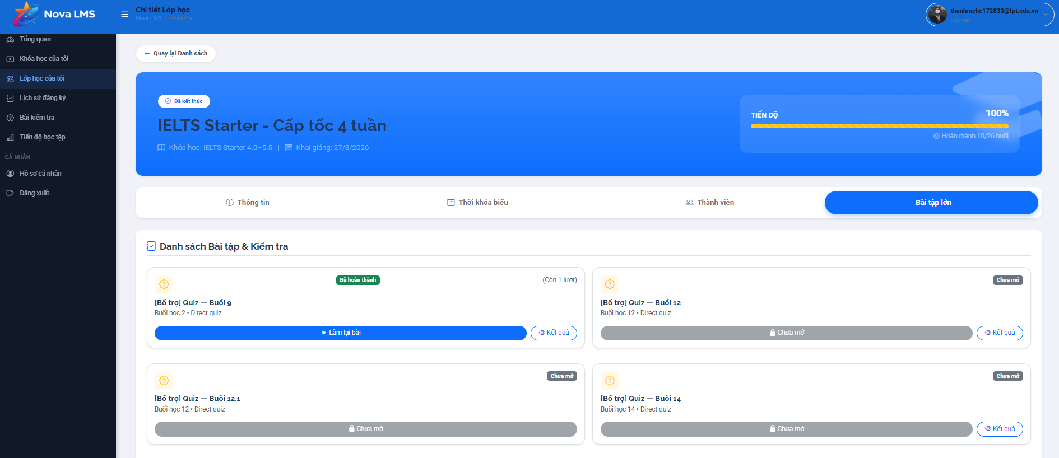
This screen allows the logged-in Student to:
- View the list of assignments and quizzes in the selected class.
- Identify assignment status such as completed, not opened, or available.
- Access quizzes/assignments to perform or review results.
- Retake quizzes if allowed by the system.
- Track remaining attempts for each quiz.
Mapped Use Cases:
- View Assignment List
- View Quiz List
- Take Quiz
- Retake Quiz
- View Quiz Result
Field Name | Description
Tab Bài tập lớn (Assignment Tab) | Active tab indicating the user is viewing assignments and quizzes.
Danh sách Bài tập & Kiểm tra (Assignment List Title) | Displays the title of the assignment/quiz list section.
Assignment List Container | Container displaying list of quizzes/assignments.
Assignment Item | Represents a quiz or assignment.
Assignment Title | Displays name of the quiz (e.g., “[Bổ trợ] Quiz – Buổi 9”).
Assignment Subtitle | Displays additional info (e.g., Buổi học, loại bài: Direct quiz).
Assignment Status Tag | Displays status such as “Đã hoàn thành”, “Chưa mở”.
Remaining Attempts | Displays remaining attempts (e.g., “Còn 1 lượt”).
Làm lại bài (Retake Button) | Button allows students to retake quiz if attempts remain.
Làm bài (Start Button) | Button to start doing a quiz (if available).
Chưa mở (Locked State) | Indicates assignment is not yet available; action button is disabled.
Kết quả (Result Button) | Button to view quiz result details.
Button State | Buttons are enabled/disabled depending on assignment status and availability.
List Behavior | Displays all assignments associated with the class.
Empty State | Displays messages when no assignments are available.
Data Binding | Assignment data is dynamically loaded based on the selected class.
Access Rule | Only accessible to students enrolled in the class.
Responsive Behavior | Layout adapts across devices; items stack vertically on smaller screens.

3.2.3 Learning Management

3.2.3.1 Enrolled Course Content
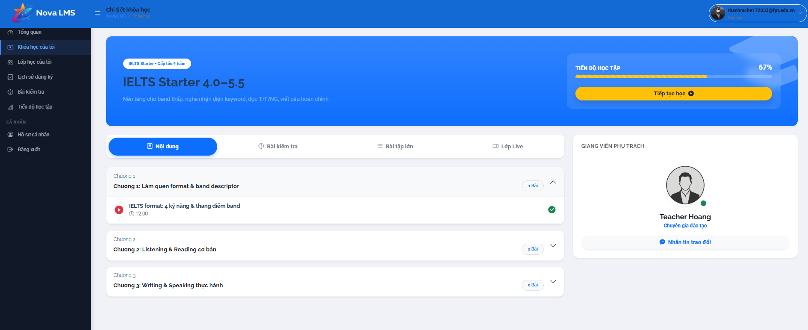
This screen allows the logged-in Student to:
- View detailed learning content of an enrolled course.
- Track overall learning progress within the course.
- Browse course structure including chapters and lessons.
- Access and start learning specific lessons.
- Navigate between different sections such as content, quizzes, assignments, and live classes.
- View instructor information and contact instructor if needed.
Mapped Use Cases:
- View Course Content
- Track Learning Progress
- View Lesson List
- Access Lesson
- View Instructor Information
Field Name | Description
Course Header | Top section displaying course name and general information.
Course Tag | Displays course category/label (e.g., IELTS Starter – Cấp tốc 4 tuần).
Course Name | Displays full course name (e.g., IELTS Starter 4.0–5.5).
Course Description | Displays short description of course content and objectives.
Tiến độ học tập (Progress Section) | Displays overall learning progress (e.g., 67%).
Progress Bar | Visual representation of course completion progress.
Tiếp tục học (Continue Learning) | Button to resume the most recent or next lesson.
Tab Nội dung (Content Tab) | Default active tab showing course chapters and lessons.
Tab Bài kiểm tra (Quiz Tab) | Tab displaying quizzes related to the course.
Tab Bài tập lớn (Assignment Tab) | Tab displaying assignments/projects.
Tab Lớp Live (Live Class Tab) | Tab displaying live class sessions if applicable.
Chapter List | Displays list of course chapters.
Chapter Item | Represents a chapter containing lessons.
Chapter Title | Displays chapter name (e.g., Chương 1: Làm quen format & band descriptor).
Chapter Toggle | Allows expansion/collapse of lessons within a chapter.
Lesson Item | Represents a lesson inside a chapter.
Lesson Title | Displays lesson name (e.g., IELTS format: 4 kỹ năng & thang điểm band).
Lesson Duration | Displays lesson duration (e.g., 12:00).
Lesson Status Icon | Indicates lesson status (e.g., completed, in progress).
Lesson Access | Clicking lesson redirects to Lesson Detail screen.
Giảng viên phụ trách (Instructor Section) | Displays instructor information.
Instructor Avatar | Displays instructor image/icon.
Instructor Name | Displays instructor name (e.g., Teacher Hoang).
Instructor Role | Displays role (e.g., Chuyên gia đào tạo).
Nhắn tin trao đổi (Message Button) | Button to initiate communication with the instructor.
Data Binding | All content is dynamically loaded based on the selected course.
Access Rule | Only accessible to students enrolled in the course.
Responsive Behavior | Layout adapts across devices; sidebar moves below on smaller screens.

3.2.3.2 Lesson Detail
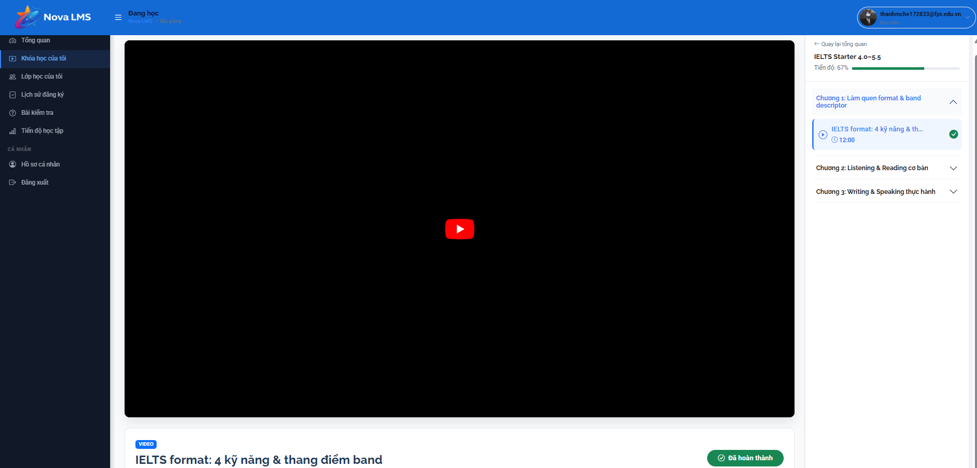
This screen allows the logged-in Student to:
- View and learn lesson content through video playback.
- Track current lesson progress within the course.
- Navigate between lessons and chapters using the sidebar.
- Mark lesson as completed after finishing learning.
- Continue learning seamlessly within the course structure.
Mapped Use Cases:
- View Lesson Detail
- Play Video Lesson
- Track Lesson Progress
- Mark Lesson as Completed
- Navigate Course Content
Field Name | Description
Video Player | Main area displaying lesson video content (e.g., embedded YouTube player).
Play Button | Allows users to start/pause video playback.
Video Controls | Includes controls such as play/pause, volume, fullscreen, progress bar.
Lesson Title | Displays lesson name (e.g., IELTS format: 4 kỹ năng & thang điểm band).
Lesson Type Tag | Displays type of lesson (e.g., VIDEO).
Lesson Status | Displays status (e.g., “Đã hoàn thành”).
Course Sidebar | Right-side panel displaying course structure (chapters and lessons).
Course Name | Displays course name (e.g., IELTS Starter 4.0–5.5).
Course Progress | Displays overall course progress (e.g., 67%).
Chapter List | Displays list of chapters in the course.
Chapter Item | Expandable section containing lessons.
Lesson Item | Displays lesson within chapter.
Current Lesson Highlight | Highlights the lesson currently being viewed.
Lesson Duration | Displays lesson duration (e.g., 12:00).
Lesson Status Icon | Indicates completion status of each lesson.
Navigation Behavior | Clicking another lesson loads corresponding content.
Mark Completed Action | The system automatically or manually marks lessons as completed after viewing.
Data Binding | Lesson content is dynamically loaded based on selected lessons.
Access Rule | Only accessible to students enrolled in the course.
Responsive Behavior | Video resizes and sidebar adjusts layout on smaller screens.

3.2.4 Assessment

3.2.4.1 Assessment Overview
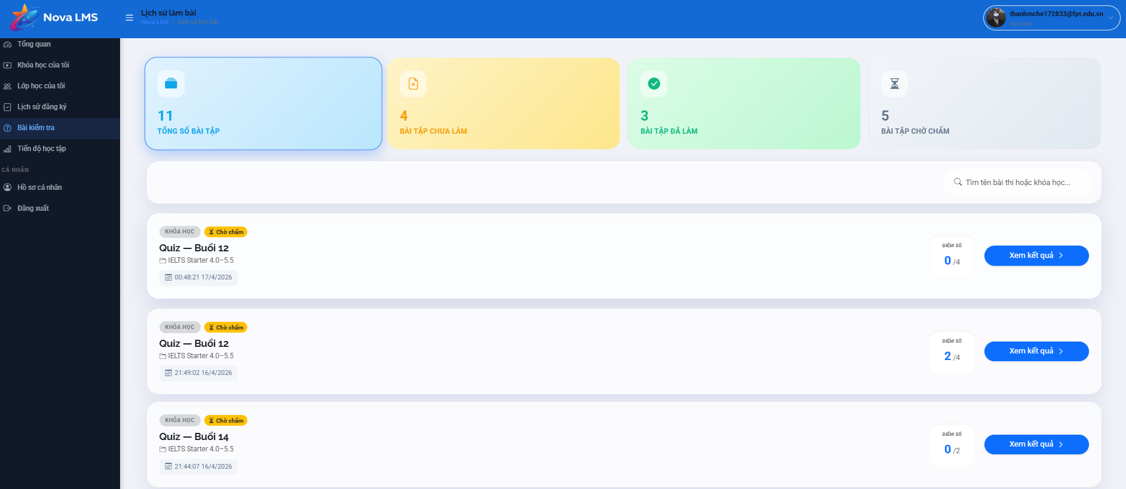
This screen allows the logged-in Student to:
- View the list of all assignments and quizzes across enrolled courses.
- Track assignment status such as not done, completed, or waiting for grading.
- View summary statistics of assignments.
- Search assignments by name or course.
- View scores and access detailed results of each assignment.
Mapped Use Cases:
- View Assignment Dashboard
- Track Assignment Status
- Search Assignment
- View Assignment Result
Field Name | Description
Tổng số bài tập (Total Assignments) | Displays total number of assignments/quizzes (e.g., 11).
Bài tập chưa làm (Pending Assignments) | Displays number of assignments not yet completed (e.g., 4).
Bài tập đã làm (Completed Assignments) | Displays number of completed assignments (e.g., 3).
Bài tập chờ chấm (Waiting for Grading) | Displays number of assignments awaiting grading (e.g., 5).
Summary Cards | Top section displaying assignment statistics in colored cards.
Search Bar | Input field allowing users to search assignments by keyword (course name or quiz name).
Search Placeholder | Displays hint text (e.g., “Tìm tên bài thi hoặc khóa học…”).
Assignment List Container | Displays list of assignment items.
Assignment Item | Represents a quiz/assignment entry.
Khóa học (Course Tag) | Displays related course name (e.g., IELTS Starter 4.0 –5.5).
Assignment Title | Displays assignment name (e.g., Quiz – Buổi 12).
Submission Time | Displays submission timestamp (e.g., 21:49 16/4/2026).
Status Tag | Displays status (e.g., “Chờ chấm”).
Điểm số (Score) | Displays achieved score (e.g., 2/4).
Xem kết quả (View Result) | Button to view detailed results of the assignment.
List Behavior | Displays assignments sorted by latest submission or system-defined order.
Empty State | Displays messages when no assignments are found.
Data Binding | Assignment data is dynamically loaded based on the student account.
Access Rule | Only accessible to logged-in students.
Responsive Behavior | Layout adapts across devices; cards and lists stack vertically on smaller screens.

3.2.4.2 Assessment Attempt
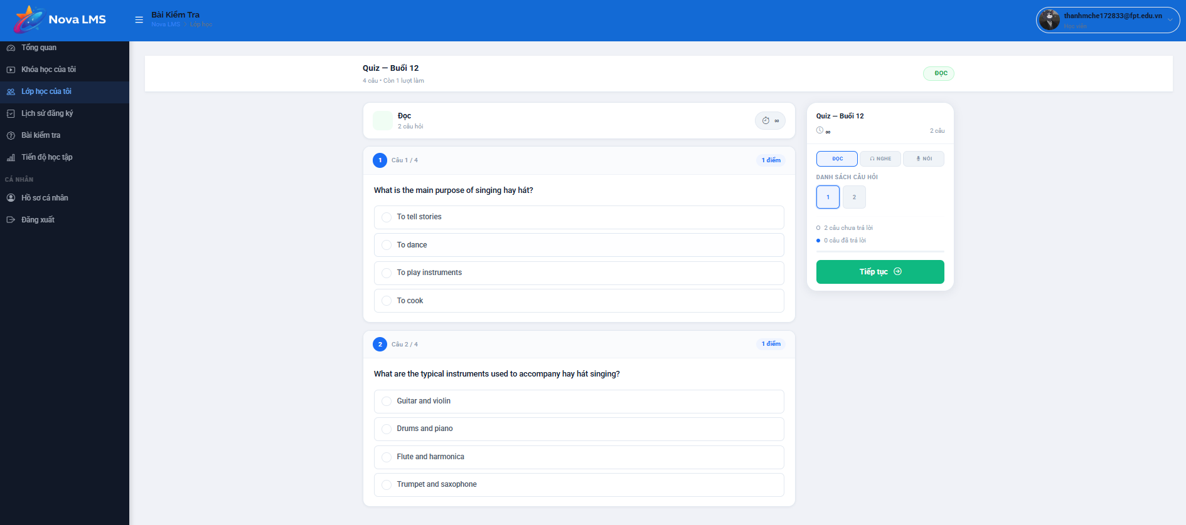
This screen allows the logged-in Student to:
- Take a quiz by answering multiple-choice questions.
- Navigate between questions within the quiz.
- View question content and select answers.
- Track quiz progress including answered and unanswered questions.
- Continue or submit the quiz based on progress.
Mapped Use Cases:
- Take Quiz
- Answer Question
- Navigate Questions
- Track Quiz Progress
- Submit Quiz
Field Name | Description
Quiz Title | Displays quiz name (e.g., Quiz – Buổi 12).
Quiz Info | Displays quiz metadata (e.g., number of questions, remaining attempts).
Question Section | Main area displaying quiz questions and answer options.
Question Number | Displays current question index (e.g., Câu 1/4).
Question Score | Displays score for the question (e.g., 1 điểm).
Question Content | Displays the question text.
Answer Options | Multiple-choice options displayed as selectable radio buttons.
Selected Answer | Indicates the option chosen by the student.
Question Navigation Panel | Sidebar displaying list of question numbers.
Question Index Button | Allows users to jump to a specific question.
Current Question Highlight | Highlights the question currently being viewed.
Answered Indicator | Indicates which questions have been answered.
Unanswered Indicator | Indicates which questions are not yet answered.
Section Tabs (Đọc / Nghe / Nói) | Allows switching between different quiz sections if applicable.
Timer | Displays remaining time for the quiz (if time-limited).
Quiz Progress Info | Displays number of answered and unanswered questions.
Tiếp tục (Continue Button) | Button to move to the next question or continue the quiz flow.
Submit Action | The system allows submission when all required questions are answered or time ends.
Auto Save | The system automatically saves selected answers during the attempt.
Data Binding | Quiz data is dynamically loaded based on selected quizzes.
Access Rule | Only accessible to students assigned to the quiz.
Responsive Behavior | Layout adapts across devices; question panel and navigation adjust accordingly.

3.2.4.3 Assessment Results
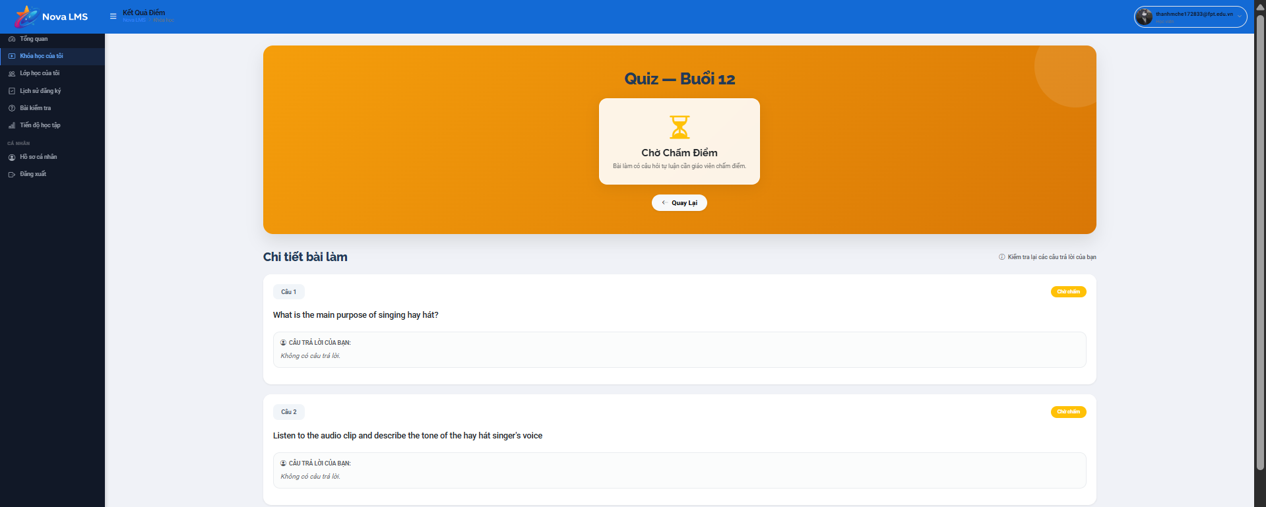
This screen allows the logged-in Student to:
- View the overall result status of a submitted quiz after completion.
- Identify whether the quiz is waiting for grading or has been graded.
- Review detailed submitted answers for each question in the quiz.
- Understand the structure of the submitted attempt including questions and responses.
- Navigate back to the previous screen such as the assignment list or dashboard.
Mapped Use Cases:
- View Quiz Result
- View Submission Detail
- Track Grading Status
- Navigate Back
Field Name | Description
Quiz Title | Displays quiz name (e.g., Quiz – Buổi 12) at the top of the screen.
Result Banner | Large highlighted section showing overall quiz status.
Status Tag (Chờ chấm điểm) | Indicates the quiz is submitted but not yet graded.
Status Icon | Visual icon (e.g., hourglass) representing waiting for grading state.
Status Description | Displays a message explaining that the system or instructor is grading the submission.
Quay lại (Back Button) | Button allows the user to return to the previous screen (e.g., assignment list).
Chi tiết bài làm (Submission Detail Section) | Section displaying detailed breakdown of submitted answers.
Question List Container | Container holding all question items in the quiz attempt.
Question Item | Represents each individual question in the quiz.
Question Number | Displays question index (e.g., Câu 1, Câu 2).
Question Content | Displays full text of the question.
Answer Section | Displays the student’s submitted answer for the question.
Answer Display | Shows selected options or input provided by the student.
Answer Status (Chưa chấm) | Indicates that the answer has not been graded yet.
Score Per Question | May be hidden or not displayed until grading is completed.
Total Score | Not displayed while status is “Chờ chấm điểm”.
Data Binding | All data (questions, answers, status) is dynamically loaded based on the selected quiz attempt.
Conditional Display | If the quiz is graded, the system will display score, correct/incorrect answers, and feedback.
Navigation Behavior | The back button returns the user to the previous context without data loss.
Access Rule | Only accessible to students who have submitted the quiz.
Security Handling | Prevents modification of submitted answers after submission.
Responsive Behavior | Layout adapts across devices; question items stack vertically on smaller screens.

3.2.5 Payment Management

3.2.5.1 Payment
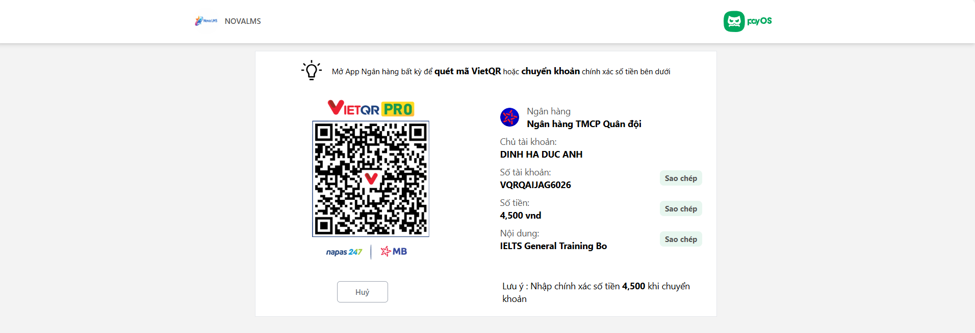
This screen allows the logged-in Student to:
- Perform course payment via bank transfer using VietQR.
- Scan QR code using a mobile banking app to complete payment quickly.
- View detailed bank transfer information including account name, account number, amount, and transfer content.
- Copy payment information fields for manual transfer.
- Cancel the payment process if needed.
Mapped Use Cases:
- Make Payment
- View Payment Information
- Copy Payment Details
- Cancel Payment
Field Name | Description
Payment Instruction | Displays instruction: “Mở App Ngân hàng bất kỳ để quét mã VietQR hoặc chuyển khoản chính xác số tiền bên dưới”.
VietQR Code | QR code that contains payment information for quick transfer via banking apps.
VietQR Logo | Displays VietQR PRO branding along with supported banks (e.g., Napas247, MB Bank).
Ngân hàng (Bank Name) | Displays bank name (e.g., Ngân hàng TMCP Quân đội).
Chủ tài khoản (Account Name) | Displays account holder name (e.g., DINH HA DUC ANH).
Số tài khoản (Account Number) | Displays bank account number (e.g., VQRQAIAJG6026).
Sao chép (Copy Button - Account Number) | Button to copy account number to clipboard.
Số tiền (Amount) | Displays required payment amount (e.g., 4,500 VND).
Sao chép (Copy Button - Amount) | Button to copy payment amount.
Nội dung (Transfer Content) | Displays transfer description (e.g., IELTS General Training Bo).
Sao chép (Copy Button - Content) | Button to copy transfer content.
Lưu ý (Note) | Displays note reminding user to transfer exact amount (e.g., “Nhập chính xác số tiền 4,500 khi chuyển khoản”).
Hủy (Cancel Button) | Button to cancel payment and return to the previous screen.
Payment Status (Implicit) | The system waits for confirmation from payment gateway or manual verification after transfer.
Data Binding | Payment information is dynamically generated based on selected course/order.
Security Handling | Ensures payment information is accurate and tied to specific transactions/order.
Access Rule | Only accessible to logged-in users during the payment process.
Responsive Behavior | Layout adapts across devices; QR and details stack vertically on smaller screens.

3.2.5.2 Payment Result
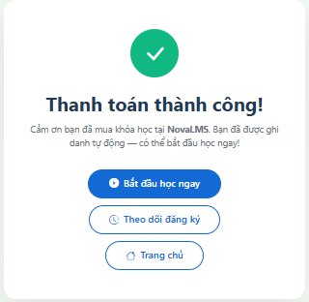
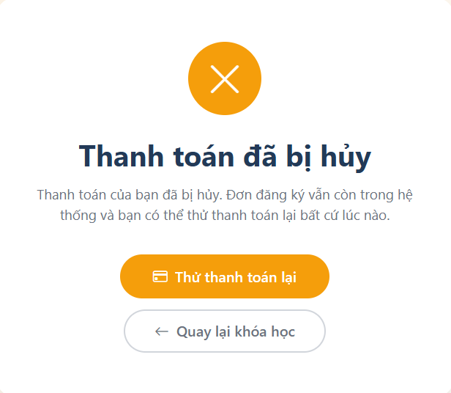
This screen allows the logged-in Student to:
- View the result of a payment transaction (success or cancelled).
- Understand the current status of course enrollment after payment.
- Navigate to start learning immediately if payment is successful.
- Track enrolled courses or return to the homepage.
- Retry payment if the transaction was cancelled.
Mapped Use Cases:
- View Payment Result
- Start Learning
- View Enrolled Courses
- Retry Payment
- Navigate Home
Field Name | Description
Payment Result Container | Main container displaying payment outcome (success or cancelled).
Success Icon | Displays visual confirmation icon (e.g., checkmark in green circle).
Thanh toán thành công! (Success Title) | Displays success message when payment is completed successfully.
Success Message | Displays description confirming course enrollment and readiness to start learning.
Bắt đầu học ngay (Start Learning) | Button to navigate directly to course learning screen.
Theo dõi đăng ký (View Enrollment) | Button to navigate to enrolled courses or enrollment tracking screen.
Trang chủ (Home Button) | Button to return to Home Page.
Cancel Icon | Displays visual icon (e.g., cross in orange circle) for cancelled payment.
Thanh toán đã bị hủy (Cancel Title) | Displays message indicating payment was cancelled.
Cancel Message | Displays explanation that the order still exists and can be paid again later.
Thử thanh toán lại (Retry Payment) | Button allows the user to retry the payment process.
Quay lại khóa học (Back to Course) | Button to return to course detail or previous screen.
Conditional Display | The system displays either success or cancelled state based on payment results.
Navigation Behavior | Each button redirects users to the corresponding screen (learning, enrollment, home, or payment).
Data Binding | Payment result is dynamically determined based on transaction status.
Access Rule | Only accessible after completing or cancelling a payment process.
Responsive Behavior | Layout adapts across devices; buttons stack vertically on smaller screens.

3.2.5.3 Course Payment History
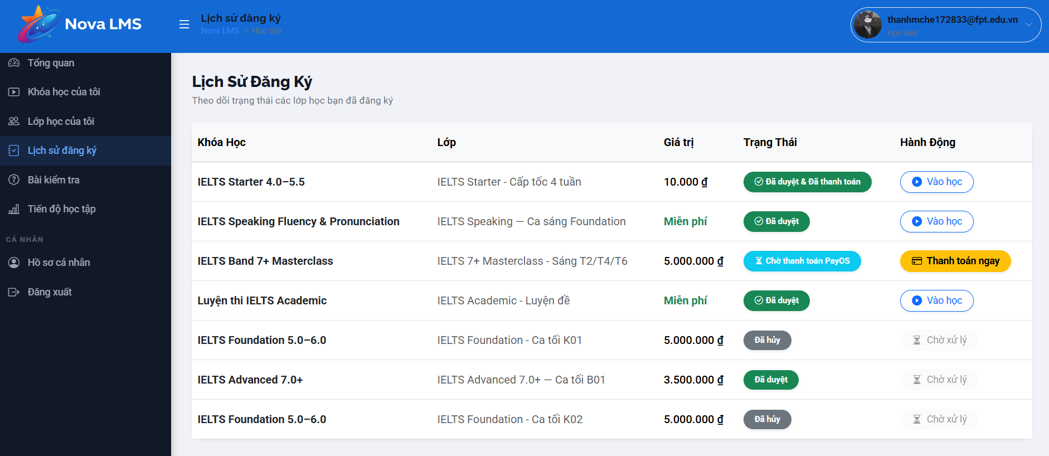
This screen allows the logged-in Student to:
- View the history of course/class registrations.
- Track registration status such as approved, paid, pending payment, or cancelled.
- View course, class, and payment value information.
- Perform actions such as entering class or making payment.
Mapped Use Cases:
- View Enrollment History
- Track Enrollment Status
- Make Payment
- Access Class
Field Name | Description
Lịch Sử Đăng Ký (Page Title) | Displays the title of the enrollment history screen.
Subtitle Description | Displays description (e.g., “Theo dõi trạng thái các lớp học bạn đã đăng ký”).
Enrollment Table | Table displaying list of registered courses/classes.
Khóa học (Course Column) | Displays course name (e.g., IELTS Starter 4.0–5.5).
Lớp (Class Column) | Displays class name (e.g., IELTS Starter – Cấp tốc 4 tuần).
Giá trị (Price Column) | Displays course price (e.g., 10.000đ, Miễn phí).
Trạng thái (Status Column) | Displays registration/payment status.
Status: Đã duyệt & Đã thanh toán | Indicates registration approved and payment completed.
Status: Đã duyệt | Indicates registration approved (for free courses or no payment required).
Status: Chờ thanh toán PayOS | Indicates waiting for payment via payment gateway.
Status: Đã hủy | Indicates registration has been cancelled.
Status: Chờ xử lý | Indicates request is pending processing.
Hành động (Action Column) | Contains action buttons based on status.
Vào học (Enter Class) | Button to access learning/class screen when registration is approved.
Thanh toán ngay (Pay Now) | Button to proceed to payment flow.
Disabled Action | The action button is disabled when status does not allow interaction (e.g., cancelled).
Conditional Behavior | Action buttons change dynamically based on status.
Data Binding | Enrollment data is dynamically loaded based on the student account.
Access Rule | Only accessible to logged-in students.
Responsive Behavior | Table adapts across devices; may support horizontal scrolling on smaller screens.

3.4 Teacher Management

3.4.1 Teacher Dashboard

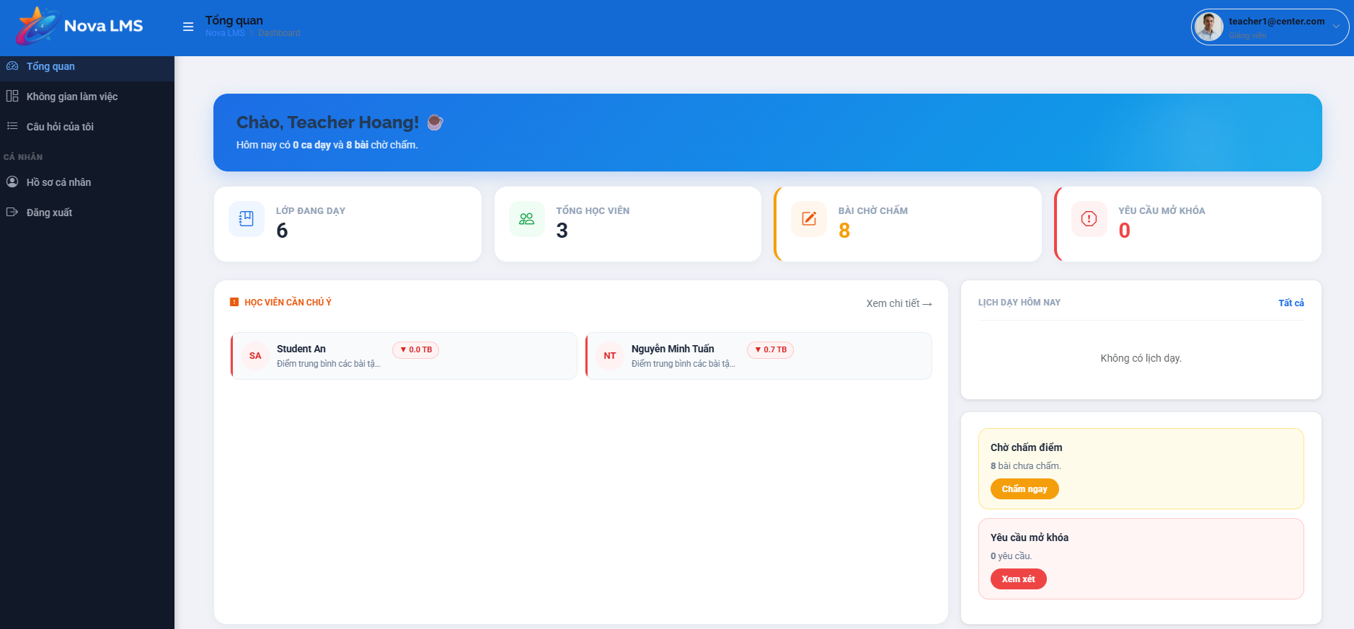
This screen allows the Teacher to:
- View a high-level summary of their active teaching workload, including the number of classes and students.
- Track pending academic and administrative tasks, such as ungraded assignments and content unlock requests.
- Identify specific students who require immediate attention (e.g., due to low average scores).
- Check their teaching schedule for the current day and access quick-action buttons for urgent tasks.
Mapped Use Cases:
- View Teacher Dashboard
Field Name | Description
Sidebar Navigation | Allows navigation to main modules: Tổng quan (Dashboard), Không gian làm việc (Workspace), Câu hỏi của tôi (My Questions), Hồ sơ cá nhân (Profile), Đăng xuất (Logout).
Greeting Banner | Displays a personalized greeting ("Chào, Teacher Hoang!") and a brief text summary of today's workload (e.g., number of teaching slots and pending grading).
LỚP ĐANG DẠY (Active Classes) | Displays the total number of classes currently assigned to the Teacher.
TỔNG HỌC VIÊN (Total Students) | Displays the total count of distinct students across all active classes taught by the Teacher.
BÀI CHỜ CHẤM (Pending Grading) | Shows the total number of student submissions that require the Teacher's grading. Clickable to navigate to the grading list.
YÊU CẦU MỞ KHÓA (Unlock Requests) | Shows the number of pending requests from students to unlock specific learning materials or tests.

3.4.2 Class Workspace

3.4.2.1 List of Classes Taught

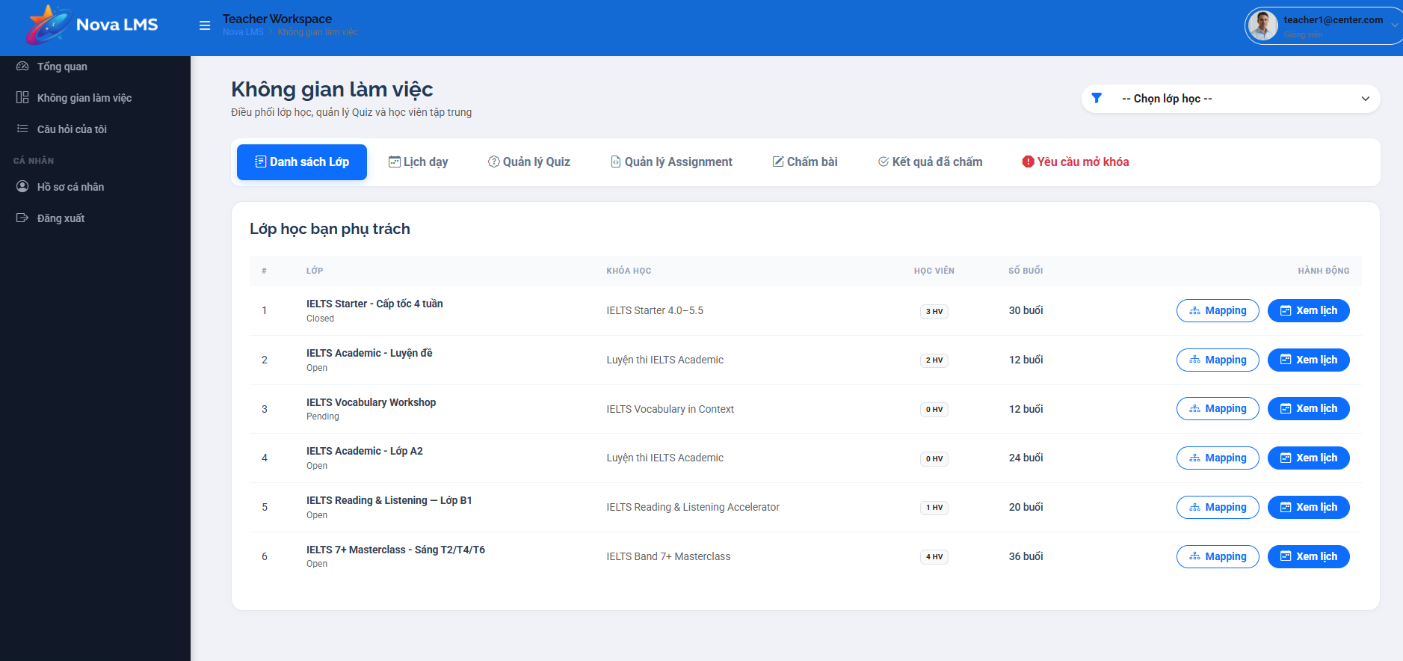
This screen allows the Manager (or Admin) to:
- View and manage the complete directory of all class instances created within the system.
- Search for specific classes using keywords such as Class Name.
- Monitor key class metrics at a glance, including assigned teachers and current enrollment capacity.
- Access detailed management pages for individual classes or initiate the creation of a new class session.
Mapped Use Cases:
- View Class List
- Search/Filter Classes
Field Name | Description
Class Filter | Dropdown menu to filter the list by class state (e.g.,Ielts 4.0, … eg).
Class ID | Displays the unique system-generated identifier for the class.
Class Name | Displays the specific name assigned to the class instance.
Course Name | Displays the name of the parent Course Shell to which the class belongs.
Teacher | Displays the name of the primary instructor assigned to lead the class.
Students | Displays the current enrollment ratio (e.g., 15/30), showing registered students versus maximum capacity.
Action | Mapping lessons to class.
View Details | Mapping buttons that navigates the user to ‘map lesson with Class’ screen.

3.4.2.2 Teaching schedule
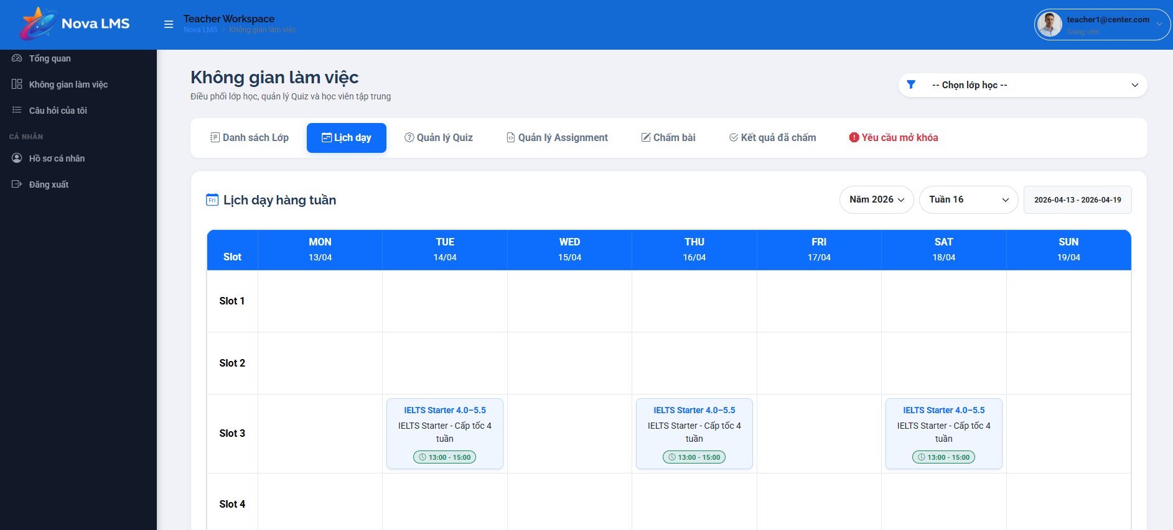
This screen allows the Teacher to:
- View their comprehensive teaching timetable organized in a structured calendar format.
- Navigate easily across different timeframes to review past sessions or plan for upcoming classes.
- Quickly snap the calendar view back to the current system date.
- Switch between different calendar perspectives to get a broad overview or a detailed daily breakdown.
- View crucial details for every assigned teaching slot, including the exact time, specific class group, and room allocation.
Mapped Use Cases:
- View Teaching Schedule
Field Name | Description
Month/Year Indicator | Displays the currently active month and year being viewed on the calendar.
Navigation Arrows (< >) | Buttons used to navigate the calendar backward or forward based on the active view mode (e.g., next month, previous week).
Today Button | Quick-action button that instantly resets the calendar view to display the current date.
View Toggle (Day/Week/Month) | A control group allowing the user to switch the calendar layout between a daily schedule, a weekly planner, or a full monthly grid.
Calendar Grid | The central interface component displaying the days of the week and dates, acting as the container for scheduled events.
Class Event Card | A distinct, color-coded block placed within a specific date cell, representing a single scheduled teaching session.
Shift / Time | Displayed within the Class Event Card, indicating the shift name (e.g., CA1, CA2) and the exact start and end time of the class.
Class Name | Displayed within the Class Event Card, showing the unique identifier or name of the enrolled student group (e.g., IELTS_01).
Room Allocation | Displayed within the Class Event Card, specifying the physical classroom or virtual link where the session will be conducted.

3.4.2.3 Quiz / Assignment for Chapters
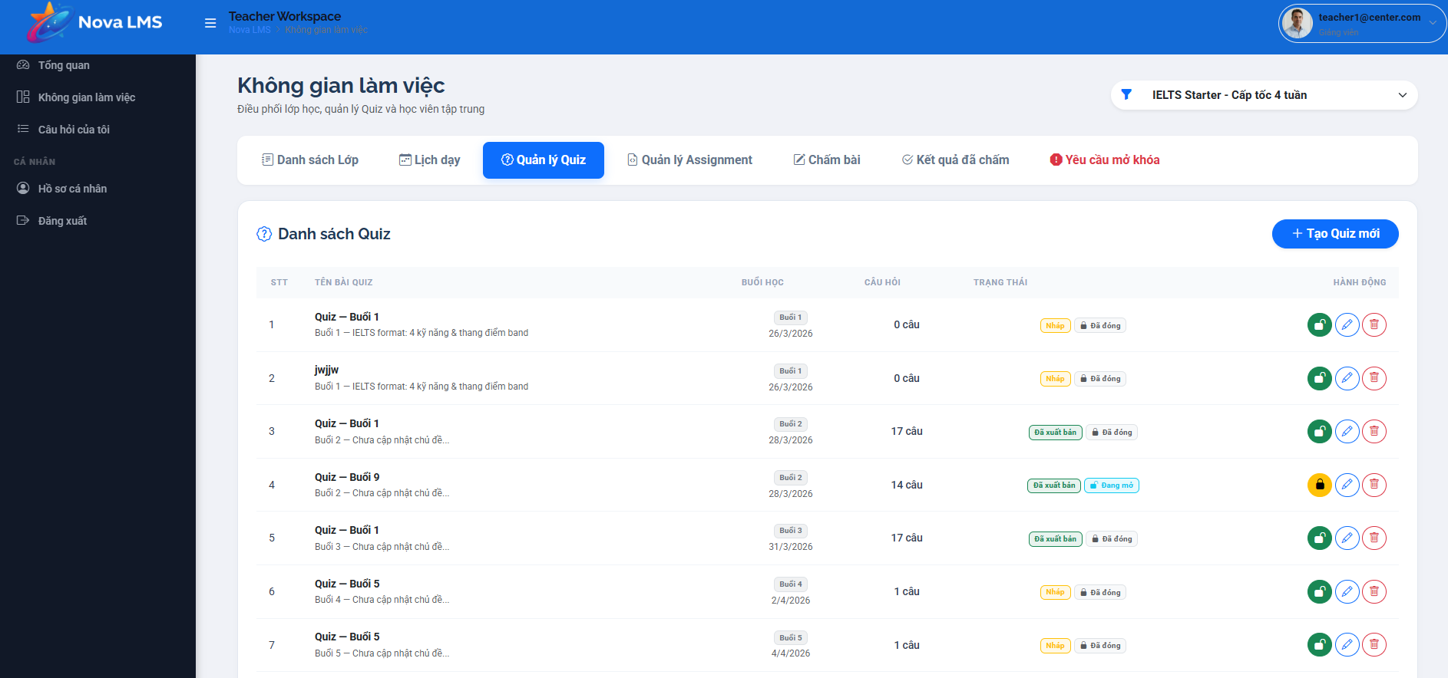

Field Name | Description
Module Title | Displays the name of the overarching module being managed (e.g., Module 1: UI/UX Foundation).
Chapter Header | Displays the chapter number and title. Acts as a clickable accordion to expand or collapse the list of underlying materials.
Expand/Collapse Icon | A directional arrow indicating whether the chapter's contents are currently visible or hidden.
Add Item (+) | Action button located on the Chapter Header used to insert a new Quiz, Assignment, or Slide into that specific chapter.
Edit Chapter | Action icon (pencil) allowing the user to rename or modify the overarching chapter details.
Delete Chapter | Action icon (trash bin) to remove the entire chapter. System prompts a confirmation warning before deletion to prevent accidental data loss.
Content Item | Displays the specific learning material (Slide, Quiz, Assignment) accompanied by a visual icon representing its format type.
Edit Item | Action icon (pencil) next to a specific item used to update its content, constraints, or grading rules.
Delete Item | Action icon (trash bin) next to a specific item used to safely remove it from the chapter sequence.

3.4.2.4 Grading
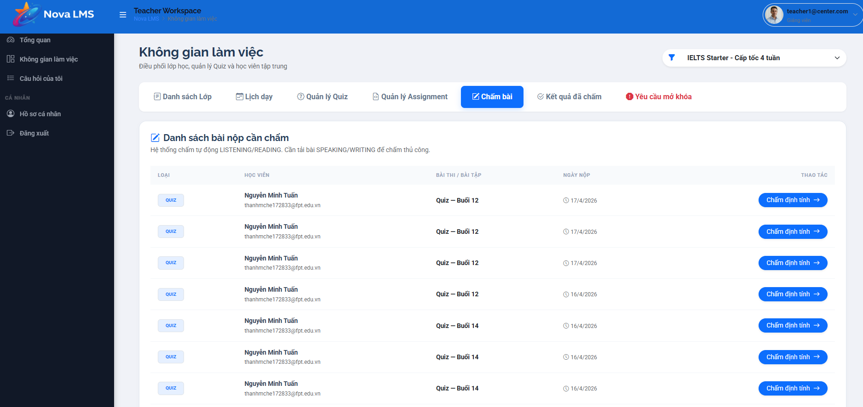
This screen allows the Teacher to:
- View and manage a comprehensive list of all student submissions across assigned classes.
- Filter submissions by assignment type, grading status, and submission date ranges to prioritize grading tasks.
- Search for specific records using student names or assignment titles.
- Monitor the real-time status of submissions (e.g., Pending, Graded) and view assigned scores.
- Navigate directly to the individual assessment grading screen to provide feedback and marks.
Mapped Use Cases:
- View Submission List
- Grade Assessment
Field Name | Description
Search Bar | Text input field used to locate specific submissions by entering Student Name or Assignment Title.
Assignment Type | Dropdown menu to filter the list by category (e.g., All types, Quiz, Assignment, Final Exam).
Status Filter | Dropdown menu to filter records based on grading progress (e.g., All status, Pending, Graded).
Date Range Filter | Date picker controls (Start Date to End Date) used to filter submissions within a specific timeframe.
Student Name | Column displaying the full name of the student who submitted the work.
Assignment Name | Column displaying the title of the specific task or test.
Type | Column indicating the category of the assessment (Quiz or Assignment).
Submission Date | Column displaying the exact date and time the student submitted their work.
Status Badge | A visual indicator showing the current state of the submission (e.g., "Pending" in orange, "Graded" in green).
Score | Displays the marks awarded (e.g., 85/100). Displays "N/A" or "-" if the item has not been graded yet.
Actions | Provides a button (typically a pencil or eye icon) to open the submission for detailed grading and feedback.

3.4.2.5 Grading Results
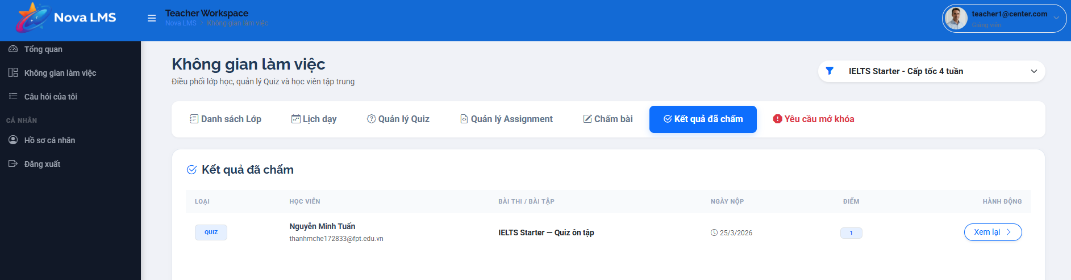
Description
This screen allows the Teacher to:
- View a list of all student submissions (Quizzes and Assignments) that have been fully graded.
- Filter the graded results by specific classes or view all classes at once.
- See key information for each graded submission, including the student's name, the activity title, submission date, and the final score awarded.
- Access the detailed review of a specific graded submission to see the provided feedback and scores.

Field Name / Description
Field Name | Description
Class Filter | A dropdown menu (e.g., "Luyện thi cấp tốc") allowing the teacher to filter the list of graded results to show only submissions from a specific class, or "All classes".
Workspace Navigation Tabs | Tabs to navigate between different workspace functions: "Danh sách Lớp" (Class List), "Lịch dạy" (Schedule), "Quản lý Quiz" (Quiz Management), "Quản lý Assignment" (Assignment Management), "Chấm bài" (Grading Queue), "Kết quả đã chấm" (Graded Results - Currently Active), and "Yêu cầu mở khóa" (Unlock Requests).
"Loại" (Type) Column | A badge indicating whether the graded submission was a "QUIZ" or an "ASSIGNMENT".
"Học viên" (Student) Column | Displays the student's full name and their registered email address.
"Bài thi / Bài tập" (Activity Title) Column | The name of the specific Quiz or Assignment that was graded.
"Ngày nộp" (Submission Date) Column | The exact date and time the student submitted the activity.
"Điểm" (Score) Column | Displays the final total score awarded to the student for this submission.
"Xem lại" (Review) Button | A button in the "Hành động" (Action) column that allows the teacher to open and review the detailed grading view for that specific submission, including all answers and teacher notes.
Pagination | Controls at the bottom of the list to navigate through multiple pages of graded results.

3.4.3 Assessment Grading
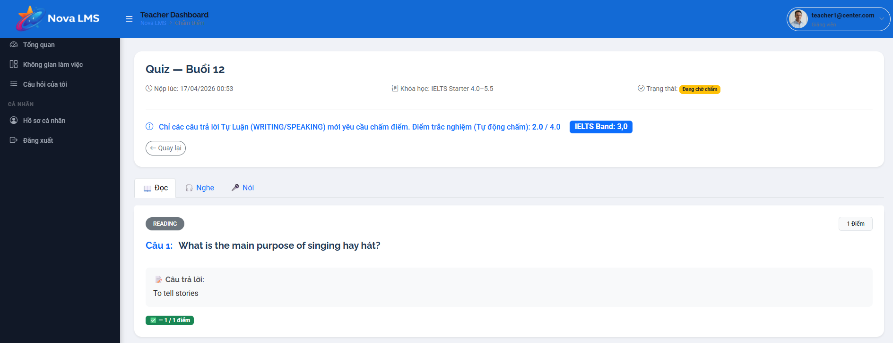
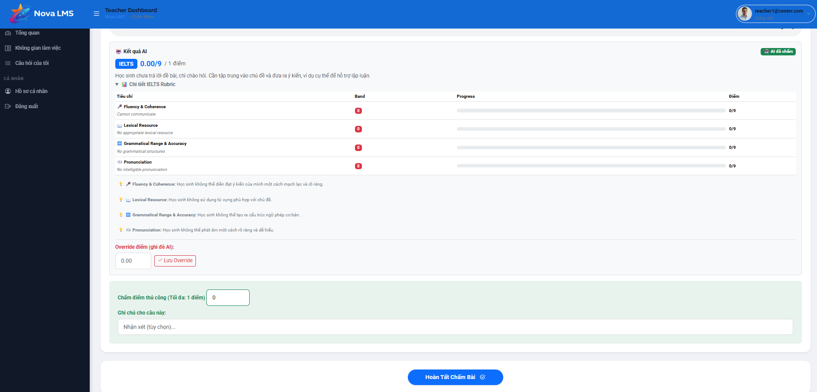
This screen allows the Teacher to:
- View detailed information about a student's specific submission (quiz or assignment).
- Review the scores of auto-graded sections (e.g., Reading, Listening) calculated by the system.
- Navigate through different skills/sections of the test using a tabbed interface.
- Evaluate subjective skills (e.g., Speaking, Writing) using a standardized, interactive IELTS rubric.
- Provide manual scores, override system-calculated scores if necessary, and leave personalized feedback.
- Finalize and publish the grade to the student's Grade Book.
Mapped Use Cases:
- Grade Student Submissions
Field Name | Description
Submission Header | Displays the Quiz/Assignment Name (e.g., "Quiz - Buổi 12"), Submission Date/Time, Course Name, and Current Status (e.g., "Đang chờ chấm" - Pending).
Back Button | "Quay lại" button navigating the Teacher back to the Pending Table in the Workspace.
Auto-grading Summary | A prominent banner summarizing the auto-calculated scores for objective parts (e.g., Multiple Choice) and displaying the current estimated overall Band score.
Skill Tabs | Allows the Teacher to navigate between different test sections (e.g., Đọc - Reading, Nghe - Listening, Nói - Speaking, Viết - Writing).
Student Answer Area | Displays the specific question prompt and the student's corresponding submitted answer (text, audio, or file).
Grading Rubric Table | A detailed evaluation matrix used for manual grading. Includes the columns listed below.
Score Override | "Override điểm (giá trị Ảo)": Allows the Teacher to manually input a final score that overrides the system's rubric calculation. Includes a "Lưu Override" (Save) button.
Manual Score Input | "Chấm điểm thủ công": An alternative field to directly enter the score for the current question/section (e.g., maximum 1 point).
Instructor Feedback | "Ghi chú cho câu này": Allows the Teacher to type qualitative, personalized feedback or corrections for the student regarding this specific answer.
Complete Grading | Primary action button ("Hoàn tất Chấm bài") at the bottom of the screen. Submits the final scores and feedback to the system, changes the status to "Graded", and returns the Teacher to the Workspace.

3.4.4 My Question Submissions
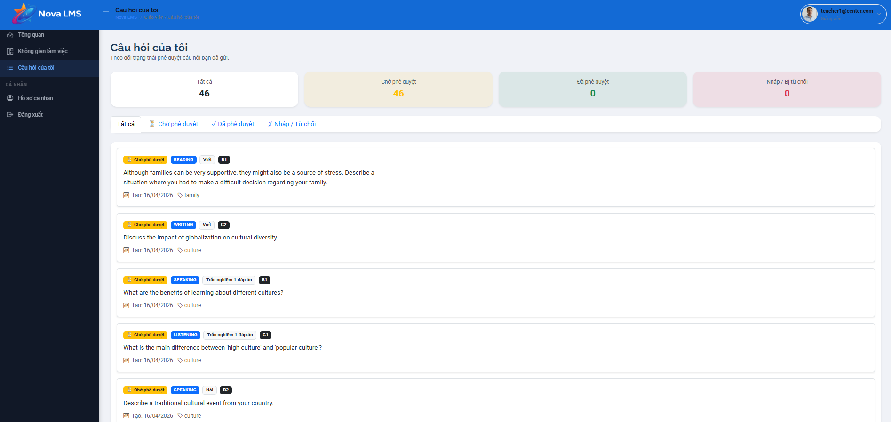
This screen allows the Teacher to:
- Track the approval status of all questions they have created and submitted to the centralized system question bank.
- View a high-level summary of their contributed questions categorized by current system statuses (All, Pending, Approved, Draft/Rejected).
- Filter the displayed list of questions quickly using status tabs.
- Review high-level details of each submitted question, including its target skill, format, difficulty level, and assigned topic tags.
Mapped Use Cases:
- Manage Contributed Questions
Field Name | Description
Status Summary Cards | Displays aggregated counts of the Teacher's questions across four categories: Tất cả (Total), Chờ phê duyệt (Pending), Đã phê duyệt (Approved), and Nháp / Từ chối (Draft/Rejected).
Filter Tabs | Quick filters corresponding to the summary cards. Clicking a tab filters the question list below to show only items with that specific status.
Question List | Displays individual cards for each submitted question based on the selected filter. Contains the elements listed below.

3.5 Manager Management

3.5.1 Manager Dashboard
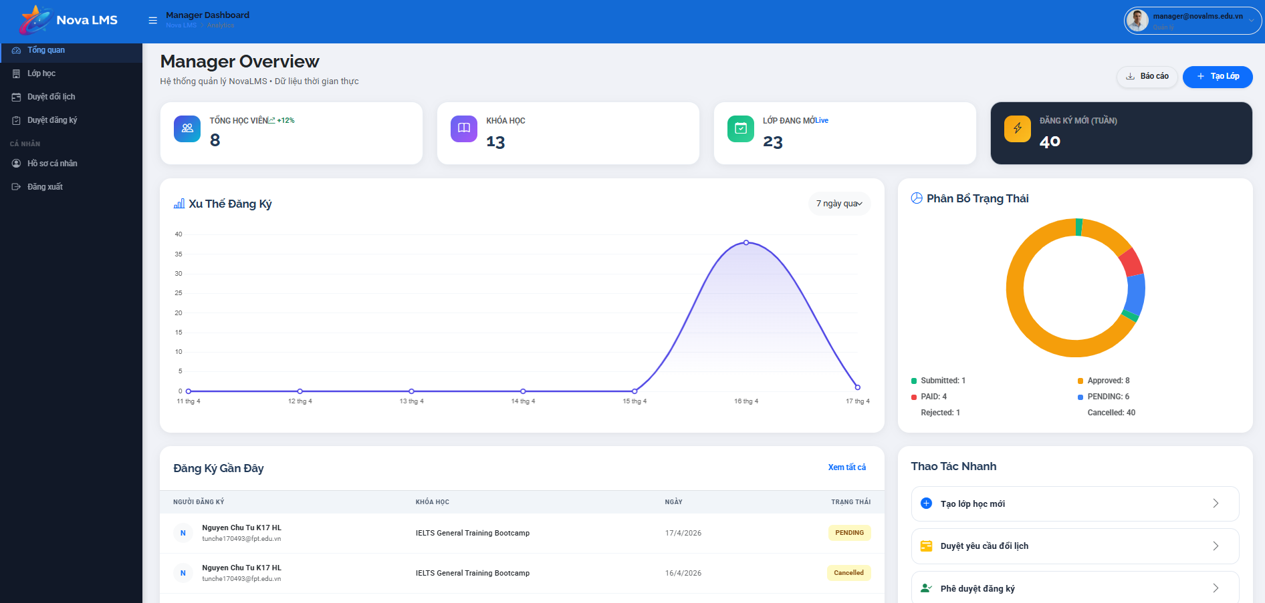
This screen allows the logged-in Manager to:
- View an overview of system performance and operational metrics.
- Monitor key statistics such as total students, courses, classes, and weekly registrations.
- Analyze registration trends over time through visual charts.
- Track status distribution of registrations (e.g., approved, pending, rejected).
- View recent registration activities and their statuses.
- Perform quick actions such as creating classes or approving requests.
Mapped Use Cases:
- View Manager Dashboard
- Monitor System Metrics
- Analyze Registration Trends
- View Registration Status
- Manage Registrations
- Perform Quick Actions
Field Name | Description
Manager Overview (Page Title) | Displays the title of the dashboard screen for the Manager role.
Subtitle Description | Displays short description (e.g., “Hệ thống quản lý NovaLMS – Dữ liệu thời gian thực”).
Tổng học viên (Total Students) | Displays total number of students along with growth indicator (e.g., +12%).
Khóa học (Total Courses) | Displays total number of courses available in the system.
Lớp đang mở (Active Classes) | Displays number of currently active/open classes.
Đăng ký mới (tuần) (New Registrations) | Displays number of new registrations in the current week.
Summary Cards | Top section displaying key metrics in card format.
Xu hướng đăng ký (Registration Trend Chart) | Line chart showing registration trend over time (e.g., last 7 days).
Time Filter | Displays time range (e.g., “7 ngày qua”).
Phân bố trạng thái (Status Distribution Chart) | Pie/donut chart showing distribution of registration statuses.
Status Legend | Displays breakdown (e.g., Submitted, Approved, Pending, Rejected, Cancelled).
Đăng ký gần đây (Recent Registrations) | Section displaying latest registration records.
Registration Table | Table showing recent registrations with columns: user, course, date, status.
Action Button (Top Right) | Buttons such as “Báo cáo” and “Tạo lớp” for additional actions.

3.5.2 Class Management

3.5.2.1 Class List

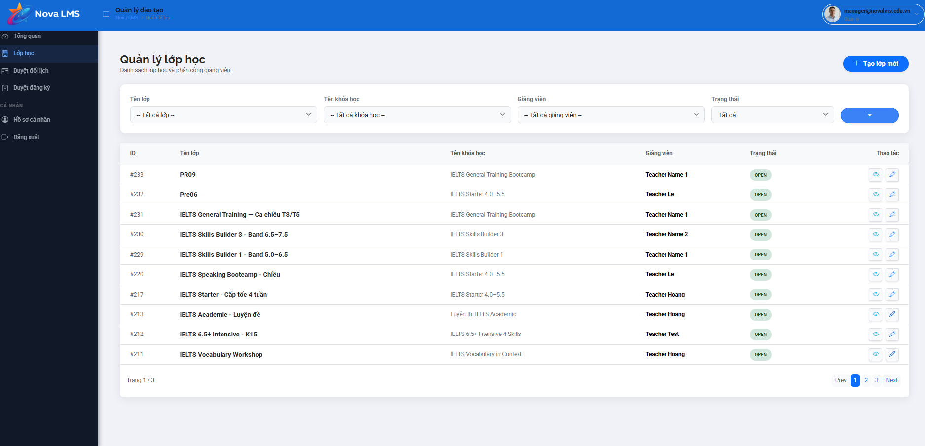
This screen allows the logged-in Manager to:
- View the list of all classes in the system.
- Filter classes by class name, course, instructor, and status.
- Search and quickly locate specific classes.
- View detailed information of each class including course, instructor, and status.
- Perform actions such as view details or edit class information.
- Navigate between pages of the class list.
- Create a new class.
Mapped Use Cases:
- View Class List
- Filter Class
- Search Class
- View Class Detail
- Update Class
- Create Class
Field Name | Description
Quản lý lớp học (Page Title) | Displays the title of the class management screen.
Subtitle Description | Displays description (e.g., “Danh sách lớp học và phân công giảng viên”).
Tạo lớp mới (Create Class Button) | Button to navigate to Create Class screen.
Filter Section | Section containing filter controls for class list.
Tên lớp (Class Name Filter) | Dropdown allowing filtering by class name. Default: “Tất cả lớp”.
Tên khóa học (Coarse Filter) | Dropdown allowing filtering by course. Default: “Tất cả khóa học”.
Giảng viên (Instructor Filter) | Dropdown allowing filtering by instructor. Default: “Tất cả giảng viên”.
Trạng thái (Status Filter) | Dropdown allows filtering by class status (e.g., Open, Closed).
Filter Button | Button to apply selected filter conditions.
Class Table | Table displaying list of classes.

3.5.2.2 New Class

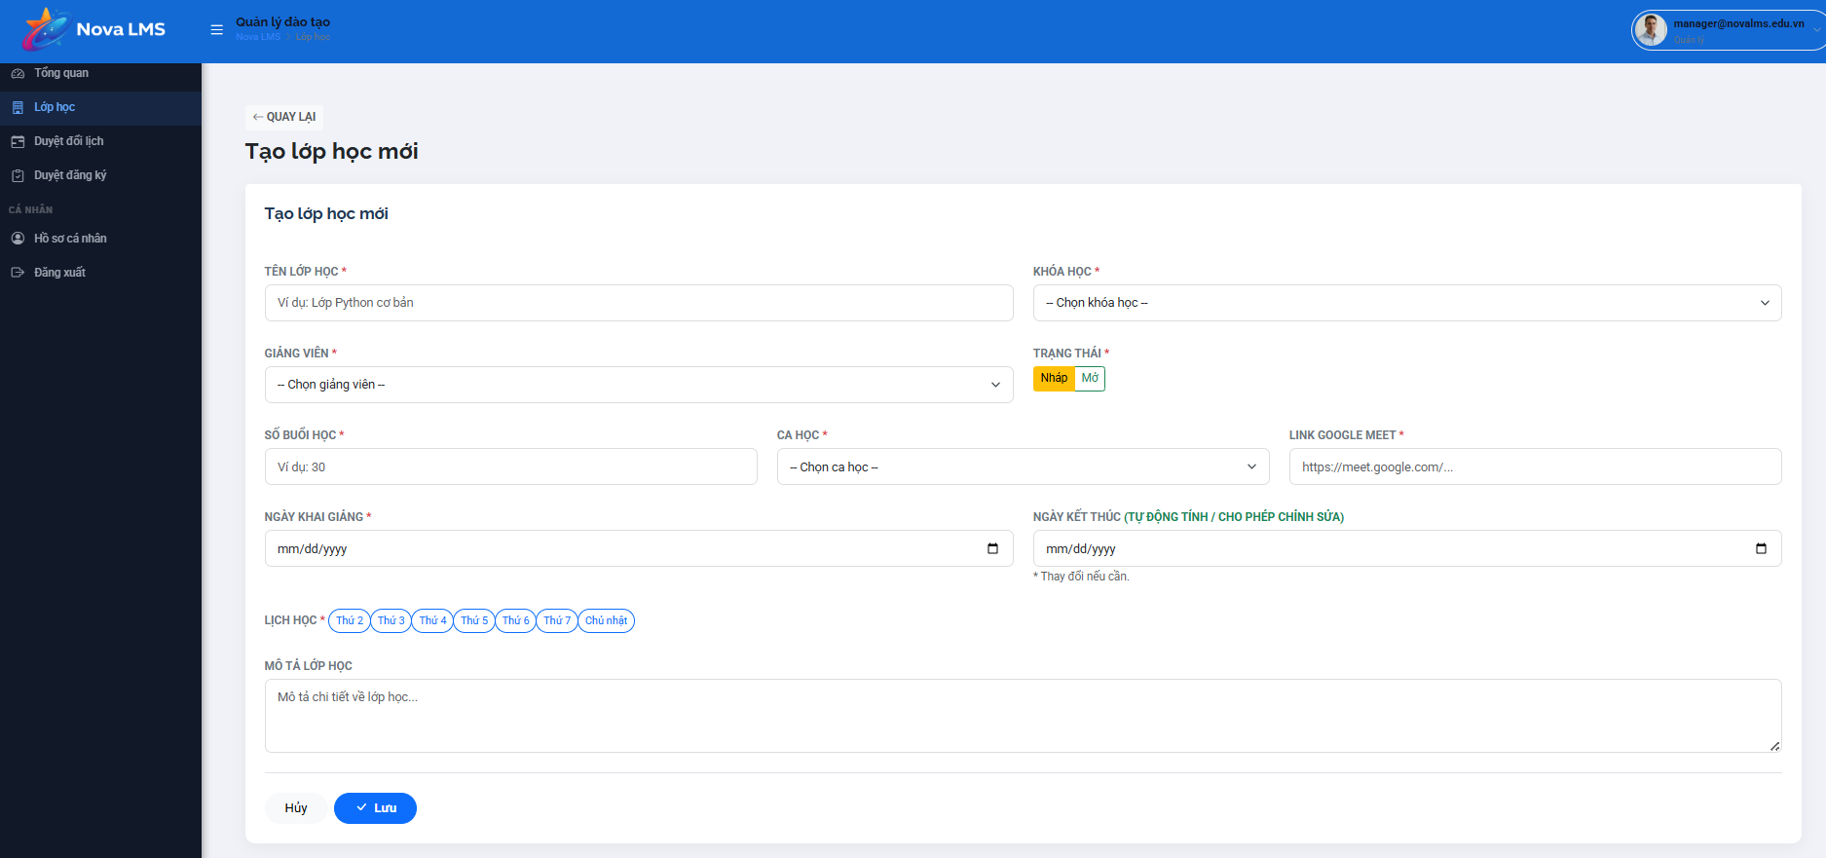
This screen allows the logged-in Manager to:
- Create a new class in the system.
- Input all required class information such as class name, course, instructor, and schedule.
- Configure class details including number of sessions, study time, and learning days.
- Set class status (draft or open).
- Automatically calculate or manually adjust class end date.
- Save or cancel the class creation process.
Mapped Use Cases:
- Create Class
- Input Class Information
- Assign Instructor
- Configure Schedule
- Save Class
- Cancel Creation
Field Name | Description
Quay lại (Back Button) | Button to navigate back to the Class List screen.
Tạo lớp học mới (Page Title) | Displays the title of the create class screen.
Tên lớp học (Class Name) | Input field for entering class name. Required field.
Class Name Placeholder | Displays hint text (e.g., “Ví dụ: Lớp Python cơ bản”).
Khóa học (Course) | Dropdown to select courses associated with the class. Required field.
Giảng viên (Instructor) | Dropdown to select instructor for the class. Required field.
Trạng thái (Status) | Toggle or selection (e.g., Nháp, Mở) indicating class status. Required field.
Số buổi học (Total Sessions) | Input field for total number of sessions (e.g., 30). Required field.
Ca học (Time Slot) | Dropdown to select study time slot. Required field.
Link Google Meet | Input field for entering online meeting link. Required field.
Ngày khai giảng (Start Date) | Date picker for selecting class start date. Required field.
Ngày kết thúc (End Date) | Date picker automatically calculated based on schedule; editable if needed.
Auto Calculation Note | Indicates end date is auto-calculated but can be manually adjusted.
Lịch học (Study Days) | Multi-select options for selecting days of the week (e.g., Thứ 2 → Chủ nhật).
Selected Days | Displays selected study days visually.
Mô tả lớp học (Class Description) | Textarea for entering additional class description.
Placeholder Description | Displays hint text (e.g., “Mô tả chi tiết về lớp học…”).
Hủy (Cancel Button) | Button to cancel creation and return to the previous screen.
Lưu (Save Button) | Button to save new class information.
Button State | Save button enabled only when all required fields are valid.
Validation Rules | Includes required fields, valid date range, valid URL format for meeting link.
Validation Message | Displays error messages when input is invalid.
Data Binding | Form data is submitted to create a new class record in the system.
Access Rule | Only accessible to users with a Manager role.
Responsive Behavior | Form layout adapts across devices; fields stack vertically on smaller screens.

3.5.2.3 Class Details
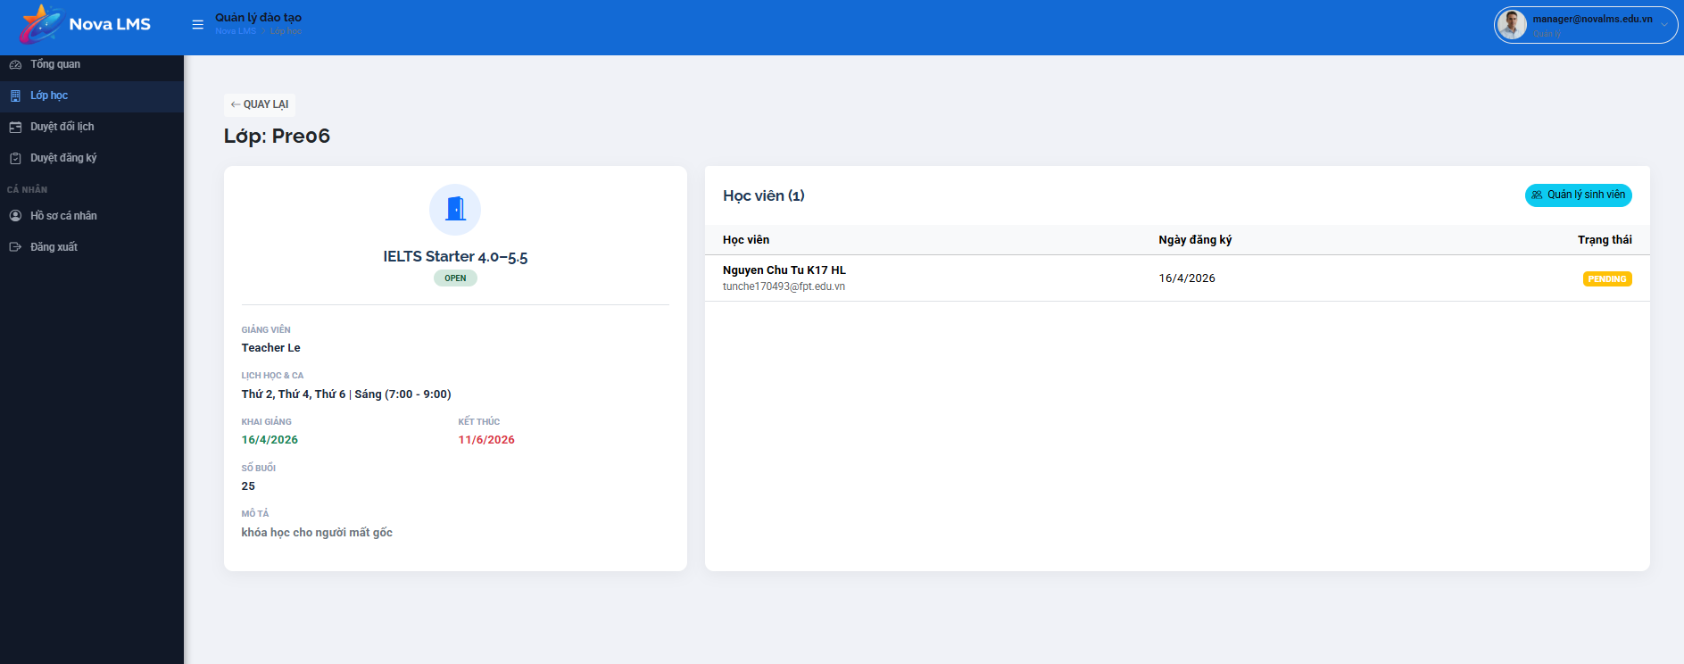
This screen allows the logged-in Manager to:
- View detailed information of a specific class.
- Monitor class status and associated course information.
- View assigned instructor and class schedule.
- Track enrolled students and their registration status.
- Navigate to student management for the class.
Mapped Use Cases:
- View Class Detail
- View Student List
- Manage Class Students
- View Class Information
Field Name | Description
Quay lại (Back Button) | Button to navigate back to the Class List screen.
Lớp: [Class Name] | Displays class name (e.g., Pre06).
Course Card | Section displaying associated course information.
Course Name | Displays course name (e.g., IELTS Starter 4.0–5.5).
Status Tag | Displays class status (e.g., OPEN).
Giảng viên (Instructor) | Displays assigned instructor name (e.g., Teacher Le).
Lịch học (Schedule) | Displays study days and time (e.g., Thứ 2, Thứ 4, Thứ 6
Ngày khai giảng (Start Date) | Displays class start date (e.g., 16/4/2026).
Ngày kết thúc (End Date) | Displays class end date (e.g., 11/6/2026).
Số buổi (Total Sessions) | Displays total number of sessions (e.g., 25).
Mô tả (Description) | Displays class description text.
Học viên (Student Section) | Section displaying list of enrolled students.
Học viên (Count) | Displays number of students in class (e.g., 1).
Student Table | Table listing students in the class.
Học viên (Student Name) | Displays student name and email.
Ngày đăng ký (Registration Date) | Displays date of student enrolled in class.
Trạng thái (Status) | Displays registration status (e.g., PENDING).
Quản lý sinh viên (Manage Students) | Button to navigate to the student management screen for this class.
Data Binding | All class and student data is dynamically loaded from the system.
Access Rule | Only accessible to users with a Manager role.
Responsive Behavior | Layout adapts across devices; sections stack vertically on smaller screens.

3.5.3 Teacher Schedule Change Approval
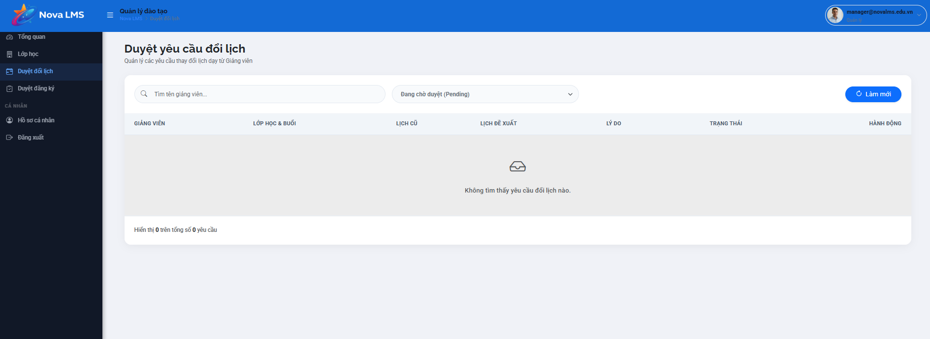
This screen allows the logged-in Manager to:
- View and manage requests for class schedule changes submitted by instructors.
- Search requests by instructor name.
- Filter requests based on approval status (e.g., pending, approved, rejected).
- Review detailed information of each request including the old schedule, proposed schedule, and reason.
- Approve or reject schedule change requests.
Mapped Use Cases:
- View Schedule Change Requests
- Search Request
- Filter Request
- Review Request Detail
- Approve Request
- Reject Request
Field Name | Description
Duyệt yêu cầu đổi lịch (Page Title) | Displays the title of the schedule change approval screen.
Subtitle Description | Displays description (e.g., “Quản lý các yêu cầu thay đổi lịch dạy từ Giảng viên”).
Search Bar | Input field allowing manager to search requests by instructor name.
Search Placeholder | Displays hint text (e.g., “Tìm tên giảng viên…”).
Status Filter | Dropdown allows filtering by request status (e.g., Pending, Approved, Rejected).
Default Filter Value | Default selected value (e.g., “Đang chờ duyệt (Pending)”).
Làm mới (Refresh Button) | Button to reload and refresh request list data.
Request Table | Table displaying list of schedule change requests.
Giảng viên (Instructor Column) | Displays instructor name who submitted the request.
Lớp học & Buổi (Class & Session) | Displays class name and session information.
Lịch cũ (Old Schedule) | Displays original schedule (date/time).
Lịch đề xuất (Proposed Schedule) | Displays requested new schedule.
Lý do (Reason) | Displays reasons provided by the instructor for change.
Trạng thái (Status) | Displays current request status (e.g., Pending, Approved, Rejected).
Hành động (Action Column) | Contains action buttons for each request.
Approve Button | Button to approve the schedule change request.
Reject Button | Button to reject the request.
Empty State | Displays message when no requests are found (e.g., “Không tìm thấy yêu cầu đổi lịch nào”).
Pagination Info | Displays number of records currently shown (e.g., “Hiển thị 0 trên tổng số 0 yêu cầu”).
Data Binding | Request data is dynamically loaded from the system.
Access Rule | Only accessible to users with a Manager role.
Responsive Behavior | Table adapts across devices; may support horizontal scrolling on smaller screens.

3.6 Expert Management

3.6.1 Expert Dashboard
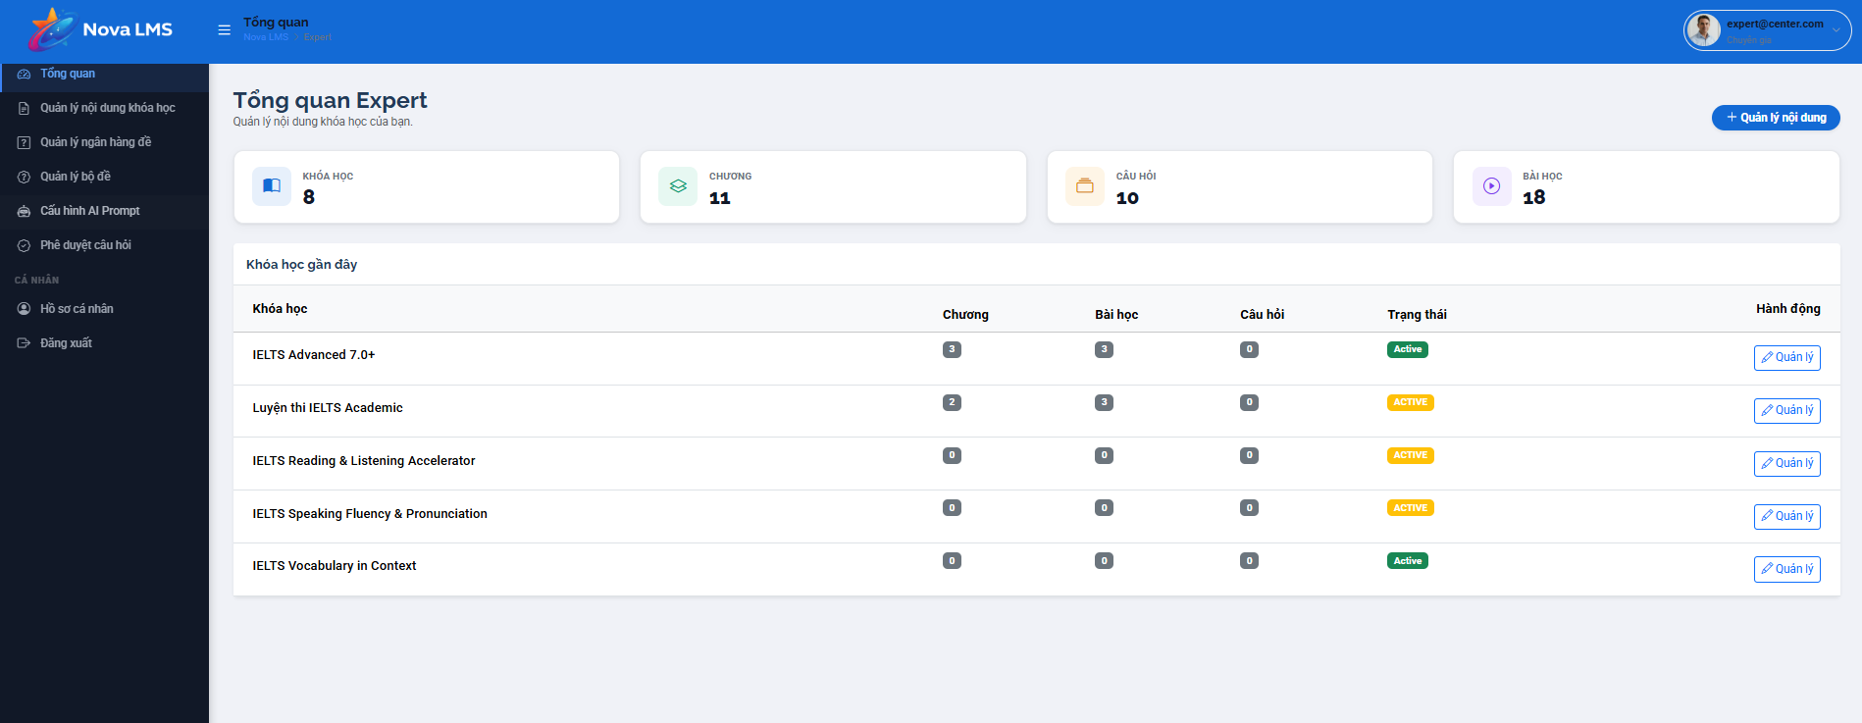
This screen allows the Expert to:
- Monitor overall statistics regarding their educational content (Courses, Chapters, Lessons, Questions).
- Quickly access and manage the list of courses they are currently overseeing.
- Navigate to advanced content management functions.
Mapped Use Cases:
- View General Statistics
- Manage Course List
- Navigate to Content Management
Field Name | Description
Expert Overview (Page Title) | Displays the main heading of the screen: "Tổng quan Expert".
Manage your course content... (Sub-title) | A brief text describing the purpose of the dashboard.
Manage Content (Primary Action Button) | A blue button with a (+) icon. Redirects the user to the global Resource Management page.
Statistic Cards | A set of 4 cards: Courses, Chapters, Questions, and Lessons.
Metric Value (Count) | Large numerical display showing the total count for each resource type (e.g., 8 Courses, 20 Lessons).
Recent Courses (Section Title) | Title for the data table section below.
Data Table | Displays a summary list of the most relevant courses.
Course Name | Displays the specific title/name of the course.
Chapter/Lesson/Question (Count Badges) | Small badges indicating the number of sub-components within each specific course.
Status Badge | Displays the current state of the course: Active (Green) or Inactive/Draft (Yellow/Grey).
Manage (Action Button) | A button with a pencil icon on each row to enter the detailed Course Editor/Management page.

3.6.2 Course & Chapter Management

3.6.2.1 Course List
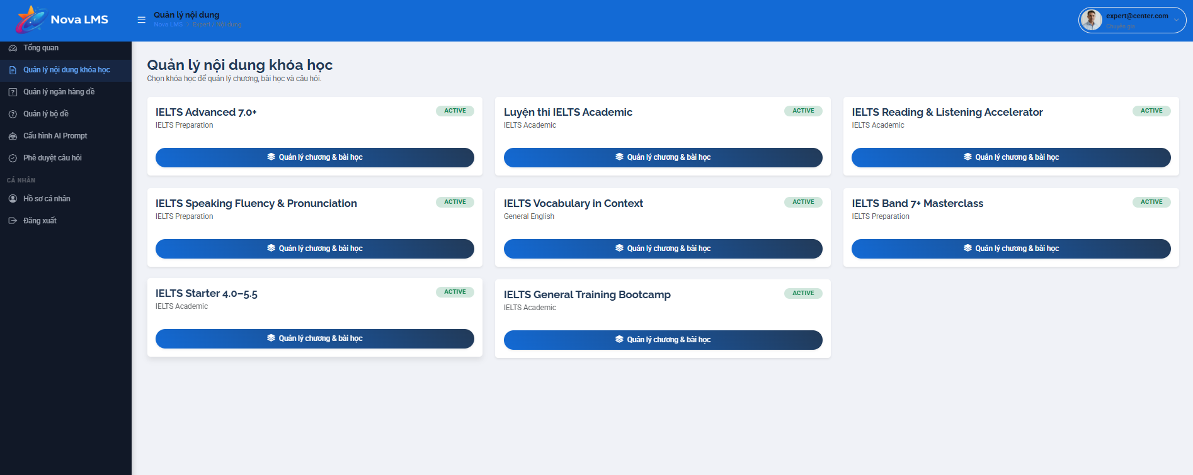
This screen allows the Expert to:
- View a comprehensive grid of all courses they are authorized to manage.
- Identify the category and operational status of each course at a glance.
- Access the specific management interface for chapters and lessons within a selected course.
Mapped Use Cases:
- View Course Grid
- Navigate to Chapter & Lesson Management
- Filter/Search Courses (implicit)
Field Name | Description
Course Content Management (Page Title) | Displays the main heading: "Quản lý nội dung khóa học".
Selection Instruction (Sub-title) | Instruction text: "Chọn khóa học để quản lý chương, bài học và câu hỏi."
Course Card | A dedicated container for each course displaying summary info.
Course Title | The prominent name of the course (e.g., "IELTS Advanced 7.0+").
Course Category | Smaller text below the title indicating the course type (e.g., "IELTS Preparation", "General English").
Status Badge | A pill-shaped indicator showing the course's current state: ACTIVE (Green) or other states like Draft.
Manage Chapters & Lessons (Action Button) | A primary blue button with a "layers" icon. This is the main entry point to modify course structure.

3.6.2.2 Chapter List

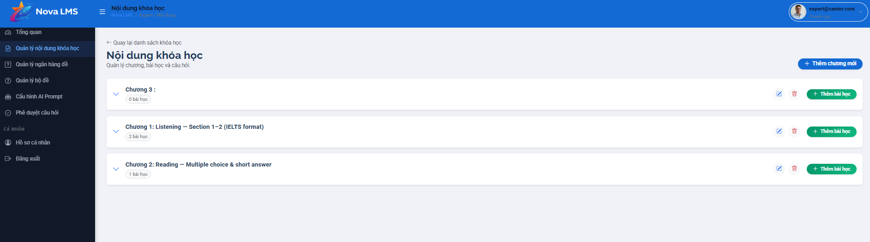
This screen allows the Expert to:
- Manage the hierarchical structure of a specific course (Chapters and Lessons).
- Create, edit, or delete chapters.
- Add lessons to specific chapters.
- Expand or collapse chapters to view nested content.
Mapped Use Cases:
- Create/Edit/Delete Chapter
- Create Lesson
- View Course Curriculum
- Back to Course List

Field Name | Description
Back to course list (Link) | A text link with a back arrow: "Quay lại danh sách khóa học". Redirects to the previous management screen.
Course Content (Page Title) | Displays the heading: "Nội dung khóa học".
Manage chapters... (Sub-title) | Contextual help text: "Quản lý chương, bài học và câu hỏi."
Add New Chapter (Primary Button) | Blue button (+ Thêm chương mới) located at the top right to trigger the "Create Chapter" modal.
Chapter Accordion/Row | A container representing a single chapter. Includes an expand/collapse toggle.
Chapter Title | Displays "Chương [Number]: [Name]".
Lesson Count Badge | A small grey badge under the title showing the number of lessons (e.g., "4 bài học").
Edit Chapter (Icon Button) | Blue pencil icon to rename or modify chapter settings.
Delete Chapter (Icon Button) | Red trash icon to remove the chapter and its associated content.
Add Lesson (Secondary Button) | Green button (+ Thêm bài học) inside the chapter row to add content to that specific chapter.

3.6.2.3 Chapter Detail
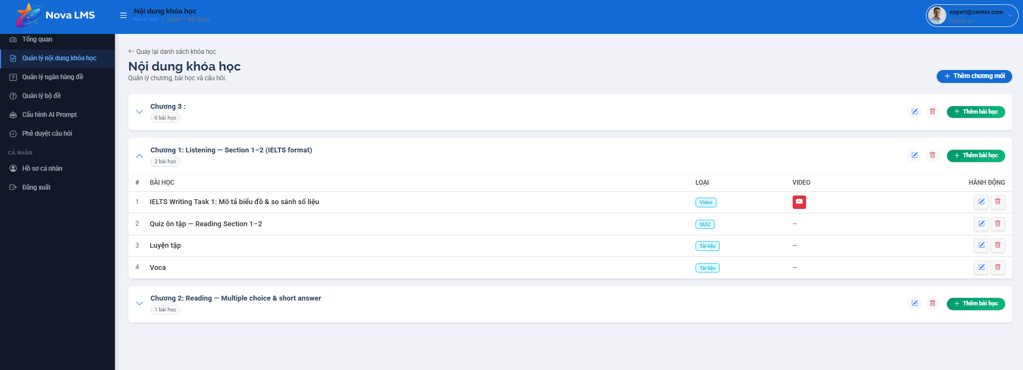
Description:
This screen allows Experts or Instructors to organize the course structure by managing Chapters and Lessons. It provides a hierarchical view where users can add, edit, or delete modules to build a complete learning path for students.
Mapped Use Cases:
- Manage Course Content
- Manage Chapters
- Manage Lessons
Field Name | Description
Add New Chapter Button | A primary button located at the top right to create a new Chapter (Chương) for the course.
Chapter Accordion | Each Chapter is displayed as a collapsible bar showing the Chapter Title and the number of lessons inside.
Chapter Actions | Includes "Edit" (pencil icon), "Delete" (trash icon), and "Add Lesson" (green button) specifically for that chapter.
Lesson List Table | When a chapter is expanded, it displays a table of lessons with the following columns:  1. #: Numerical order.  2. Lesson Name: Title of the lesson.  3. Type: Badge indicating content type (e.g., Video, Quiz, Document/Tài liệu).  4. Video: Icon link to the video source (if the type is Video).  5. Action: Buttons to Edit or Delete individual lessons.
Breadcrumb Navigation | Displays the path (Nova LMS / Expert / Content) to help users identify their current location in the system.
Sidebar Menu | Provides quick access to related management functions: Dashboard, Course Content, Question Bank, AI Prompt Configuration, etc.

3.6.3 Question Management

3.6.3.1 Question List

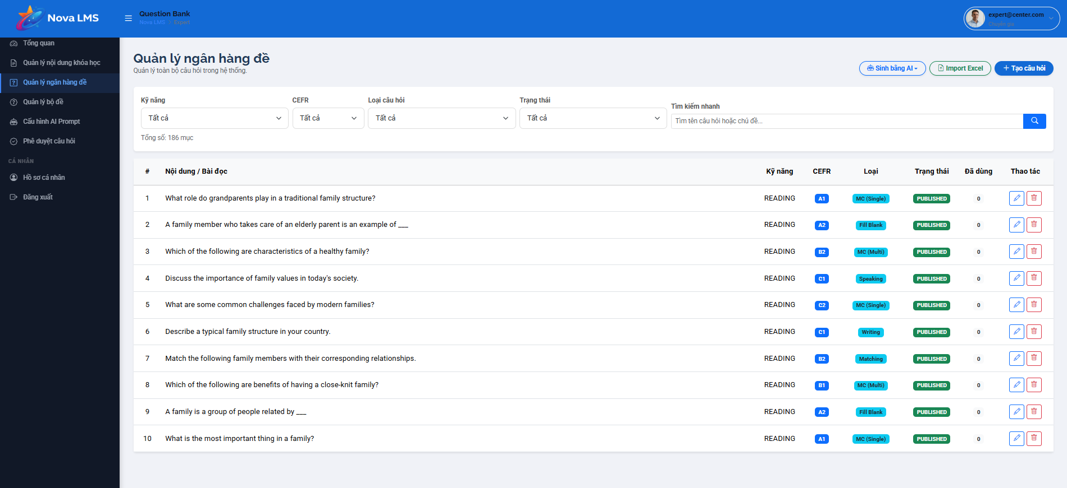
This screen allows the Expert to:
- View a comprehensive list of all questions available in the system question bank.
- Search and filter questions by multiple criteria (skill, CEFR level, format, status).
- Create new questions manually, import them in bulk via Excel, or generate them dynamically using an AI integration.
- Track the usage frequency of each question across different tests/quizzes.
- Edit or delete existing questions.
Mapped Use Cases:
- Manage Question Bank
- Import Questions (Excel)
- Generate Questions via AI
Field Name | Description
Generate via AI | "Sinh bằng AI": Triggers the AI prompt interface to automatically generate new questions based on specific criteria.
Import Excel | Allows the User to upload a standardized Excel template to bulk-import multiple questions into the bank.
Create Question | Primary action button ("+ Tạo câu hỏi") to manually open the question creation form.
Skill Filter | "Kỹ năng": Filters the list by targeted language skill (e.g., Reading, Writing, Listening, Speaking). The default is "Tất cả" (All).
CEFR Filter | "CEFR": Filters questions by difficulty level/band (e.g., A1, B2, C1). The default is "Tất cả".
Question Type Filter | "Loại câu hỏi": Filters by format (e.g., Multiple Choice, Fill Blank, Matching). Default is "Tất cả".
Status Filter | "Trạng thái": Filters by the current status of the question (e.g., Draft, Published). The default is "Tất cả".
Quick Search | "Tìm kiếm nhanh": Allows keyword searches across the question prompts or reading passages.
Question Bank Table | Displays the central list of questions. Contains the columns listed below.

3.6.3.2 New Question

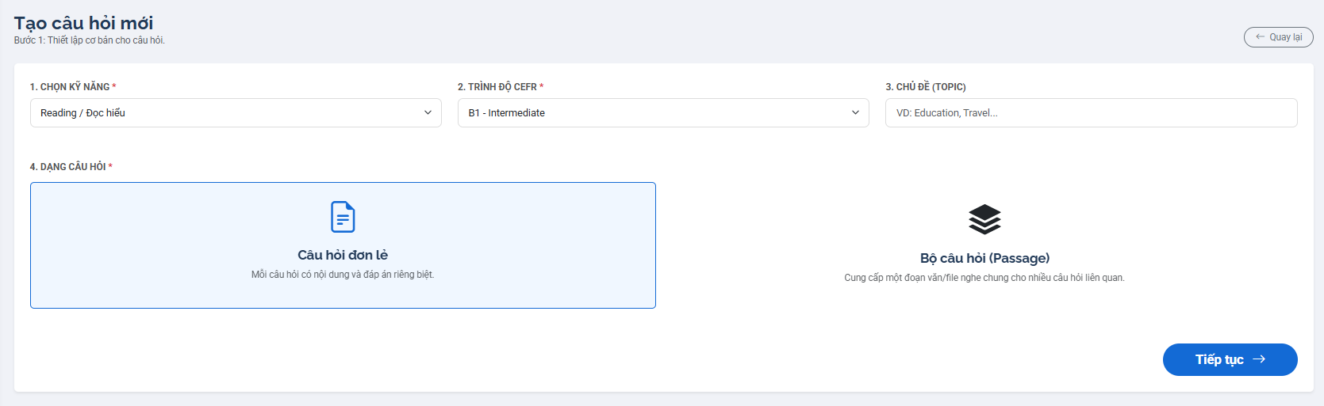

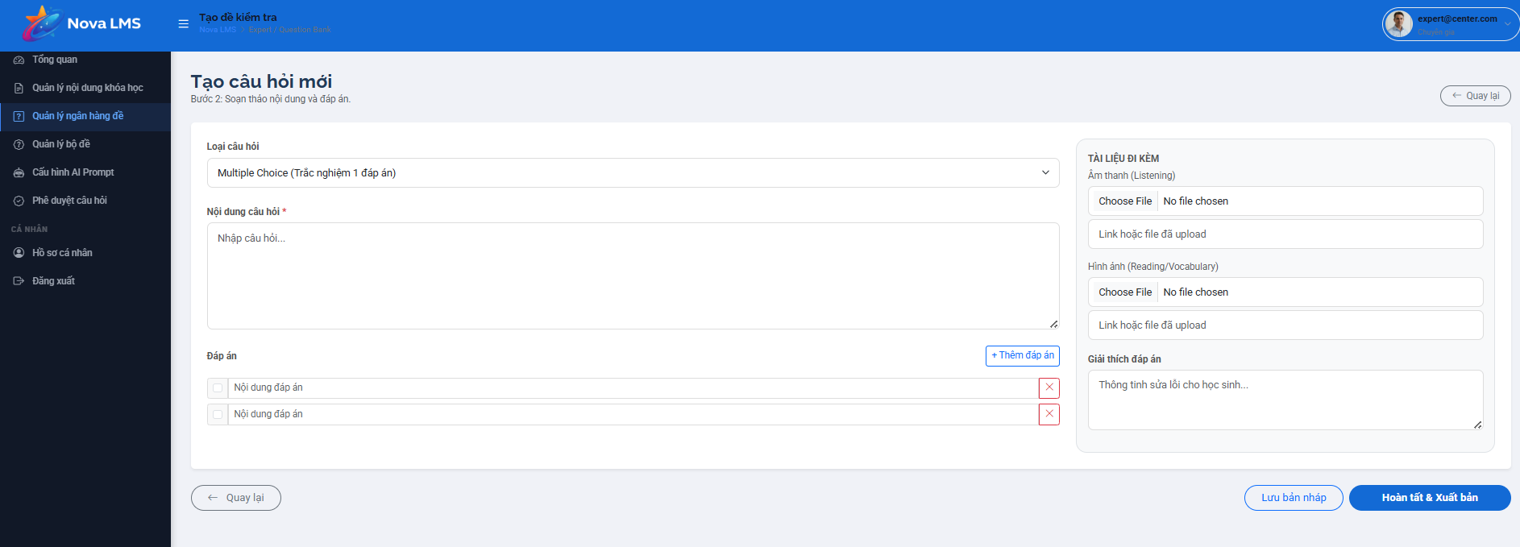
This screen allows the logged-in Manager (or Expert) to:
- Create a new question for the question bank.
- Define basic information such as skill, CEFR level, and topic.
- Choose question type (single question or passage-based question).
- Input question content and answer options.
- Attach supporting materials such as audio or images.
- Provide an explanation for the correct answer.
- Save draft or publish the question.
Mapped Use Cases:
- Create Question
- Input Question Content
- Add Answer Options
- Upload Media
- Save Draft
- Publish Question
Field Name | Description
Tạo câu hỏi mới (Page Title) | Displays the title of the create question screen.
Step Indicator | Indicates current step (e.g., Bước 1: Thiết lập cơ bản, Bước 2: Soạn thảo nội dung).
Quay lại (Back Button) | Button to navigate back to the previous screen.
Step 1: Basic Information
Field Name | Description
Chọn kỹ năng (Skill) | Dropdown to select skill (e.g., Reading, Listening, Speaking, Writing). Required field.
Trình độ CEFR | Dropdown to select level (e.g., A1, B1, C1). Required field.
Chủ đề (Topic) | Input field to enter topic (e.g., Education, Travel).
Dạng câu hỏi (Question Type Selection) | Section allowing users to choose a type of question.
Câu hỏi đơn lẻ (Single Question) | Option to create an independent question.
Bộ câu hỏi (Passage) | Option to create a group of questions based on a shared passage/audio.
Tiếp tục (Next Button) | Button to proceed to Step 2. Enabled only when required fields are filled.

Step 2: Question Content
Field Name | Description
Loại câu hỏi (Question Format) | Dropdown to select format (e.g., Multiple Choice – 1 correct answer).
Nội dung câu hỏi (Question Content) | Textarea to input question text. Required field.
Đáp án (Answer Section) | Section to define answer options.
Answer Option | Input field for each answer choice.
Correct Answer Selector | Checkbox/radio button to mark correct answer.
Thêm đáp án (Add Answer) | Button to add a new answer option dynamically.
Xóa đáp án (Delete Answer) | Button to remove an answer option.
Tài liệu đính kèm (Attachment Section) | Section to upload supporting materials.
Audio Upload | File upload field for listening questions.
Image Upload | File upload field for reading/vocabulary questions.
File Link | Input field to provide external file link if needed.
Giải thích đáp án (Explanation) | Textarea to input explanation for the correct answer.
Lưu bản nháp (Save Draft) | Button to save questions as draft.
Hoàn tất & Xuất bản (Publish Button) | Button to publish questions to the system.
Validation Rules | Includes required fields, at least one correct answer, valid file formats.
Validation Message | Displays error messages if input is invalid.
Data Binding | Question data is saved to the question bank system.
Access Rule | Accessible to Manager or Expert roles based on permission.
Responsive Behavior | Form layout adapts across devices; sections stack vertically on smaller screens.

3.6.3.3 Question Detail

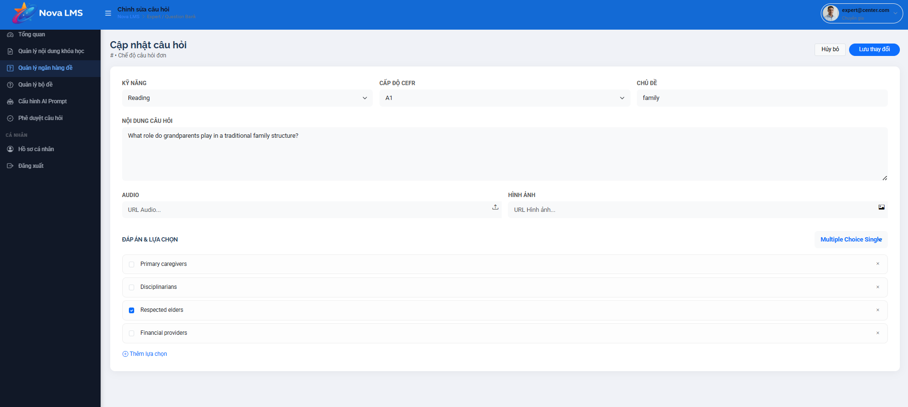
This screen allows administrators or instructors (Experts) to modify the details of an existing question in the question bank, including its classification, content, media attachments, and answer choices.
Mapped Use Cases:
- Edit Question Metadata: Modify the skill, CEFR level, or topic.
- Update Question Content: Edit the main text of the question.
- Manage Media Attachments: Update URL links for Audio or Image files.
- Modify Answer Options: Add, delete, or edit the text of answer choices and set the correct answer.
- Save Changes: Confirm and apply all modifications to the system.
Field Name | Description
Hủy bỏ (Cancel) | Discards any unsaved modifications and navigates the User back to the Question Bank list.
Lưu thay đổi (Save) | Primary action button. Validates the inputs and saves the updated question data to the system.
Kỹ năng (Skill) | Allows the User to reassign the target language skill (e.g., Reading).
Cấp độ CEFR | Allows the User to adjust the difficulty level (e.g., A1, B2).
Chủ đề (Topic) | Allows the User to update the topic tags or keywords associated with the question (e.g., "family").
Nội dung câu hỏi | The main text editor to modify the question prompt.

3.6.3.4 AI Question Generation
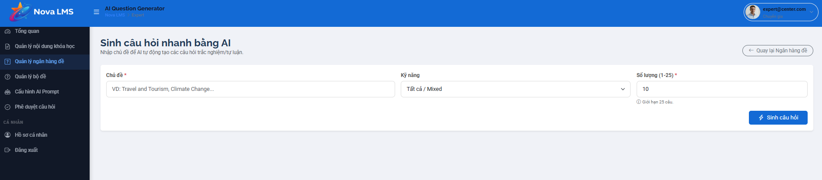This screen allows administrators or instructors to automatically generate multiple-choice or essay questions using AI by providing specific topics and parameters.
Mapped Use Cases:
- Generate Questions via AI
- Define Generation Parameters (Topic, Skill, Quantity)
- Navigate back to Question Bank
Field Name | Description
Back Button | "<- Quay lại Ngân hàng đề": Allows the User to navigate back to the main Question Bank management screen without executing the generation.
Chủ đề (Topic) | Mandatory field (*). Allows the User to input the specific subject matter or keywords for the AI to base its questions on (e.g., "Travel and Tourism, Climate Change...").
Kỹ năng (Skill) | Allows the User to specify the target language skill for the generated questions. The default option is "Tất cả / Mixed" (All/Mixed).
Số lượng (Quantity) | Mandatory field (*). Defines the exact number of questions the AI should generate in one batch. The system enforces a strict limit: minimum 1, maximum 25 questions per request (indicated by "Giới hạn 25 câu"). The default value is set to 10.
Sinh câu hỏi (Generate) | Primary action button. Validates the inputs (Topic and Quantity) and triggers the backend API call to the AI service to begin generating the questions.

3.6.4 Assessment Management

3.6.4.1 Assessment List

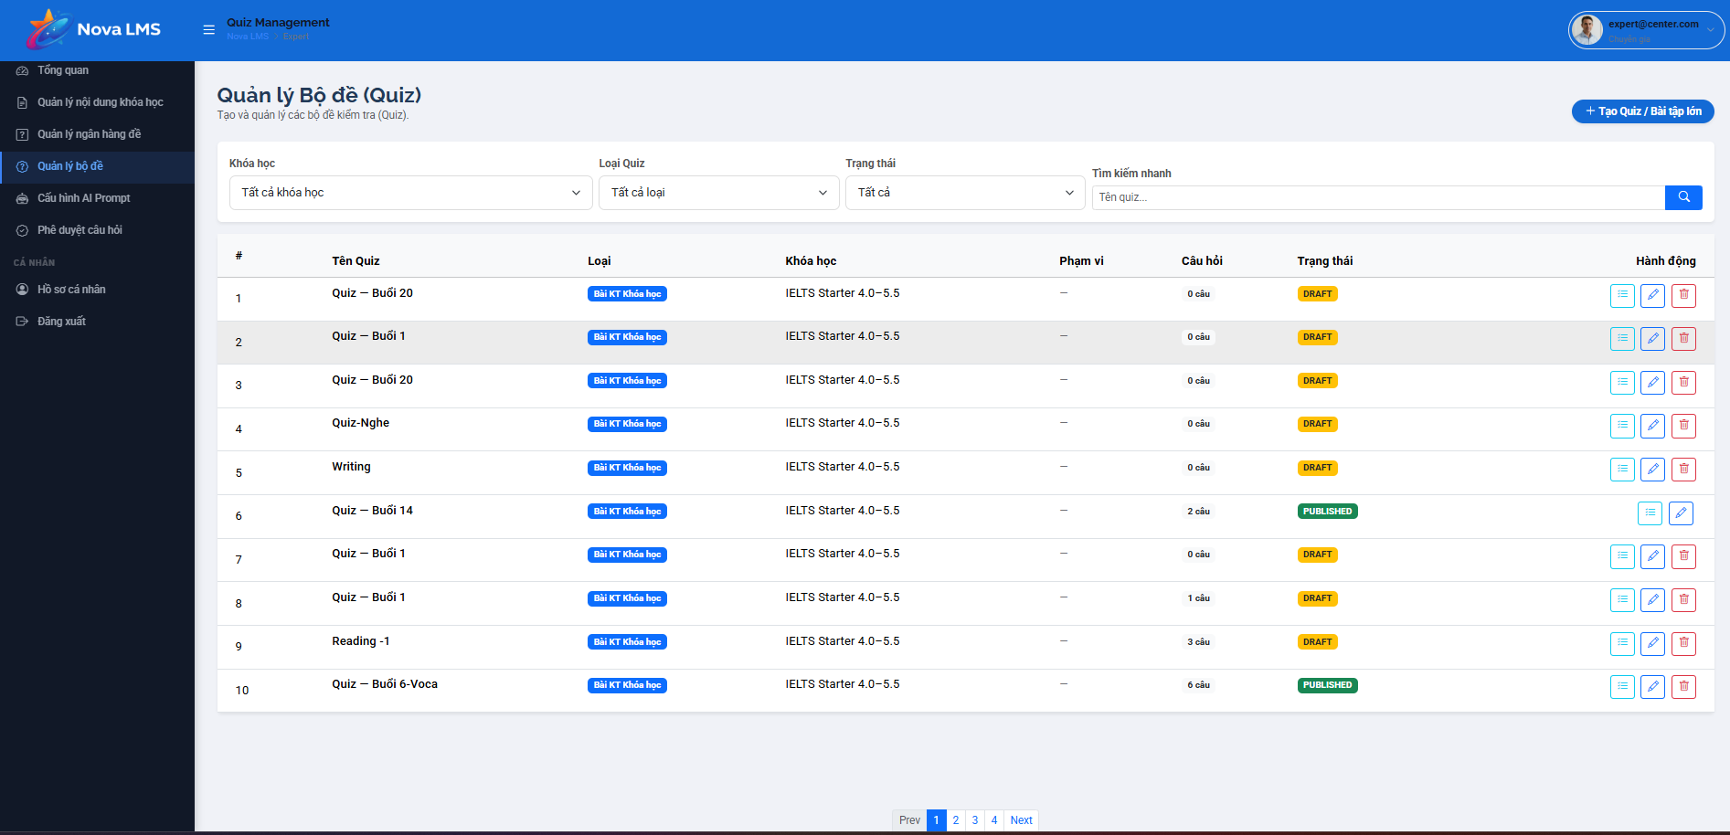
This screen allows the logged-in Manager (or Expert) to:
- View and manage the list of quizzes in the system.
- Filter quizzes by course, quiz type, and status.
- Search quizzes by name using keywords.
- View detailed information of each quiz such as course, number of questions, and status.
- Perform actions such as view, edit, or delete quizzes.
- Create new quizzes or assignments.
Mapped Use Cases:
- View Quiz List
- Filter Quiz
- Search Quiz
- View Quiz Detail
- Update Quiz
- Delete Quiz
- Create Quiz
Field Name | Description
Quản lý Bộ đề (Quiz) (Page Title) | Displays the title of the quiz management screen.
Subtitle Description | Displays description (e.g., “Tạo và quản lý các bộ đề kiểm tra (Quiz)”).
Tạo Quiz / Bài tập lớn (Create Button) | Button to navigate to Create Quiz or Assignment screen.
Filter Section | Section containing filtering and search controls.
Khóa học (Course Filter) | Dropdown allowing filtering by course. Default: “Tất cả khóa học”.
Loại Quiz (Quiz Type Filter) | Dropdown allowing filtering by quiz type (e.g., bài kiểm tra, bài tập).
Trạng thái (Status Filter) | Dropdown allows filtering by quiz status (e.g., Draft, Published).
Tìm kiếm nhanh (Search Bar) | Input field allowing users to search quiz by name.
Search Placeholder | Displays hint text (e.g., “Tên quiz…”).
Search Button | Button to trigger search action.
Quiz Table | Table displaying list of quizzes.
# (Index Column) | Displays row number.
Tên Quiz (Quiz Name) | Displays quiz name (e.g., Quiz – Buổi 20, Writing).
Loại (Type) | Displays quiz type (e.g., Bài KT khóa học).
Khóa học (Course Name) | Displays associated course name.
Phạm vi (Scope) | Displays scope or applicability of quiz (if any).
Câu hỏi (Question Count) | Displays number of questions in the quiz.
Trạng thái (Status Column) | Displays quiz status (e.g., DRAFT, PUBLISHED).
Status Tag | Visual label indicating quiz status.
Hành động (Action Column) | Contains action buttons for each quiz.
View Button | Button to view quiz details.
Edit Button | Button to edit quiz information.
Delete Button | Button to delete quiz.
Confirmation Dialog | Displays confirmation before deleting a quiz.
List Behavior | Displays quizzes based on filter/search conditions.
Empty State | Displays messages when no quizzes are found.
Data Binding | Quiz data is dynamically loaded from the system.
Access Rule | Accessible to Manager or Expert roles depending on permission.
Responsive Behavior | Table adapts across devices; may support horizontal scrolling on smaller screens.

3.6.4.2 New Assessment
Step 1:

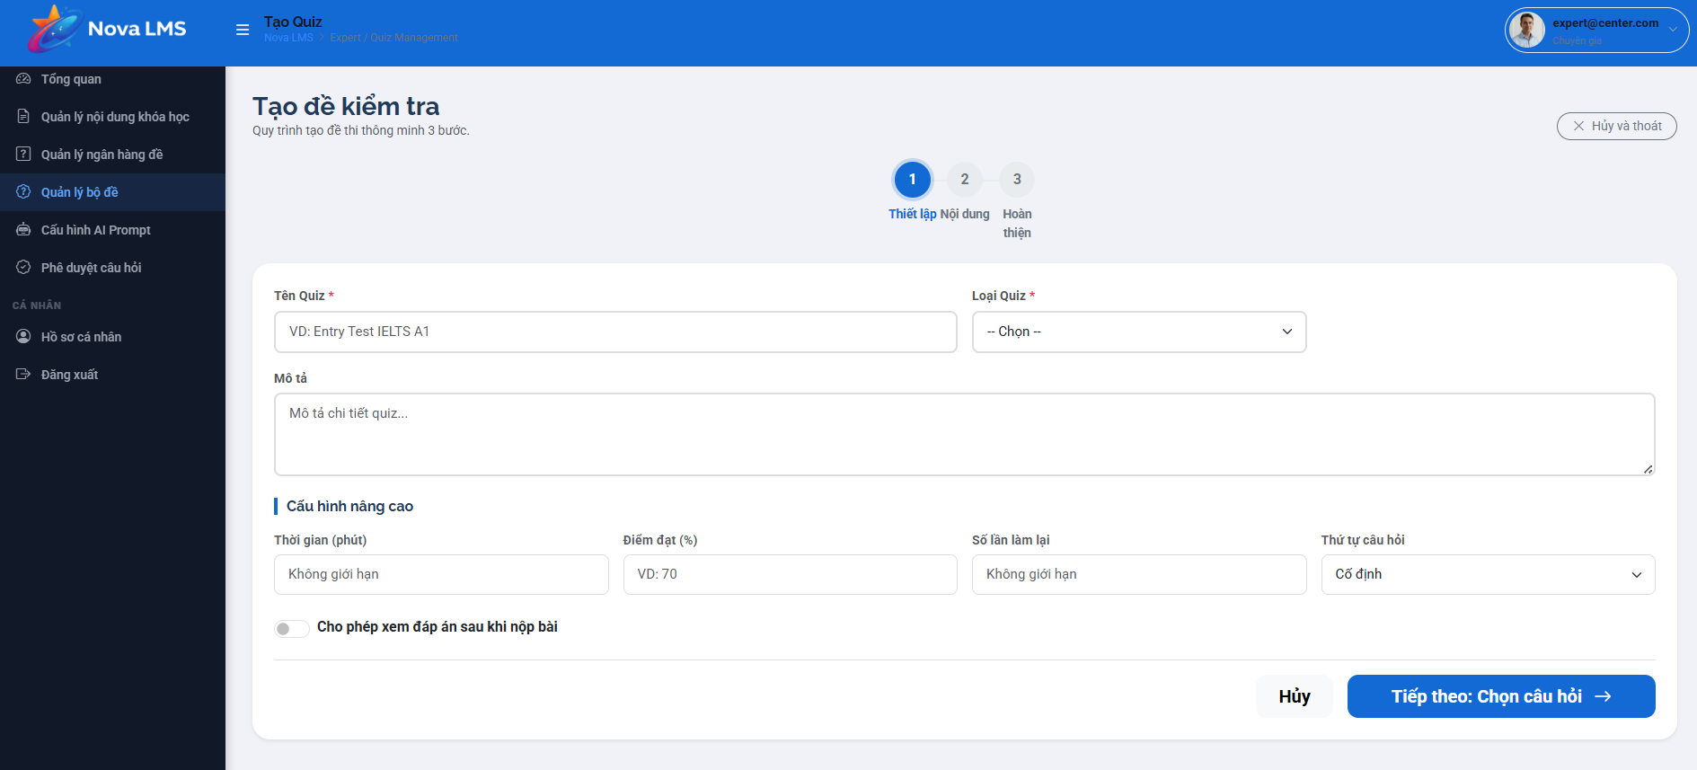
This screen allows the logged-in Expert (or Admin) to:
- Update existing question information in the question bank.
- Modify basic attributes such as skill, CEFR level, and topic.
- Edit question content and answer options.
- Update or replace attached media such as audio or images.
- Change the correct answer and adjust the answer list.
- Save updated changes or cancel editing.
Mapped Use Cases:
- Update Question
- Edit Question Content
- Manage Answer Options
- Upload Media
- Save Changes
- Cancel Update
Field Name | Description
Cập nhật câu hỏi (Page Title) | Displays the title of the update question screen.
Hủy bỏ (Cancel Button) | Button to discard changes and return to the previous screen.
Lưu thay đổi (Save Button) | Button to save updated question information.
Kỹ năng (Skill) | Dropdown displaying selected skills (e.g., Reading). Editable.
Cấp độ CEFR | Dropdown displaying level (e.g., A1). Editable.
Chủ đề (Topic) | Input field displaying topic (e.g., family). Editable.
Nội dung câu hỏi (Question Content) | Textarea displaying question text. Editable.
Audio | Field to upload or update audio file (for listening questions).
Audio URL | Displays current audio link if available.
Hình ảnh (Image) | Field to upload or update image file.
Image URL | Displays current image link if available.
Đáp án & Lựa chọn (Answer Options) | Section displaying all answer options.
Answer Option | Input field for each answer (e.g., Primary caregivers, Disciplinarians).
Correct Answer Indicator | Radio button/checkbox indicating the correct answer.
Selected Answer | Shows which answer is currently marked as correct.
Thêm lựa chọn (Add Option) | Button to add a new answer option.
Xóa lựa chọn (Delete Option) | Button to remove an answer option.
Question Type Label | Displays format (e.g., Multiple Choice Single).
Validation Rules | Includes required fields, at least one correct answer must be selected.
Validation Message | Displays error messages if validation fails.
Data Binding | Existing question data is pre-filled and updated upon save.
Update Behavior | On successful update, the system saves changes and shows success notification.
Error Handling | Displays error if update fails due to system issue.
Access Rule | Accessible to Manager or Expert roles based on permission.
Responsive Behavior | Layout adapts across devices; sections stack vertically on smaller screens.

Step 2:
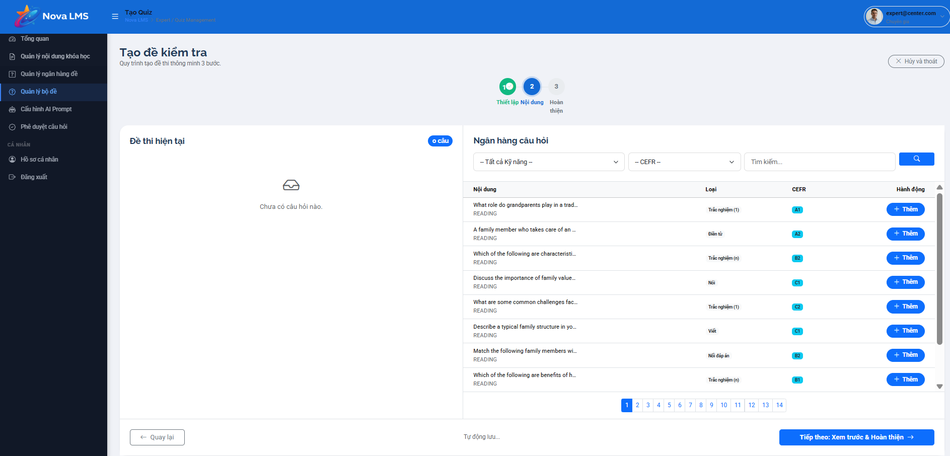
This screen allows the logged-in Expert (or Admin) to:
- Create a new quiz/test by selecting questions from the question bank.
- Browse and search questions based on skill and CEFR level.
- Add questions into the current test.
- View and manage selected questions in the test.
- Navigate through steps of the test creation process.
- Proceed to review and finalize the test.
Mapped Use Cases:
- Create Quiz
- Browse Question Bank
- Search Question
- Filter Question
- Add Question to Quiz
- Review Quiz Content
Field Name | Description
Tạo đề kiểm tra (Page Title) | Displays the title of the quiz creation screen.
Step Indicator | Displays progress of steps (e.g., Step 1: Thiết lập, Step 2: Nội dung, Step 3: Hoàn thiện).
Hủy và thoát (Cancel Button) | Button to cancel the process and exit quiz creation.
Đề thi hiện tại (Current Test Section) | Section displaying questions already added to the test.
Empty State (Current Test) | Displays message when no questions are added (e.g., “Chưa có câu hỏi nào”).
Question Count | Displays number of questions currently in the test.
Ngân hàng câu hỏi (Question Bank Section) | Section displaying available questions for selection.
Skill Filter | Dropdown to filter questions by skill (e.g., Reading).
CEFR Filter | Dropdown to filter questions by level (e.g., A1, B1).
Search Bar | Input field to search questions by keyword.
Search Button | Button to trigger search action.
Question Table | Table displaying list of questions from question bank.
Nội dung (Question Content) | Displays question text preview.
Loại (Type) | Displays question type (e.g., trắc nghiệm, điền từ, nói).
CEFR Level | Displays difficulty level (e.g., A1, B2, C1).
Thêm (Add Button) | Button to add selected questions into the current test.
Pagination | Allows navigation through multiple pages of question list.
Selected Question Behavior | Added questions appear in “Đề thi hiện tại” section.
Remove Question (Implicit) | Allows removing questions from the current test (if implemented).
Tiếp theo: Xem trước & hoàn thiện (Next Button) | Button to proceed to the next step of quiz creation.
Auto Save (Implicit) | The system may auto-save selected questions during the process.
Data Binding | Question data is dynamically loaded from the question bank.
Access Rule | Accessible to Manager or Expert roles based on permission.
Responsive Behavior | Layout adapts across devices; sections stack vertically on smaller screens.

Step 3:
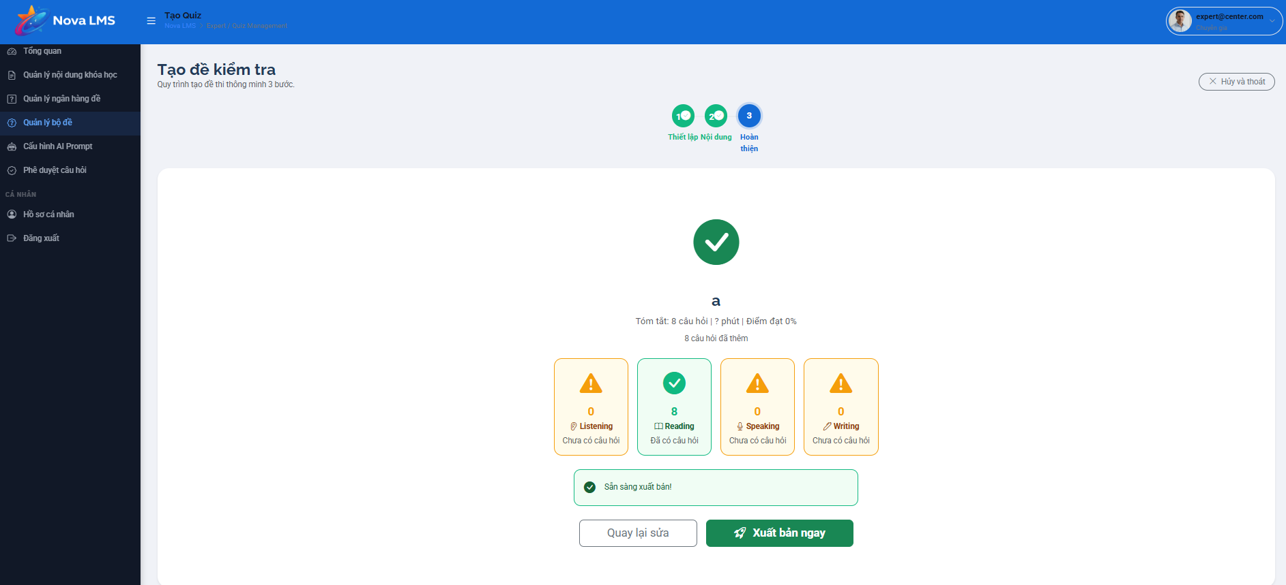
This screen allows the logged-in Manager (or Expert) to:
- Review the final summary of a quiz before publishing.
- Verify total number of questions, estimated duration, and passing criteria.
- Check distribution of questions by skill (Listening, Reading, Speaking, Writing).
- Identify missing sections or incomplete content before publishing.
- Navigate back to edit the quiz if needed.
- Publish the quiz to make it available in the system.
Mapped Use Cases:
- Review Quiz Summary
- Validate Quiz Content
- Publish Quiz
- Edit Quiz
Field Name | Description
Step Indicator | Displays current step in process (Step 3: Hoàn thiện).
Completion Icon | Visual indicator (checkmark) showing completion status.
Quiz Name | Displays name/title of the quiz (if available).
Summary Information | Displays summary (e.g., total questions, duration, passing score).
Question Count Summary | Displays total number of questions (e.g., 8 câu hỏi).
Duration | Displays estimated time to complete quiz (if configured).
Passing Score | Displays required score to pass (e.g., 0%).
Skill Distribution Section | Displays number of questions per skill.
Listening Count | Displays number of listening questions (e.g., 0 – chưa có câu hỏi).
Reading Count | Displays number of reading questions (e.g., 8 – đã có câu hỏi).
Speaking Count | Displays number of speaking questions (e.g., 0 – chưa có câu hỏi).
Writing Count | Displays number of writing questions (e.g., 0 – chưa có câu hỏi).
Status Indicators | Visual indicators (warning/check) showing completeness of each skill section.
Sẵn sàng xuất bản (Ready to Publish) | Message indicating quiz is ready for publishing.
Quay lại sửa (Back to Edit) | Button to return to the previous step for editing quiz content.
Xuất bản ngay (Publish Now) | Button to publish the quiz immediately.
Validation Rules | Ensures quiz meets minimum requirements before publishing.
Data Binding | Summary data is dynamically calculated based on selected questions.
Access Rule | Accessible to Manager or Expert roles.
Responsive Behavior | Layout adapts across devices; summary blocks stack vertically on smaller screens.

3.6.4.3 Assessment Details

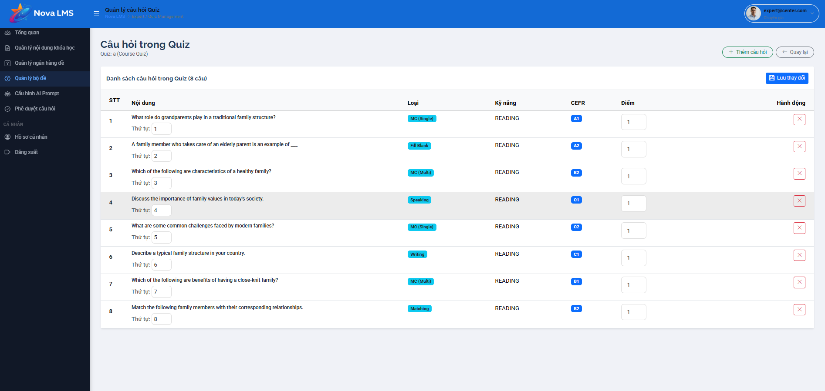
This screen allows the logged-in Manager (or Expert) to:
- View the list of questions included in a specific quiz.
- Manage question order within the quiz.
- Adjust score/points for each question.
- Remove questions from the quiz.
- Review question details such as type, skill, and difficulty level.
- Save updates to the quiz structure.
Mapped Use Cases:
- View Quiz Questions
- Reorder Questions
- Update Question Score
- Remove Question
- Save Quiz Changes
Field Name | Description
Danh sách câu hỏi trong Quiz (Page Title) | Displays the title of the question list within the quiz (e.g., 8 câu).
Lưu thay đổi (Save Button) | Button to save all modifications made to the quiz (order, score, etc.).
Question Table | Table displaying all questions included in the quiz.
STT (Index Column) | Displays sequential numbers of each question.
Nội dung (Question Content) | Displays question text preview.
Thứ tự (Order Field) | Input field allowing manual adjustment of question order.
Loại (Type Column) | Displays question type (e.g., MC Single, Fill Blank, Speaking, Writing, Matching).
Kỹ năng (Skill Column) | Displays skills associated with questions (e.g., Reading).
CEFR Level | Displays difficulty level (e.g., A1, B2, C1).
Điểm (Score Field) | Input field allowing setting score for each question (e.g., 1 point).
Hành động (Action Column) | Contains actions for each question.
Xóa (Remove Button) | Button to remove questions from the quiz.
Remove Confirmation | The system may prompt confirmation before removing a question.
Table Behavior | Displays all selected questions in the current quiz.
Validation Rules | Ensures valid order values and score inputs (e.g., numeric, non-negative).
Data Binding | All question data is dynamically loaded from quiz configuration.
Save Behavior | On save, the system updates quiz structure and persists changes.
Access Rule | Accessible to Manager or Expert roles.
Responsive Behavior | Table adapts across devices; may support horizontal scrolling on smaller screens.

3.6.5 Approval & AI Management

3.5.5.1 Question Approval

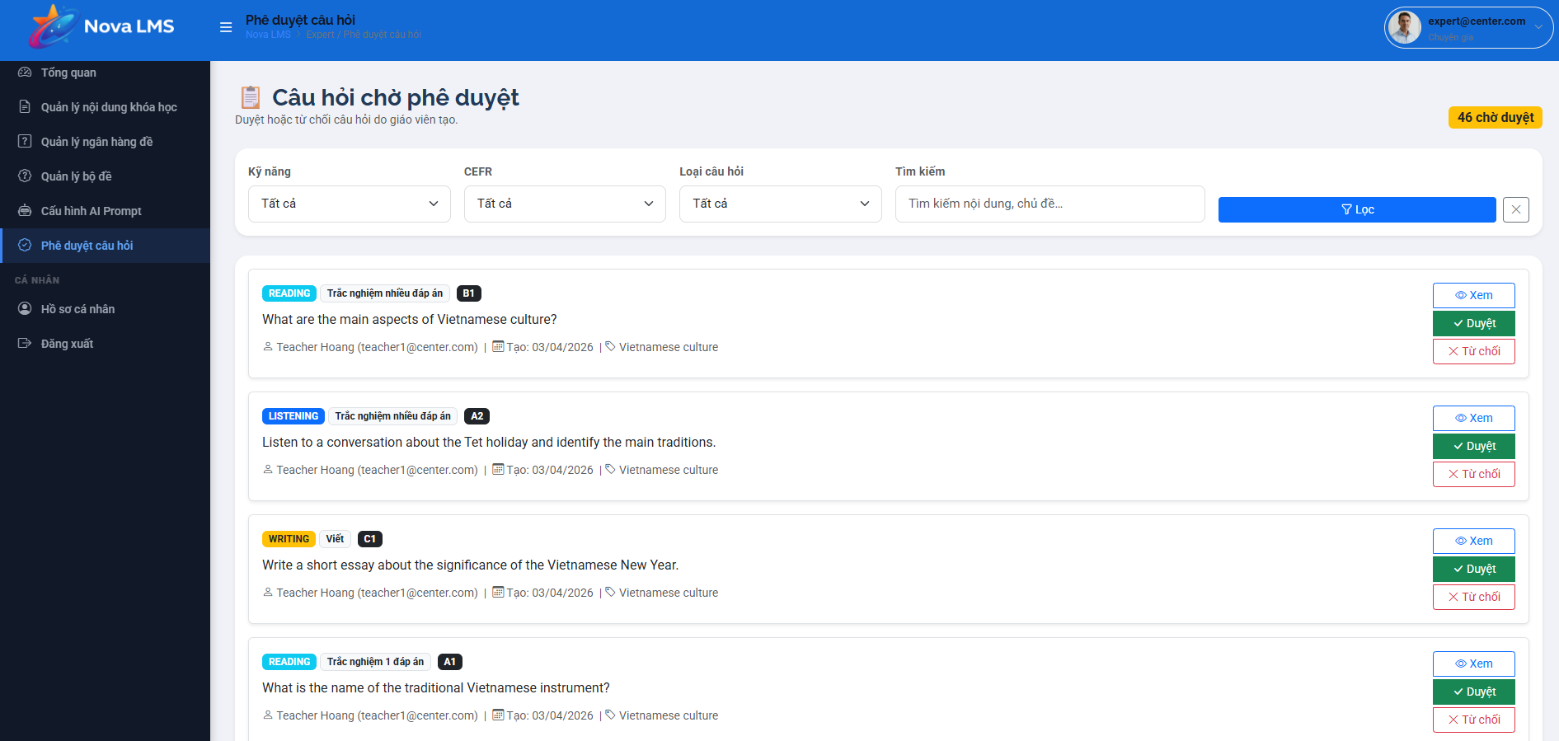
This screen allows the Manager (or Expert) to:
- Review all assessment items that are currently in a pending state (Teacher-created drafts or AI-generated suggestions).
- Search for specific questions using ID or content keywords to facilitate faster moderation.
- Filter the list by status (e.g., Draft, AI_Draft) or by course category to manage content in segments.
- View the original author of the question, whether it was a specific Teacher or the AI Engine.
- Perform batch actions to publish multiple selected questions simultaneously, making them active in the master question bank.
- Access a detailed view of each question to verify answer options and accuracy before approval.
Mapped Use Cases:
- 2.9.3 Publish Teacher Questions
- 2.9.4 Publish AI-Generated Questions
Field Name | Description
Search Bar | Text input used to find questions by entering their unique ID or snippet of the question content.
Status Filter | Dropdown menu used to filter questions by lifecycle state (e.g., All Status, DRAFT, AI_DRAFT).
Course Filter | Dropdown menu used to filter questions belonging to a specific course shell.
Batch Publish | Primary action button that updates the status of all selected questions to "Published" in one action.
ID | Displays the system-generated unique identifier for the question.
CONTENT | Displays a short preview of the question text or prompt.
TYPE | Indicates the category of the assessment item (e.g., Quiz, Question Bank).
STATUS | Displays a colored badge indicating the current state (DRAFT for Teacher-created, AI_DRAFT for AI-generated).
CREATED BY | Displays the name of the Teacher who authored the question or "AI Engine" for system-generated items.
Actions | Provides an icon to navigate to the detailed review page for individual assessment validation.

3.5.5.2 AI Prompt Configuration
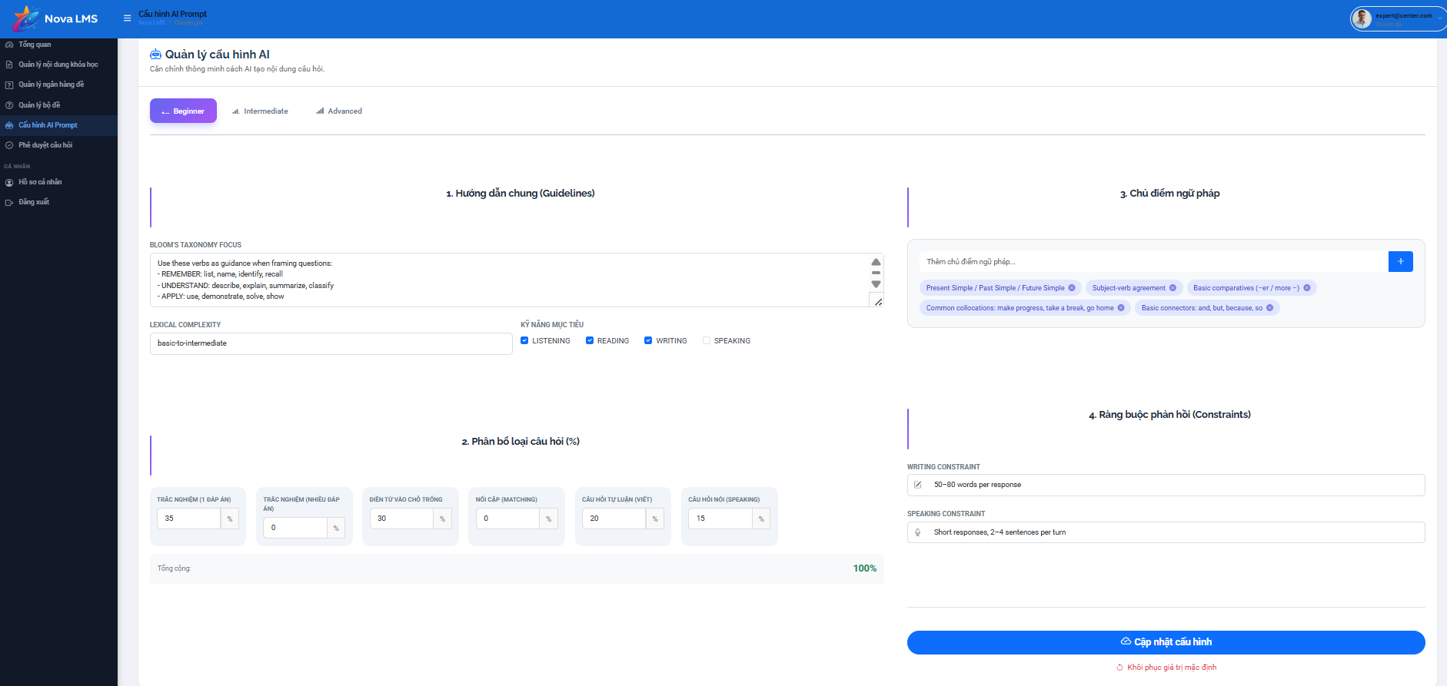

This screen allows the Admin to:
- Define the operational logic of the AI Engine used for generating questions and grading support.
- Select the specific Large Language Model (LLM) that will power the system's AI features.
- Tune technical parameters such as "Temperature" and "Max Tokens" to control the creativity and length of AI responses.
- Author "System Instructions" to establish the persona and rules the AI must follow when interacting with data.
- Customize the "User Prompt Template" to ensure that AI-generated questions align with specific course levels and formats.
- Save the configurations globally to the system settings or reset to default parameters.
Mapped Use Cases:
- 2.10.1 View Admin Dashboard (Configuration Access)
- 3.7.4 Admin Settings (Implicit via System Configuration)
Field Name | Description
Select Model | Dropdown menu to choose the underlying AI model (e.g., GPT-4o, GPT-3.5, Gemini Pro).
Temperature | Slider or numeric input (range 0 to 1) to control the randomness of the AI. Lower values make results more deterministic and factual.
Max Tokens | Numeric input field to limit the maximum length of the AI's generated response to control costs and output depth.
System Instruction | Large text area used to define the AI's core logic, such as "You are an English IELTS expert who generates MCQ questions."
User Prompt Template | Rich text area used to create a template for requests, utilizing variables like {topic} or {level} to be filled during the generation process.
Reset | Button that clears all unsaved changes and reverts the fields to the last saved configuration.
Save Config | Primary button that validates the settings and applies them globally to the AI Engine service.

3.7 Admin Management

3.7.1 Admin Dashboard
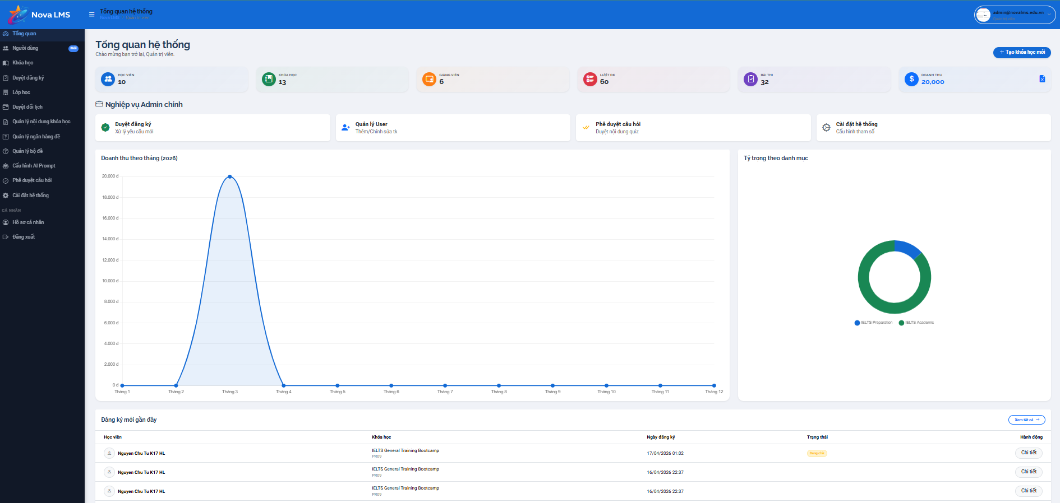
This screen allows the Admin to:
- Monitor high-level system metrics and platform health in real-time.
- Track total counts of users, courses, active classes, and assessments.
- View a summarized log of the most recent system activities for auditing.
- Access quick management modules through a centralized interface.
Mapped Use Cases:
- View Admin Dashboard
Field Name | Description
Total Users | Displays the total number of registered accounts across all roles (Student, Teacher, Manager, Expert, Admin).
Total Courses | Displays the total number of course shells currently created in the system.
Total Active Classes | Displays the count of class instances that are currently in "Ongoing" status.
Total Quizzes | Displays the total number of assessment items available across the platform.
Activity Title | Displays the name or subject of the recently logged system event.
Activity Type | Indicates the category of the logged action (e.g., Lesson Update, Question Creation).
Activity Status | Shows the current state of the activity record (e.g., Active).
Created Date | Displays the specific timestamp when the activity was performed.
Actions | Provides buttons to view details or edit the specific record linked to the activity log.

3.7.2 Account Management

3.7.2.1 Account List
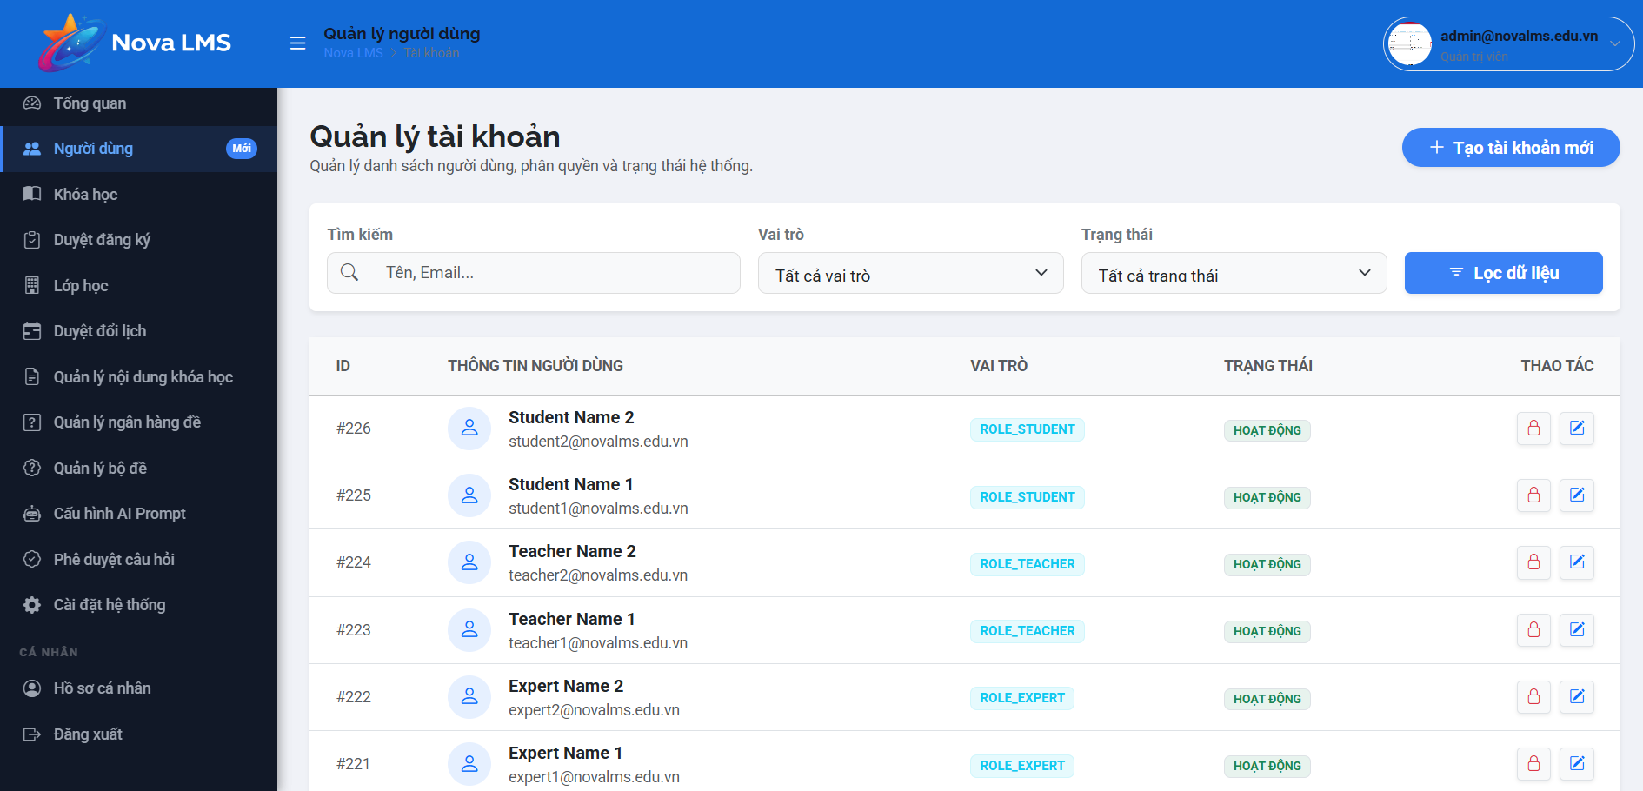
This screen allows the Admin to:
- View a comprehensive list of all system users.
- Filter and search for accounts based on roles or current status.
- Manage account access by manually locking or unlocking specific users.
Mapped Use Cases:
- View Account List
- Block/Unblock Account
Field Name | Description
Search | Text input to find accounts using name or email keywords.
Role Filter | Dropdown menu to filter the list by specific system roles (e.g., ROLE_TEACHER).
Status Filter | Dropdown to filter accounts by "Active" or "Locked" status.
User Information | Displays the user's full name and registered email address.
Role Badge | Indicates the current permissions level assigned to the user.
Account Status | Displays a status badge showing if the account is currently "Active" or "Locked".
Lock/Unlock Button | Toggle action to restrict or restore system access. Prevents blocking the final Admin account.
Edit Button | Navigates the Admin to the detailed account modification screen.
Add New Account | Primary button used to initiate the creation of a new internal account.

3.7.2.2 New Account
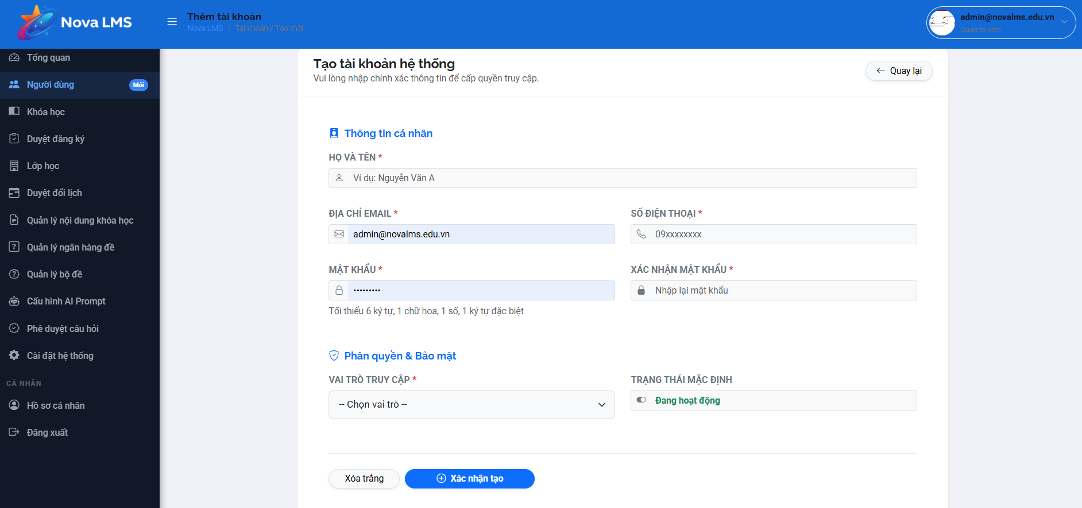
This screen allows the Admin to:
- Create new internal accounts for staff and faculty members.
- Define mandatory profile details and system permissions for new users.
Mapped Use Cases:
- Add New Account
Field Name | Description
Full Name | Required field to enter the legal name of the new user.
Email | Required field for a unique email address. Serves as the primary login credential.
Phone Number | Field for entering the user's contact information.
System Role | Dropdown to assign a specific role (Teacher, Manager, Expert, or Admin).
Initial Status | Dropdown to set the account as "Active" or "Locked" upon creation.
Save Account | Validates all inputs and creates the new user record in the database.
Cancel | Discards all inputs and returns the Admin to the account list.

3.7.2.3 Account Detail
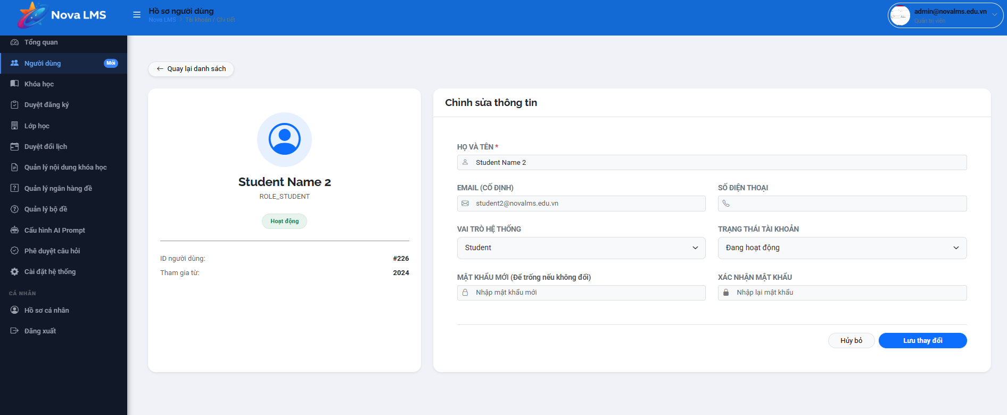
This screen allows the Admin to:
- View the full profile and history of a specific user.
- Modify contact details and update system roles for existing accounts.
Mapped Use Cases:
- Update Account Details
- Block/Unblock Account
Field Name | Description
Profile Header | Displays the user's name, assigned role, and current status badge.
Full Name | Editable field to update the user's name record.
Email | Read-only display of the registered email address.
Phone Number | Editable field for updating contact details.
System Role | Dropdown allows the Admin to reassign the user to a different organizational role.
Current Status | Displays the live state of the account (Active/Locked).
Status Toggle | Button used to change the account status between Active and Locked.
Update Information | Saves all modified fields to the user’s master record.

3.7.3 Course Management

3.7.3.1 Course List
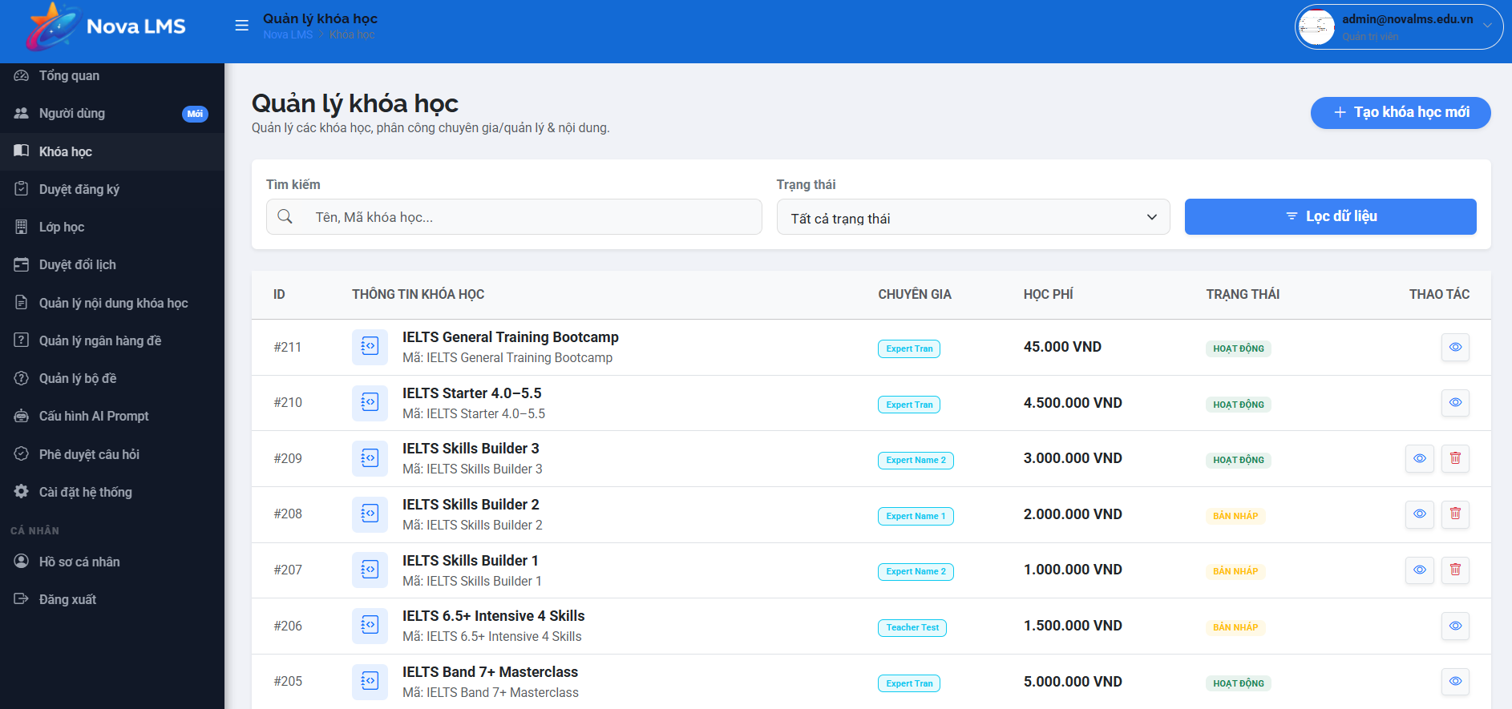
This screen allows the Admin to:
- Browse the full directory of training programs and courses.
- Manage course visibility and track pricing configurations.
Mapped Use Cases:
- View Course List
Field Name | Description
Search Bar | Input used to find courses by ID, unique course code, or name.
Status Filter | Dropdown to view courses by their lifecycle state (All, Active, Inactive).
Course Info | Displays the course title and its system-generated code.
Price | Shows the current tuition fee configured for the course in VND.
Status Badge | Indicates if the course is "Active" (visible to users) or "Inactive".
View Details | Action icon that redirects the Admin to the comprehensive course detail page.
Create New Course | Navigation button to the course initialization form.

3.7.3.2 New Course
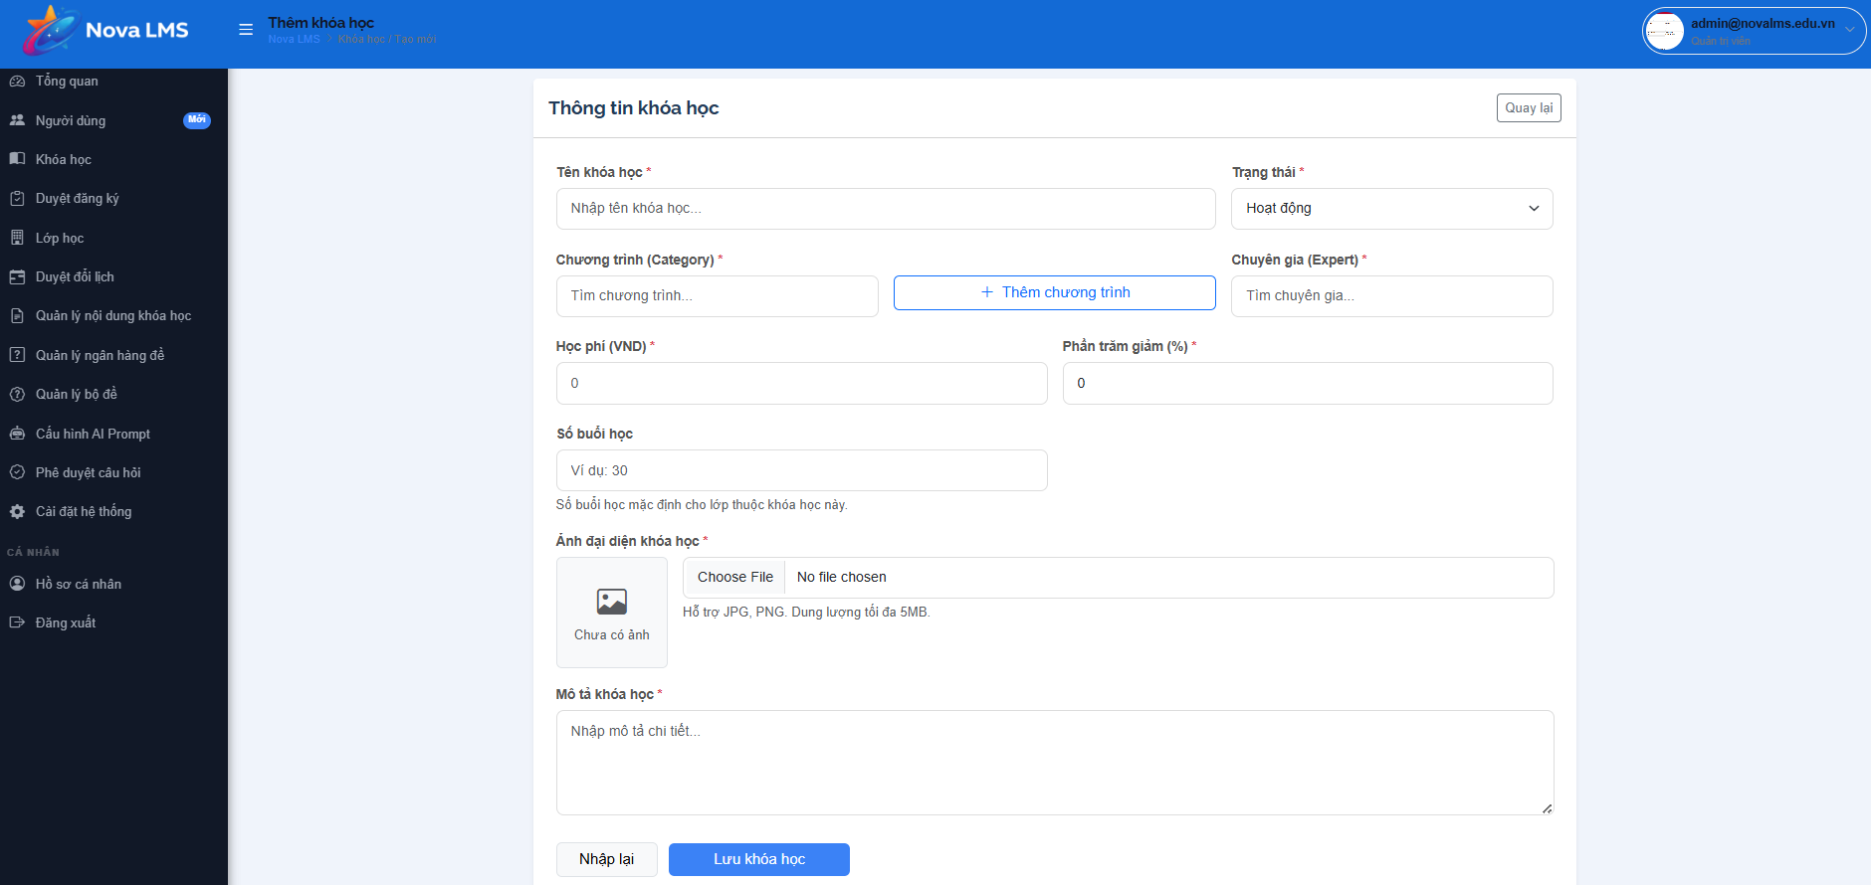
This screen allows the Admin (or Manager) to:
- Initialize a new course by defining its basic profile and properties.
- Assign a unique identification code and a descriptive name to the course.
- Configure the enrollment cost (Tuition Fee) for the training program.
- Set the initial operational status to control course visibility.
- Provide a comprehensive description to inform potential students about the course content.
- Reset the form to clear all inputs or save the information to create the course record.
Mapped Use Cases:
- Create New Course
Field Name | Description
Course Code | Required text input for the unique identifier of the course. The value must be unique within the system.
Course Name | Required text input for the public title of the training program. This name must be unique.
Tuition Fee (VND) | Numeric input field used to define the cost of enrollment. The default value is 0 for free courses.
Status | The dropdown menu is used to set the course state (e.g., Hoạt động - Active, Inactive). Controls course visibility for students.
Course Description | Large text area for entering a detailed overview, learning objectives, and curriculum summary of the course.
Reset | Button that clears all current inputs in the form and restores default values.
Save Course | Primary action button that validates the provided data and creates a new course record in the database.
Back | Navigation button that returns the user to the Course List screen without saving any changes.

3.7.3.3 Course Detail
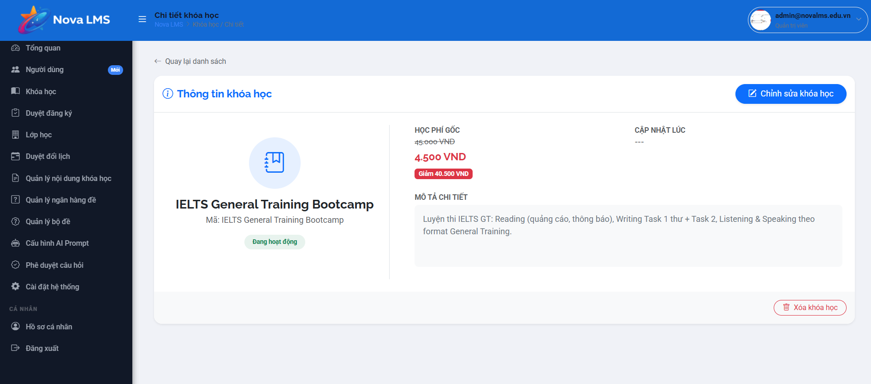

This screen allows the Admin to:
- Review complete course information and historical data.
- Modify course attributes or archive programs that are no longer active.
Mapped Use Cases:
- Update Course Details
Field Name | Description
Information Header | Displays course name, code, and live status.
Price Display | Highlights the current cost required for student enrollment.
Creation Date | Displays the read-only timestamp of when the course was first created.
Detailed Description | Shows the full text overview and curriculum summary.
Edit Course | Button to enable modification mode for the course attributes.
Archive/Delete Course | Action to remove the course from active listings. Restricted if active classes exist.
Back to Catalog | Link to return to the main course management list.

3.7.4 Admin Settings
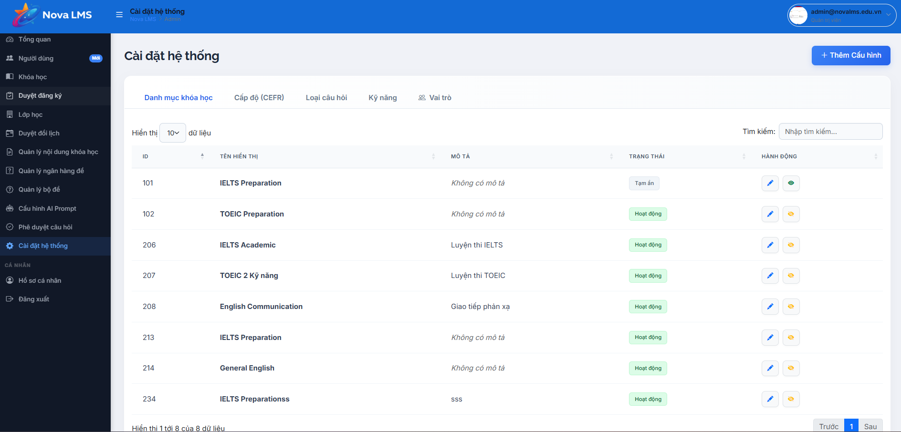

This screen allows the Admin to:
- Manage global platform configurations and shared lookup data.
- Update business rules such as assessment limits and course categories.
Mapped Use Cases:
- Update System Settings
Field Name | Description
Category Management | Interface to add, rename, or remove course groupings (e.g., IELTS, TOEIC).
Test Attempt Limit | Configuration field to set the maximum number of times a student can take a Placement Test.
Currency Configuration | Settings for defining how pricing and financial transactions are displayed.
System Logs | Link to access detailed diagnostic logs and error reports.
Save Configurations | Button to apply all changes globally to the Nova LMS environment.

4. Non-Functional Requirements
This section defines the non-functional requirements of the Nova Learning Management System (Nova LMS). These requirements describe the system’s quality attributes, external interfaces, operational constraints, and performance standards.

4.1 External Interfaces

4.1.1 User Interface
Nova LMS is a web-based Learning Management System designed to provide a responsive and role-based user interface. The system shall:
- Provide a responsive interface compatible with Desktop, Tablet, and Mobile devices.
- Support role-based dashboards for the following actors: (Guest, Student, Teacher, Manager, Expert, Admin)
- Maintain consistent navigation structure across all modules.
- Display clear feedback messages for user actions (success, warning, error).
- Ensure page loading time does not exceed three (3) seconds under normal network conditions.
- Provide intuitive workflows for course enrollment, quiz participation, content management, and system administration.

4.1.2 Hardware Interface
Nova LMS shall operate on standard computing devices, including:
- Desktop computers
- Laptops
- Tablets
- Smartphones
The system shall be deployed on cloud infrastructure and must support scalable computing resources to handle increasing numbers of concurrent users.

4.1.3 Software Interface
Nova LMS shall integrate with external systems and services, including:
- Online Payment Gateway (e.g., VNPay, Stripe)
- Email Notification Service (SMTP or third-party mail services)
- AI Engine for question generation and content support
- Cloud Storage for video hosting and document management
- Relational Database Management System (MySQL)
- RESTful APIs for communication between frontend and backend
All external integrations must use secure authentication mechanisms and encrypted communication channels.

4.1.4 Communication Interface
The system shall:
- Use HTTPS protocol with TLS 1.2 or higher.
- Exchange data in JSON format.
- Implement JWT (JSON Web Token) for authentication and session management.
- Support configurable session timeout policies.
- Log all API requests related to payment, authentication, and content publishing.

4.2 Quality Attributes

4.2.1 Performance
Nova LMS shall meet the following performance requirements:
- Page response time shall not exceed 3 seconds.
- Quiz submission processing time shall not exceed two seconds.
- The system shall support at least 5,000 concurrent users.
- The system shall handle at least 500 simultaneous quiz submissions without failure.
- Average database query response time shall not exceed one second.

4.2.2 Security
The system shall implement comprehensive security mechanisms, including:
- Password encryption using bcrypt hashing algorithm.
- Role-Based Access Control (RBAC).
- Protection against:SQL Injection, Cross-Site Scripting (XSS), Cross-Site Request Forgery (CSRF)
- Secure payment processing without storing credit card information locally.
- Logging of critical actions such as: Login attempts, Payment transactions, Account status changes, Content publishing, Quiz activation/deactivation

4.2.3 Availability
Nova LMS shall:
- Maintain a minimum uptime of 99%.
- Perform automated daily database backups.
- Provide disaster recovery within four hours in case of major system failure.
- Ensure auto-save functionality for quizzes to prevent data loss during network interruptions.

4.2.4 Scalability
The system architecture shall:
- Support horizontal scaling through load-balanced application servers.
- Allow modular feature expansion.
- Be capable of scaling to support at least 50,000 registered users in future releases.

4.2.5 Usability
The system shall:
- Provide a simple, consistent, and intuitive UI with key functions accessible within ≤ 3 clicks.
- Allow students to complete registration within ≤ 3 minutes and ≤ 5 steps.
- Provide clear navigation with menu, breadcrumbs, easy access to courses within ≤ 2 clicks.
- Display clear, user-friendly validation and error messages instantly.
- Minimize learning time for teachers/admins (≤ 2 hours) with logical structure and basic guidance.

5. Requirement Appendix

5.1 Business Rules
Rule ID | Rule Definition
BR-01 | Each user must have a unique email address in the system.
BR-02 | Only Admin can create Manager, Teacher, and Expert accounts.
BR-03 | The last active Admin account cannot be blocked or downgraded.
BR-04 | A blocked account cannot log into the system.
BR-05 | Passwords must comply with defined complexity requirements.
BR-06 | Role changes can only be performed by Admin.
BR-07 | Course names must be unique.
BR-08 | Only published courses are visible to Guests and Students.
BR-09 | A course cannot be archived if it has active classes.
BR-10 | Only Admin or Manager can create or update course information.
BR-11 | A class must be linked to an existing course.
BR-12 | Only the Manager or Admin can assign a Teacher to a class.
BR-13 | A class cannot exceed its maximum capacity.
BR-14 | Class schedule must not conflict with the assigned Teacher schedule.
BR-15 | Completed classes cannot be modified.
BR-16 | Students can enroll only if class status = Open.
BR-17 | Paid course enrollment must have status = Pending Payment before confirmation.
BR-18 | Enrollment becomes active only after successful payment.
BR-19 | A student cannot enroll in the same class more than once.
BR-20 | Only enrolled students can access learning materials.
BR-21 | Payment transactions must be recorded and linked to enrollment.
BR-22 | Students must be logged in to take the Placement Test.
BR-23 | Placement Test attempts may be limited by configuration.
BR-24 | Placement Test results must be stored per student.
BR-25 | Course recommendation is generated based on test score.
BR-26 | The quiz must contain at least one question before activation.
BR-27 | Quiz cannot be deleted if attempts exist.
BR-28 | Only active quizzes are accessible to students.
BR-29 | Quiz cannot be structurally modified after attempts exist.
BR-30 | Quiz duration must be defined before activation.
BR-31 | Each question must define a valid question type.
BR-32 | Objective questions must define at least one correct answer.
BR-33 | Teacher-created questions must initially have Draft status.
BR-34 | AI-generated questions must be reviewed by experts before publishing.
BR-35 | Only published questions can be used in quizzes.
BR-36 | Questions used in active quizzes cannot be deleted.
BR-37 | A module must belong to exactly one course.
BR-38 | A lesson must belong to exactly one module.
BR-39 | Lessons must be published to be visible to students.
BR-40 | Lesson prerequisites must be completed before access (if configured).
BR-41 | Only assigned Teachers (or Manager/Admin) may edit course content.
BR-42 | Access control must follow Role-Based Access Control (RBAC).
BR-43 | Students may only access their own enrollments and grades.
BR-44 | Teachers may only manage classes assigned to them.
BR-45 | Experts may review and publish AI-generated questions only.
BR-46 | Managers oversee operations but cannot override Admin privileges.
BR-47 | All critical actions must be logged.
BR-48 | Logs must include timestamp, user ID, and action details.
BR-49 | Confirmed payment transactions cannot be edited.
BR-50 | System-generated IDs must be unique.
BR-51 | Learning progress is calculated based on lesson completion.
BR-52 | Grade Book displays only graded activities.
BR-53 | Course completion status follows configured completion criteria.

5.2 System Messages
STT | Message Code | Message Type | Context | Content
I | SUCCESS MESSAGES
1 | MSG-SUC-001 | Success | Login | Đăng nhập thành công
2 | MSG-SUC-002 | Success | User Registration | Đăng ký tài khoản thành công!
3 | MSG-SUC-003 | Success | Quiz | Tạo quiz thành công
4 | MSG-SUC-004 | Success | Payment | Gửi liên kết thanh toán thành công
5 | MSG-SUC-005 | Success | Reschedule | Gửi yêu cầu đổi lịch thành công
6 | MSG-SUC-006 | Success | Assignment | Đã gửi câu hỏi chờ duyệt
7 | MSG-SUC-007 | Success | Course Completion | Chúc mừng! Bạn đã hoàn thành khóa học và đạt điều kiện cấp chứng chỉ.
8 | MSG-SUC-008 | Success | Student Assignment | Bài làm của bạn đã được gửi thành công.
9 | MSG-SUC-009 | Success | Teacher Grading | Đã lưu điểm và phản hồi cho học viên.
10 | MSG-SUC-010 | Success | Materials | Tải tài liệu lên thành công.
II | ERROR MESSAGES
11 | MSG-ERR-001 | Error | Login | Tài khoản của bạn đã bị khóa hoặc chưa kích hoạt.
12 | MSG-ERR-002 | Error | User Registration | Mật khẩu xác nhận không khớp!
13 | MSG-ERR-003 | Error | User Registration | Email này đã được sử dụng!
14 | MSG-ERR-004 | Error | Password Reset | Mã xác minh không chính xác hoặc đã hết hạn.
15 | MSG-ERR-005 | Error | Course | Không thể xóa khóa học đã có học viên đăng ký
16 | MSG-ERR-006 | Error | Quiz | Quiz đã được gắn với bài học này
17 | MSG-ERR-007 | Error | Quiz | Bạn cần hoàn thành quiz trước để mở khóa quiz này
18 | MSG-ERR-008 | Error | AI Generation | Số lượng câu hỏi yêu cầu quá lớn hoặc quá nhanh so với giới hạn.
19 | MSG-ERR-009 | Error | Payment | Bạn đã thanh toán đăng ký này.
20 | MSG-ERR-010 | Error | System | File không được vượt quá 5MB.
21 | MSG-ERR-011 | Error | Reschedule | Bạn không có quyền gửi yêu cầu cho buổi học này
22 | MSG-ERR-012 | Error | AI Speaking | Hệ thống không thể xử lý âm thanh bài nói. Vui lòng thử lại.
23 | MSG-ERR-013 | Error | Payment Webhook | Chữ ký thanh toán không hợp lệ. Vui lòng liên hệ hỗ trợ.
24 | MSG-ERR-014 | Error | Learning Flow | Bài học này đã bị khóa. Vui lòng hoàn thành bài học trước đó.
25 | MSG-ERR-015 | Error | File Upload | Định dạng file không được hỗ trợ.
III | WARNING MESSAGES
26 | MSG-WAR-001 | Warning | Quiz | Chỉ câu hỏi từ giáo viên mới cần duyệt
27 | MSG-WAR-002 | Warning | Quiz | Câu hỏi không ở trạng thái chờ duyệt
28 | MSG-WAR-003 | Warning | Attendance | Buổi học này chưa diễn ra, bạn chắc chắn muốn điểm danh?
29 | MSG-WAR-004 | Warning | Quiz Taking | Thời gian làm bài sắp hết. Hệ thống sẽ tự động nộp bài sau 1 phút.
IV | INFO MESSAGES
30 | MSG-INF-001 | Info | Auth | Mã xác minh đã được gửi đến email của bạn.
31 | MSG-INF-002 | Info | AI Grading | Câu hỏi đang được AI phân tích, kết quả sẽ có sau 1-2 phút.
32 | MSG-INF-003 | Info | Teacher Dashboard | Bạn có [X] bài làm đang chờ chấm điểm.

5.3 Other Requirements
- Future versions may support export functionality (CSV/Excel) for grade reports, enrollment data, and financial transactions.
- A native mobile application is out of scope for the current release. The system will be delivered as a web-based platform only.
- The web system must support modern browsers, including the latest versions of Chrome, Edge, and Firefox.
- AI-powered features (such as question generation and learning recommendations) rely on external AI services. If the AI service is unavailable, related UI functions shall display friendly error messages without blocking other system modules.
- Online payment processing depends on third-party payment gateways. If the payment gateway service is unavailable, enrollment status shall remain “Pending Payment.”
- The system requires stable internet connectivity for full functionality.
- Email notifications (registration, password reset, enrollment confirmation) rely on external email services. If the email service fails, core learning functionality shall remain unaffected.
- Real-time analytics dashboards are limited to predefined metrics in the current release.
- Multi-language support beyond English and Vietnamese is out of scope for this version.
- Advanced AI learning personalization features may be introduced in future releases.

